CONFIDENTIAL AND PROPRIETARY

**Aries Systems Corporation**



**Product Functional Specification**

13.0-03_V8

checkCIF Integration

**Status: Post –OTS enhancements**

Copyright © 2015, Aries Systems Corporation

This document is the confidential and proprietary property of Aries Systems Corporation. The contents hereof are for use only by recipients specifically identified by Aries, and may not be further disclosed to any other third party. Specifications, designs and drawings contained herein are subject to withdrawal or change by Aries, without notice. Aries shall have no liability resulting from such withdrawal or change. Editorial Manager is a registered trademark and the property of Aries Systems Corporation.

Aries Systems reserves the right to share this specification with other individuals or organizations that have entered into confidentiality agreements with Aries Systems, in which case the specification will be appropriately blinded so that no identifying or proprietary information will be exposed.

**Document Summary**

|  |  |
| --- | --- |
| **Enhancement Name** | checkCIF integration |
| **Specification Number** | 13.0-03 |
| **Enhancement Type** | General |
| **Implemented In** | EM Version 13.0 |

**Document Revision History**

|  |  |  |
| --- | --- | --- |
| **Date** | **Author** | **Comments** |
| 3/16/2015 | C. Webber | Based on FRA # 466 |
| 6/8/2015 | C. Webber | V2 &3- After internal review   * Added use cases * Removed “Enable checkCIF’ checkbox in HA per LSH – no charge for this feature so it does not need to be controlled in HA, and users can elect to send files to checkCIF or not themselves. * Set checkCIF to default on per LSH; files will not be sent unless configured. * Clarified that if only one results PDF exists for the current revision, clicking the ‘checkCIF Results’ link will download that PDF without navigating to the interim *View checkCIF Results* page. * Added the ‘View checkCIF Results’ link to the PDF, similar to the ‘click here to view linked references’ link. * Added a merge field to download the results PDFs. * Changed the display of various file grids per feedback by S. Macrae * Added logic to display the View checkCIF Results link in Editor and Publisher folders even if no results yet exist, as long as at least one file associated with the current revision of the submission is configured to go to the checkCIF tool; to provide information about files with the status “Not yet Tested” and “Testing in Progress”. |
| 7/2/2015 | C. Webber | V4 – After management review   * Clarified some places where columns should wrap/not wrap * Changed the appearance of the PDF cover page to clarify that both the .cif file and results file are separately downloadable * Changed position of Results links on the Technical Check page to be on the same line |
| 7/6/2015 | C. Webber | V5 – Cleanup after engineering handover   * Removed a few stray references to HA, Set Journal Features. The checkCIF feature was originally enabled there, but is now enabled in PolicyManager. * Omit “pm” logo per LSH. This was an open question in the prior version. * Removed reference to asynch queue – the feature will run on the asynch servers, not the asynch queue on the web servers * Added page layout #15A for Transmittal Form Proof and Print |
|  |  | V6 – Changes during coding phase   * Clarified behavior of PDF results files in XML and .go.xml files. |
| 8/3/2015 | C. Webber | V7 – Changes during coding phase – scope reduction   * It was determined that V6 could not be coded during the available timeframe, therefore the following features were removed from V6 and moved to “Future Enhancements”:   + Using checkCIF results files for Submission Production task Assignment   + Using checkCIF results files for Schedule Group Production task Assignment   + Ability to transmit a checkCIF results file.   + Selecting a checkCIF results file as an e-mail attachment. * checkCIF Results link added to Schedule Group File Inventory page – this was an oversight in earlier spec versions. Additionally, the rest of the Schedule Group File Inventory page redesigned to match Submission File Inventory page. * New checkCIF results popup for Schedule Group added. The checkCIF results popup used for a submission cannot be used as is for Schedule Group checkCIF results. * Added logic regarding the checkCIF Results link on a details page. This link is now suppressed if there are no files associated with the current revision of the submission that are configured to go to the checkCIF tool. * Added information about the testing URL, username and password. * Fixed discrepancies in the prior version of the spec regarding the default instructions on the checkCIF page. * Updated additional use cases. |
| 8/24/2015 | C. Webber | V8 – After ‘Over the Shoulder’ review.   * Added page layout for Schedule Group checkCIF Results popup – missing from version 7 * Changed Insert Special Character popup from separate window to jquery popup. Was originally spec’ed as separate window but was coded as jquery popup; spec will be changed to match coding. |
|  |  |  |

Specification Approvals

|  |  |  |  |
| --- | --- | --- | --- |
| **Department** | **Date** | **Version** | **Name** |
| Corporate | 7/5/2015 | 4 | L Holmes |
| Product Mgt. |  |  |  |
| Engineering | 7/1/2015 | 4 | B. Massicotte |
| Operations | 7/1/2015 | 4 | M. Martini |
| Customer Service |  |  |  |
| Aries KG |  |  |  |
| Sales | 7/1/2015 | 4 | R. Wynne |

**Table of Contents**

1 Overview 8

1.1 Related Specifications 10

1.1.1 EM Spec 3.0-02 Artwork Quality Checking 10

1.1.2 EM Spec 3.0-22 Sheridan AQC Interface 10

1.1.3 EM Spec 3.0-24 Elsevier AQC Interface 10

1.1.4 3.1-06 Resubmission of AQC errors 10

1.1.5 EM Spec 4.0-01 Editorial Manager Reference Checking 10

1.1.6 EM Spec 4.0-04 Production Tracking 10

1.1.7 EM Spec 7.0-38 10

1.1.8 Em Spec 7.0-83 eXtyles Automatic Reference Correction 11

1.1.9 EM Spec 8.0-21 Cross-Check Phase 2 11

1.1.10 EM Spec 10.0-35 Cross Check Deposit Retry 11

1.1.11 EM Spec 10.0-39 Allow Authors and Reviewers Access to Similarity Report 11

1.1.12 EM Spec 13.0-13 Restrict File Types 11

1.2 Glossary 11

2 Application Impact 12

2.1 Asynch Servers 12

2.2 Supported File Types 12

2.3 PolicyManager 13

2.3.1 PolicyManager Main Menu 13

2.3.2 Add/Edit Submission Item 18

2.3.3 PDF Builders 19

2.3.4 Details page layouts 24

2.4 RoleManager 28

2.4.1 Author and Reviewer RoleManager pages 28

2.4.2 Editor and Publisher RoleManager pages 30

2.5 Custom Details page 32

2.6 Technical Check [technicalCheck.asp] 34

2.7 Create Submission Interface 36

2.7.1 Create Submission Confirmation Page 36

2.7.2 File Inventory 38

2.9 Search Submissions 47

2.10 Transmittal Form 48

2.11 Upload Companion Files for Submission or Schedule Group 48

2.12 checkCIF results link and Results pages 49

2.12.1 checkCIF Results Link - Editor Facing pages 49

2.12.2 checkCIF Results link – Publisher facing pages 50

2.12.3 Submission-related checkCIF Results popup for Editors/Publishers 51

2.12.4 checkCIF results link – Author facing pages 56

2.12.5 checkCIF results link – Reviewer facing pages 57

2.12.6 Error Messages 59

2.12.7 Schedule Group-related checkCIF results popup 60

2.13 Trigger point logic 64

2.14 AdminManager 64

2.14.1 File Transfer Statistics results page 64

2.15 EMIA (Editorial Manager Internal Administration) 65

2.15.1 Quick and Dirty Reports – Setup 65

2.15.2 Quick and Dirty Reports – Results 67

3.1 Hosting Administration 68

4 Database Impact 68

4.1 DB Content Changes 68

4.2 UDB Impact 68

5 Multi-Lingual Considerations 68

6 Performance Processing Impact 68

6.1 Performance Requirements 68

6.1.1 Data Server 68

6.1.2 Web Server 68

6.1.3 Network 68

6.1.4 Client Machine 68

6.2 Engineering Assessment 69

6.2.1 Engineering Test Results 69

7 Merge Field Impact 70

8 Upgrade Script Impact 1

9 Site Cleanout 1

10 Report Implications 1

10.1 Canned Reports 1

10.2 General Data Export 1

10.3 Custom Reports 1

10.4 Enterprise Analytics Reporting 1

10.5 Cross-Publication EAR 1

11 Hosting Documentation Impact 1

12 Portal (IJRS,etc.) Impact 1

13 Sys Admin Audit Trail 2

14 Import/Export Impact 2

14.1 Transmittal Impact 2

14.2 Aries Export Impact 2

14.3 Aries Import Impact 2

15 Transfer Impact 2

16 Cross-Publication Impact 2

17 Documentation and Training 2

18 Operations’ Considerations 2

18.1 Journal Rename 2

18.2 Journal Redirects 2

19 Utilities 2

20 Audit/Monitor/Diagnostics 3

21 Journal Configuration 3

21.1 Hosting Administration – Set Journal Features 3

21.2 PolicyManager 3

21.2.1 Configure checkCIF 3

21.2.2 Add/Edit Submission Item 3

21.3 RoleManager 3

22 Style Sheet impact 3

23 Deployment Considerations 4

23.1 Associated Revenue Model 4

23.2 Sales and Marketing Rollout Anticipation 4

23.3 Customer Service Rollout Preparation 4

23.4 Release Target 4

24 Possible Future Development 4

24.1.1 Possible Future Development - Add/Edit Submission Production Task 4

24.1.3 Batch Assign Production Task 7

24.1.4 Add/Edit Schedule Group Production Task 7

24.1.5 Add/Edit Article Type 8

24.2 Possible Future Development - Assign Submission Production Task 8

24.3 Possible Future Development – Assign Schedule Group Production Task 10

24.4 Possible Future Development – Transmittal Form 10

24.4.1 Transmittal Form Proof and Print page 12

24.4.2 Possible Future Development – E-mail Attachments 13

24.4.3 Assignment Files 14

24.4.4 Production Task Assignment Files 15

24.5 Assign Schedule Group Production Task 16

24.5.1 Select Companion Files from Submissions 17

25 Mobile Considerations 19

26 Use Cases and Test Scenarios 19

26.1 Regression Test Cases 19

26.2 Specification Test Cases 19

27 Appendix A: Sample API call 38

28 Appendix B: Technical Specification 42

# Overview

There is a tool from the International Union of Crystallography called “checkCIF”. It allows the user to upload a file with the extension .cif [Crystallographic Information Format], which is then examined by the tool. A report on the file is generated in HTML and/or PDF format. The checkCIF tool reports on the consistency and integrity of crystal structure determinations contained in the .cif file. .cif was adopted in 1990 as a standard file structure for the archiving and distribution of crystallographic information. (Note: .cif files cannot be built into a PDF).

An API version of the tool is also available. The API version allows the sender to request a response (with the test results) in PDF or HTML format.

Related web sites:

Manual checkCIF: [http://checkCIF.iucr.org](http://checkcif.iucr.org)

.cif information: [http://www.iucr.org/resources/.cif](http://www.iucr.org/resources/cif)

checkCIF API documentation: [http://publ.cif.co.uk/checkCIF.html](http://publcif.co.uk/checkcif.html)

This specification adds a new ‘checkCIF’ feature to EM/PM, which will send a .cif file asynchronously to the API version of the tool hosted by the IUCr organization at key workflow points (and when a Companion File configured to go to the tool is uploaded) and receive back the results of the check in PDF format. The checkCIF results PDF is then stored within EM/PM and downloadable by Authors, Editors, Reviewers and Publishers who have a new ‘View checkCIF Results’ RoleManager permission, and from the system PDFs for all users with access to the PDFs. Note: the results file is downloadable from the PDF only if the .cif file itself is configured to be built into the PDF as a hyperlink, and the file has results.

Editors/Publishers with a new ‘Initiate checkCIF’ RoleManager permission will be able to manually send the .cif files (or re-send the files, in the case of an error) to the checkCIF tool. The solution is similar to the Reference Checking, Artwork Quality Checking and Similarity Checking features.

1. To access the checkCIF API, there will be one URL and a common username and password used for all EM journals. This may be stored in the SMDB (TBD in the tech spec).
   1. The journal full title will be sent as part of the message so that the checkCIF tool can keep statistics on which journals are sending files.
   2. A separate test global username and password will be used for test sites, and the journal full title used for the engineering development test site will be “Aries Test Journal”. The same URL is used for test and production environments.

Test userid: AriesTest

Test passcode: Aries123

* 1. Beta testing procedures are TBD. They may use the production username and password, but be distinguished as beta sites by means of the journal full title (which includes the word “beta” for all beta sites).

1. The test and production user accounts must be set up in checkCIF *before* checkCIF functionality is configured in EM. The setting up of these accounts is handled outside of EM, by Aries and Union of Crystallography personnel.
2. The feature is “on” by default, but can be turned off in PolicyManager. It will be invoked when a file configured as ‘Include this Item Type for checkCIF’ reaches a workflow trigger point, when a Companion File configured in this way is uploaded into the system, or when a file configured this way is manually sent to the tool by an Editor/Publisher.
3. The API remains open while the file is being processed, however the call to the API and passing of the .cif file is handled by Aries’ asynch servers [a/k/a PDF Builders], so that the end user is not waiting for results real-time. Similar to AQC, the link to the results is available once a file associated with the current revision [or a Companion File] has been sent to the checkCIF tool, whether or not results have yet been returned. A ‘Testing in Progress’ status is displayed on the results page while the EM/PM system is waiting for results.
4. The results PDFs are downloadable within the EM/PM interface from a page similar to the *CrossCheck Quality Results* page. This page is accessible to Authors, Reviewers, Editors and Publishers with ‘View checkCIF Results’ RoleManager permission, and from the Author/Editor and Reviewer PDF.
   1. If only one file associated with the current revision of the submission is configured as ‘Include this Item Type for checkCIF’, and that file has a results PDF, clicking the ‘View checkCIF Results’ link from a folder will download that PDF directly, without directing the user to an interim interface page.
5. The results file is downloadable via a link in the system PDFs only if the .cif file with which it is associated is built into the PDF as a link. Note: .cif files themselves cannot be built into PDFs, so they must be configured to be included in the system PDFs as a link, which requires that the Item Type is configured as ‘Build Hyperlink to Item into the PDF’ (a configuration option available only if Author Supplementary Materials are enabled for the publication in HA, *Set Journal Features*).
   1. Separate ‘Download’ icons are displayed in the PDF for .cif files and their associated results PDF.
6. Multiple files per submission may be sent to the checkCIF tool via the API (similar to the existing AQC tool or the API version of the CrossCheck Tool.)
7. Any file that has errored out (due to the checkCIF tool unavailability or error) or has not yet been sent to the checkCIF tool can be sent to it via a new ‘checkCIF: Selected Files’ button on the *checkCIF Results* pages, by Editors/Publishers with a new ‘Initiate checkCIF’ RoleManager permission.
8. File traffic statistics and file counts are added:
   1. To the AdminManager page *File Transfer Statistics* See section 2.16.
   2. The EMIA Quick and Dirty Stats page (internal page for Aries personnel). See section 2.17.

## Related Specifications

### EM Spec 3.0-02 Artwork Quality Checking

Created the Artwork Quality Checking feature. This feature allows the journal to configure Artwork Quality Checking. EM Spec 3.0-22 implemented first specific AQC tool used by the feature. EM Spec 3.0-24 implemented an additional AQC tool for use by the feature. Initial implementation of Hosting Administration. Also, established the PolicyManager page *Configure Artwork Quality Checking,* allowing the journal to configure workflow trigger points at which an Item Type configured as “Include this Item Type for Artwork Quality Checking” is automatically sent to the AQC tool configured in HA. Also provided for stratification of the file traffic statistics to separately identify traffic sent to/from the AQC tool.

### EM Spec 3.0-22 Sheridan AQC Interface

Implemented the interaction between EM and the Sheridan “Digital Expert” AQC tool. A file configured to be sent to AQC is zipped and ftp’ed to the Aries hosted server running the AQC tool when it reaches a workflow trigger point. A “.done” file is also ftp’ed, containing XML that the file has finished uploading The Digital Expert tool returns AQC results in XML format, for each file sent to it. . The XML results are stored in EM and are rendered into an HTML page using XSLT. This initial implementation supported three AQC profiles supported by the Sheridan tool – low, medium and high.

### EM Spec 3.0-24 Elsevier AQC Interface

Extended the Artwork Quality Checking feature established in spec 3.0-02 to support a second AQC tool specific for Elsevier journals. Files are transmitted to the Elsevier AQC tool using SOAP protocol. Results are returned in XML format and rendered into HTML within the EM interface using XSLT.

### 3.1-06 Resubmission of AQC errors

Added the ‘Resend’ button to the Artwork Quality Results page.

### EM Spec 4.0-01 Editorial Manager Reference Checking

Version 4.0. Introduced the Reference Checking Feature/incorporation of the Inera ‘eXtyles’ tool within EM/PM. A job is created in the asynch server jobs table when a workflow trigger point is reached, and an asynch server configured to run the eXtyles tool picks up the job, finds the Submission Item configured as “Include this Item Type for Reference Checking”, extracts it from EM and creates an XML “manifest” file. It then invokes the eXtyles tool. The eXtyles tool returns results in XML (and possibly Word format)

EM Spec 4.0-01A Editorial Manager Reference Checking Enhancement

Version 4.0. De-coupled Reference Linking and Reference Cleanup in the Reference Checking workflow.

### EM Spec 4.0-04 Production Tracking

Version 4.0. Added the ability to send a Companion file to Reference Checking or to Artwork Quality Checking.

### EM Spec 7.0-38

Added the “Create Submission” feature including adding the ‘Create Submission’ workflow trigger point to the *Configure Artwork Quality Checking* and *Configure Reference Checking* pages in PolicyManager, and the code to call the Artwork Quality and Reference Checking tools when a submission is made using the Create Submission interface.

### Em Spec 7.0-83 eXtyles Automatic Reference Correction

Version 8.0. Added the eXtyles feature ‘Automatic Reference Correction’ as an option to the EM/PM interface.

### EM Spec 8.0-21 Cross-Check Phase 2

Version 9.0. Enhanced the manual CrossCheck functionality introduced in EM Spec 7.0-65 with the ability to send files to CrossCheck via an API, using XML-RPC calls and responses.

### EM Spec 10.0-35 Cross Check Deposit Retry

Version 10.1. Enhancement to EM Spec 8.0-21. On receiving an error in response to the first attempt [to make a CrossCheck Deposit or receive CrossCheck Results], the Asynch Processor re-schedules the same request to run at a later time, and tracks the number of times the Request has already been run. When the maximum number of iterations is reached, this cycle stops, i.e. if we continue to receive errors, we run through one cycle of retries, up to the configured maximum number of retries configured for the Request Type.

Some of the retry functionality is incorporated into 13.0-03.

### EM Spec 10.0-39 Allow Authors and Reviewers Access to Similarity Report

Version 9.0. Added the premission to see CrossCheck similarity results to Author and Reviewer roles. Previously the similarity results permission was only available for Editors and Publishers.

### EM Spec 13.0-13 Restrict File Types

Originally scheduled for version 13.0, pushed to version 13.1. Allows the journal to restrict the file types (.pdf, .jpg, etc) that are allowed for uploaded files.

## Glossary

checkCIF – a tool hosted by the International Union of Crystallography

.cif - Crystallographic Information Format, a file format

IUCr – International Union of Crystallography ([www.iucr.org](http://www.iucr.org)) .

# Application Impact

## Asynch Servers

The solution is similar to the solution used for Reference Checking. The checkCIF job is handled by the asynch servers and the connection stays open to receive the results. A standard timeout limit is applied, and follow-up retry attempts occur up to a maximum number unless the tool returns a fatal error (i.e. an error not related to the tool being down - similar to the coding established for CrossCheck Requests in 10.0-35 CrossCheck Deposit Retry).

Testing of the sample files provided by the IUCr returned results for the “multistructure.cif” file (2.9MB) in approximately 72 seconds, and the “structure.cif” file (49KB) in 5 seconds. IUCr performed testing of the “multistructure.cif” file via the API and received results in 30 seconds. However, the structure.cif file does not have the full set of structure files; therefore the full set of tests could not be run. Based on this analysis, an initial timeout of 2 minutes (120 seconds) seems reasonable. If desired, engineering can perform additional testing via manual invocation of the API before making a final determination on the timeout period.

## Supported File Types

Editorial Manager currently does not support the upload of files with a .cif extension as Submission Files that are built into the PDF (they are supported as Companion Files or as Items in the Supplemental Family which are configured to be built into the PDF as a hyperlink).

* Note: the checkbox ‘Allow Author Supplementary Materials’ must be selected in HA, *Set Journal Features* to allow Submission Items to be configured in the Supplemental Family.

Per Mike Hoyland of the IUCr, there is not a business requirement to build .cif files into the PDF. Having links to download the .cif file and the checkCIF results file from the EM PDF is sufficient. Therefore, the .cif format is not added as a supported file type for building into the PDF in this specification, but must be able to be uploaded as a Submission Item in the Supplemental family (with a link to the file built into the PDF) or as a Submission Item Type of any Submission Item Family configured as a Companion File (this would be less likely, as Companion Files are not built into the PDF).

Note: a related spec, 13.0-13 – Limit File Types for Submissions, was originally planned for version 13.0. The .cif format is *not* added to the new selector boxes described in that spec (the selector boxes allow a journal to include or exclude file types for upload when the Item is configured to be built into the PDF). Note: we may need to rethink this so that this file type can be included; however, this spec has been rescheduled from EM Version 13.0 to EM Version 13.1.

## PolicyManager

### PolicyManager Main Menu

New ‘Configure checkCIF’ link added at upgrade. The new link is displayed directly under the ‘Configure Similarity Check’ (if Configure Similarity Check is shown), otherwise added in the same place as the Configure Similarity Check link would appear.

Clicking this link navigates the user to the configuration page described in section 2.3.1.1.

Page Layout #1 – PolicyManager Main Menu

* New Configure checkCIF link added at upgrade.
* Shown in pink, to be coded in the standard font for the page.

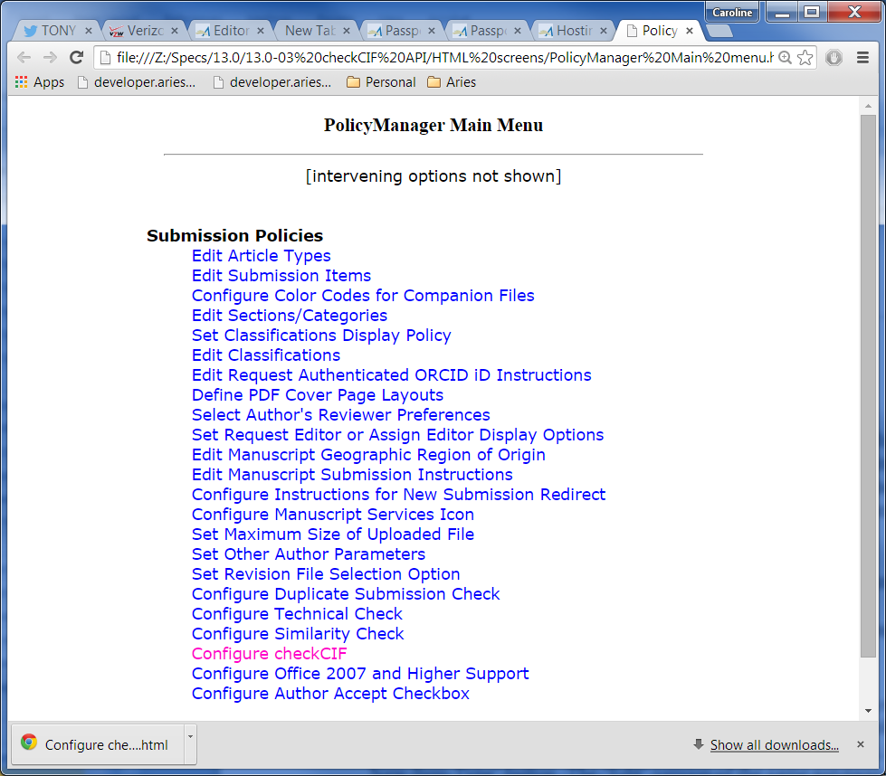

#### PolicyManager - Configure checkCIF

The SysAdmin user reaches this new PolicyManager popup by clicking the new ‘Configure checkCIF’ link on the PolicyManager Main menu. This page allows the SysAdmin user to configure the trigger points and instructions for the checkCIF feature. It is based on the *Configure Reference Checking* page and the *Configure Similarity Check* page. The page consists of the following:

1. The page header is ‘Configure checkCIF’. Note: an icon from the IUCr will be added either to the page header or as hardcoded instructional text; waiting on them to provide.
2. Page instructions are: Configure the options below. Submit this page, then click the 'Edit Submission Item Types' link to select at least one Submission Item to be sent to the checkCIF tool. If you need to disable checkCIF, please unselect the checkbox labelled 'Enable checkCIF'.
3. A checkbox labelled ‘Enable checkCIF’. This checkbox is default selected at upgrade to 13.0 per LSH.
   1. When this checkbox is selected, the checkboxes for the workflow trigger points are enabled.
   2. When the checkbox is unselected, the checkboxes for the workflow trigger points are unselected, disabled and grayed out. The user must re-select the ‘Enable checkCIF’ checkbox to make the workflow trigger point checkboxes active.
4. Checkboxes allowing selection of workflow trigger points (same workflow trigger points as for Reference Checking)
   1. The checkboxes are grayed out/unselected/disabled unless the ‘Enable checkCIF’ checkbox is selected.
   2. At upgrade, the ‘Enable checkCIF’ checkbox is selected, and the workflow trigger point ‘Original PDF Building by Author’ is selected. Note: this will not cause files to go to checkCIF – further configuration is needed on the *Edit Submission Item* page in PolicyManager.
   3. When a selected workflow trigger point is reached, Submission Items that are associated with the current revision of the submission, and configured with the new ‘Include this Item Type for checkCIF’ selected, are sent to the checkCIF tool via the API created in this specification. Exceptions:
      1. If a results PDF already exists for a specific file, the same file is not sent to the checkCIF tool again, even if a new trigger point is reached. (This is similar to logic used for Reference Checking). Business logic: the results will not vary if the file is sent to the tool again.
      2. If a file is currently being tested, it is not sent to the tool.
      3. Submission Items include submission files and Companion Files. Companion files are not built into the PDF, but may be uploaded on the Attach Files page and are therefore sent to the tool when a workflow trigger point relating to PDF building is reached.
      4. Note: if a Companion File configured as ‘Include this Item Type for checkCIF’ is uploaded on the existing ‘Upload Companion File’ popup, clicking the ‘Upload This File’ button triggers the checkCIF API (similar to coding for Reference Checking).
5. A textarea with an ‘Insert Special Character’ link and default instructions is provided, and the standard ‘View Default Instructions’ and ‘Revert to Default Instructions’ links are also displayed. The user has the option of customizing the instructions and saving them.
   1. The textarea, View Default Instructions, Revert to Default Instructions, and Insert Special Character links are all grayed out/disabled when the ‘Enable checkCIF’ checkbox is unselected. Note: the instructions are shown in the textarea but in gray text, and the textarea is disabled.
   2. When the ‘Enable checkCIF’ checkbox is selected (as at upgrade), the instructional textarea is active and the instructions can be customized, and the View Default Instructions, Revert to Default Instructions and Insert Special Character links are all active.
   3. The default instructions must be tokenized. The text is: The files shown below are eligible for analysis using the checkCIF tool from the International Union of Crystallography (IUCr). If the files have already been sent to the checkCIF tool, the analysis report can be viewed by clicking the 'Completed' link. *Engineering note: we are waiting on the IUCr to see if they want to provide branding language and/or a graphic. This would be hardcoded and not part of the instructions that can be customized.*
   4. Clicking the Insert Special Character link opens the jquery “Insert Special Character” popup window [specialChars.asp]).

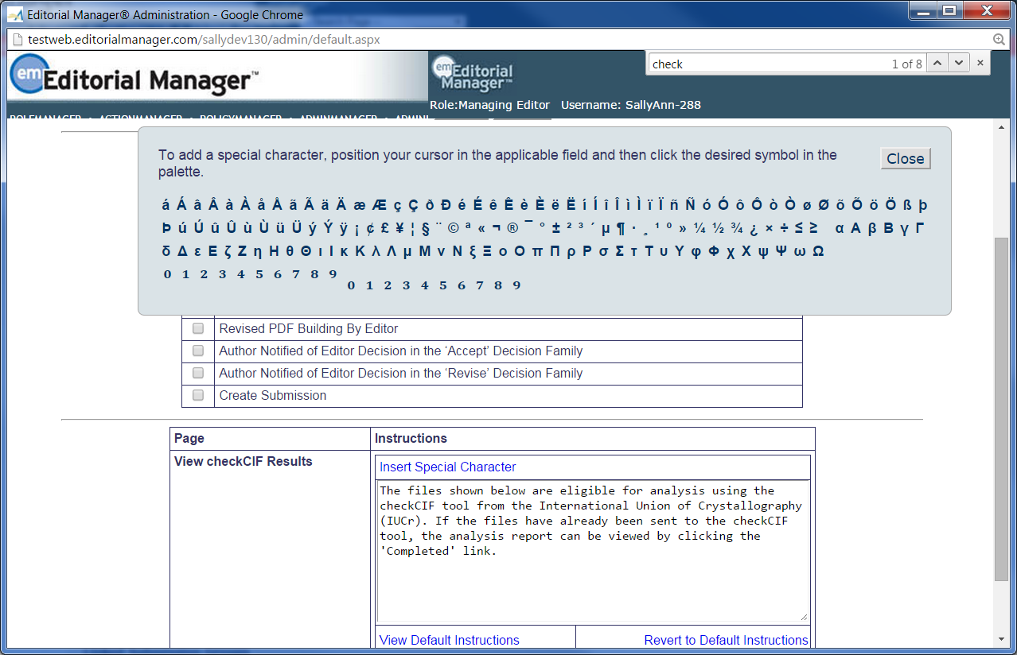

* 1. The instructions can be customized, and standard HTML tags can be used. Script tags are not allowed.
     1. If script tags are present, when the page is submitted, an jquery box is shown with the following text:

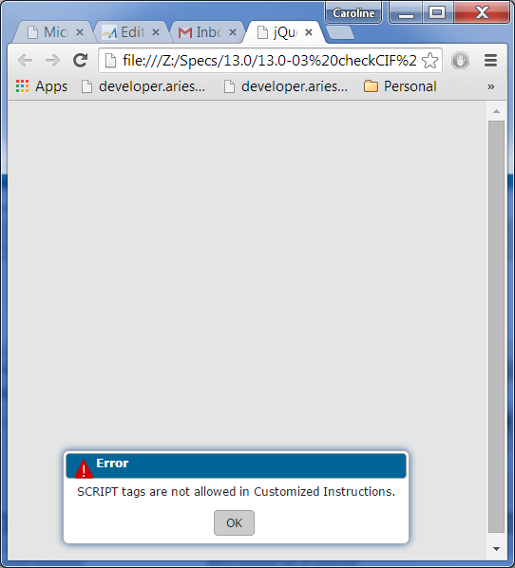

(Same coding as the *Customize Reviewer Selection Summary Instructions* PolicyManager page [CustomizeReviewerSelectionSummaryInstructions.aspx], except that the browser alert box is replaced by the jquery alert box. This text is already tokenized as Pages.Admin.Common.Text.SciptTagsNotAllowedInInstructionsMsg [the token has a typo in the name]

* 1. Clicking the ‘View Default Instructions’ link opens a new popup, similar to the “Default Instructions for Reference Checking Results” popup.
     1. The text above the instructions box is “The text shown below is the default text which appears when the user views the checkCIF results. You may revert to this text by clicking the 'Revert to Default Instructions' link under the instructions box.
     2. A grid similar to the instructions box on the page is shown, with the column headers ‘Page’ and ‘Instructions’ and the row header ‘View checkCIF Results’. The default instructions described in bullet a are shown.
     3. A Close button is shown. Clicking the Close button closes the popup.
  2. Clicking the ‘Revert to Default Instructions’ link opens a jquery dialog box (not a browser dialog): *Would require a re-write of the custom instructions control – which will not be done.*
     1. The Title bar contains the text “Warning” with the yellow warning triangle from the EM Mobile application, resized if necessary.
     2. The body of the dialog box contains the following already tokenized text: Warning: You are about to change instructions on the page to the Default Instructions. Click OK to change the instructions, or Cancel to retain existing instructions.
     3. The buttons OK and Cancel are displayed on the dialog box.
        1. As per coding for the ‘Revert to Default Instructions’ feature on the Configure Similarity Check page, clicking the ‘OK’ button in the dialog box closes, the dialog box, changes the text in the instructions box on the page only, and does not save the rest of the page.
        2. Clicking the ‘Cancel’ button on the dialog box closes the jquery dialog box without making any changes to the underlying page. The user remains on the page.

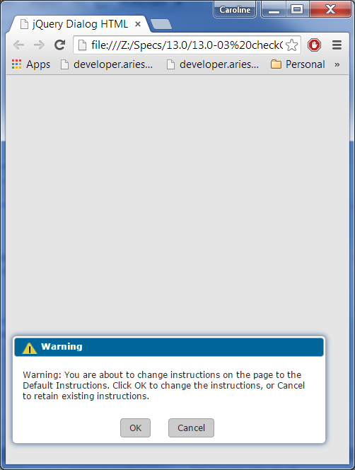

1. Validation is added to the ‘Submit’ button.
   1. If the ‘Enable checkCIF’ checkbox is unselected, clicking the Submit button :
      1. Sets the ‘Enable checkCIF’ field in the database to FALSE. (TBD exact field in the tech spec).
      2. Clears all workflow trigger points (i.e. the ‘Original PDF Building by Author’ is set to TRUE by the upgrade script, but if the ‘Enable checkCIF’ checkbox is subsequently cleared and the page is submitted, this trigger point and all other trigger points are set to FALSE and there is no longer a default workflow trigger point. If the user subsequently re-selects the ‘Enable checkCIF’ checkbox, no trigger point is selected by default).
   2. If the ‘Enable checkCIF’ checkbox is selected when the Submit button is clicked, at least one workflow trigger point must also be selected. If no workflow trigger points have been selected, the following jquery alert box is shown:
      1. Title bar contains the standard EM red warning triangle (resized if necessary, and the text “Error”).
      2. Content of the box: Please select at least one workflow point that will trigger checkCIF, or, to disable the feature, clear the ‘Enable checkCIF’ checkbox and click the Submit button again.

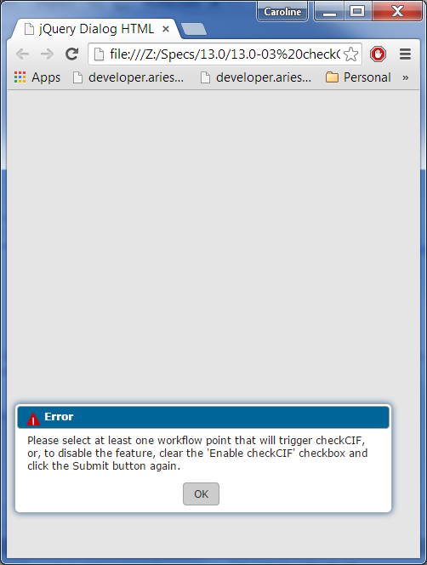

1. The instructions text area cannot be null or contain all blank characters. If this is the case, the following jquery alert box is shown:
   * 1. Title bar contains the text “Error” with the standard EM red warning triangle.
     2. Please enter customized instructions for the ‘View checkCIF Results’ page, or click the ‘Revert to Default Instructions’ link to use the default instructions on that page.

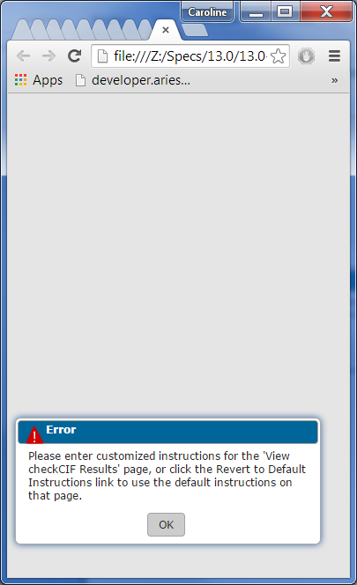

1. When the above validations are passed and the ‘Enable checkCIF’ checkbox is selected:
   1. The selected workflow trigger points are saved
   2. Leading and trailing blanks are stripped from the instructional text, and the instructions are saved. Note: newlines are preserved.
2. The user is navigated to the confirmation page shown in Page Layout #2A.Page Layout #2: Configure checkCIF

* Based on the *Configure Reference Checking* and *Configure Similarity Check* pages.
* Shown in its default state at upgrade: Enable checkCIF checkbox selected and Original PDF Building by Author selected as the trigger point. Default instructions shown – must be tokenized.

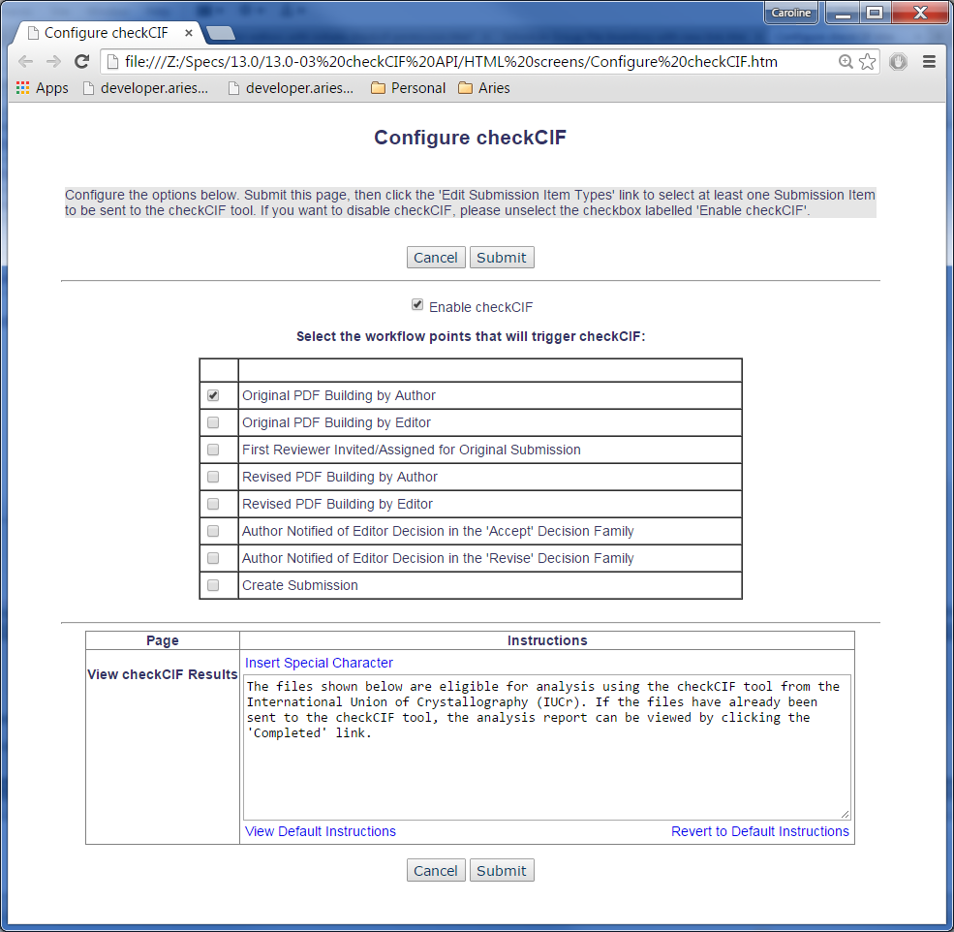

Page Layout #2A: Configure checkCIF Confirmation page

Based on the existing confirmation page for *Configure Reference Checking*.

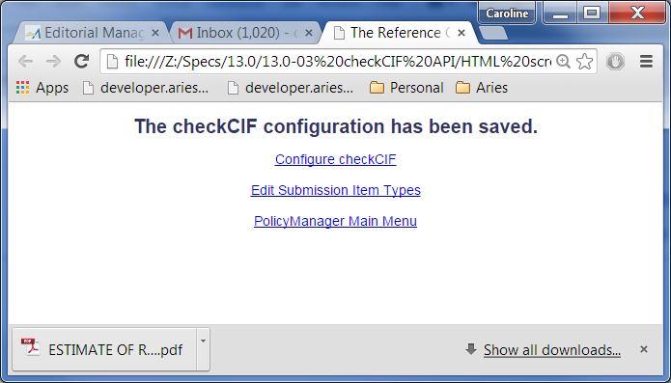

Page Layout #2B – View Default Instructions

* Page title: Default checkCIF Results Page Instructions
* Page header, with standard gray background color: The text shown below is the default text which appears when the user views the checkCIF results. You may revert to this text by clicking the "Revert to Default Instructions" link under the instructions box.
* The default instructions are: The results from each file sent to the checkCIF tool from this submisison are available below. Click on the 'Completed' link to view the full report from checkCIF.

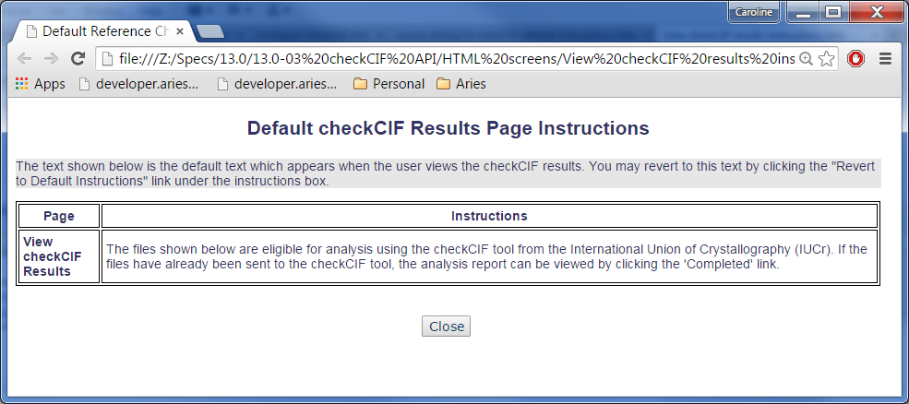

### Add/Edit Submission Item

The PolicyManager Page *Add Submission Item* [filetype2.asp]is reached when a SysAdmin user clicks the ‘Edit Submission Items’ link from the PolicyManager main menu and is navigated to the *Edit Master Submission Item Types* page, then clicks the ‘Add New Item Type’ button. The ‘Edit’ version of the same .asp page is reached when the SysAdmin user clicks an ‘Edit’ link next to an existing Submission Item from the *Edit Master Submission Item Types* page.

1. New in this spec, both versions of the page are updated to examine the setting for the new ‘Enable checkCIF API’ checkbox in PolicyManager, *Configure checkCIF*.
2. If the ‘Enable checkCIF API’ is selected for the journal, a new checkbox ‘Include this Item Type for checkCIF’ is added to both the Add and Edit versions of the page, similar to the existing checkboxes ‘Include this Item Type for Artwork Quality Checking’ and ‘Include this Item Type for Reference Checking’. The default state of the checkbox is unselected.
   1. The checkbox is grayed out/disabled unless:
      1. The PDF Handling drop-down is set to one of :
         1. Build Hyperlink to the Item into the PDF (Item not displayed in PDF) [Note: this choice is available only when Author Supplementary Materials is enabled for the journal in HA, *Set Journal Features*].
         2. Companion File (not built into PDF)
      2. AND the URL/URI/External Resource is set to Hidden or Optional (i.e., if the URL/URI/External Resource is set to Required, the checkbox must be disabled).
         1. If the URL/URL Resource is changed from Hidden or Optional to Required, this must null out/gray out/disable the checkbox.
         2. If the user selects the checkbox, then changes the URL/URI Resource setting from Hidden to Optional, the checkbox remains selected, and vice versa (i.e. if the user selects the checkbox, then changes the URL/URI setting to another one where the selection is still valid, the checkbox is not nulled out).
   2. If the PDF Handling method is set to either a. i. or a. ii. above, then the checkbox is selected, and the PDF Handling method is set to another method, the checkbox is cleared/grayed out/disabled when the PDF handling method is switched off of one that allows this checkbox to be selected.

NOTES: *this section ,at best, is confusing and contradictory. Leave it coded as is and see if PM can clarify at bug fix.*

### PDF Builders

Code on the PDF Builders (asynch servers) is enhanced in this spec as described below:

1. Current coding will build a link to the .cif file into the PDF, if the Item is configured in the Supplemental Item family with the PDF Handling option “Build Hyperlink to the Item into the PDF”. This coding is retained in this specification.
2. Current coding will place the file into the COMPANION_FILES table, and not build the file or a hyperlink to the file into the PDF if the Item Type is configured with the PDF Handling option as ‘Companion File (not built into PDF)’. This coding is retained in this specification.
3. New coding in this spec adds a ‘checkCIF Results’ link to the PDF. This link is built into the Author/Editor and Reviewer PDFs if the Submission Item also listed on the page is configured to go to the checkCIF tool and a trigger point has been reached. Note: the link is shown whether or not a results PDF has been returned. Notes: if the Submission Item Type is configured as a Companion File, it is not built into the PDF and there is no link to it in the PDF, therefore no “View checkCIF Results” link is added to the PDF for that Submission Item. If the Submission Item Type has been uploaded as a URL/URI/External Resource, a link to the file may be present in the PDF, but the View checkCIF Results link is not shown.
   1. When clicked, the ‘checkCIF’ Results link:
      1. Downloads the checkCIF results PDF associated with the related .cif file (if the results PDF is available), without visibly navigating the user to the EM interface (similar behavior as clicking the file name, which downloads the source file without navigating the user to EM interface).
      2. If the results PDF is not available for that file, and navigates the user to a standalone Author/Reviewer version of the *View checkCIF Results* page (the user is not logged in), where the person viewing the PDF sees a message that the results are not yet available. (Similar coding to the ‘click here to view linked references’ link in the PDF).
         * Note: even if the person viewing the PDF is an Editor, there is no way to detect this fact from the PDF, therefore everyone clicking the link from the PDF sees the Author/Reviewer version of the *View checkCIF Results* page without being logged in.
4. New coding in this spec sends Submission Item Types configured as ‘Include this Item Type for checkCIF’ to the checkCIF API when the PDF is built, depending on which PDF is being built and the workflow trigger points configured for the journal on the *Configure checkCIF* page as explained below. Reference Checking logic can be used as a guideline, since the Reference Checking feature uses the same trigger points. Note: if the Item is attached as a URL/URI/External Resource, it is not sent to the checkCIF tool, as the item itself is not contained in the EM database and is therefore not available to be sent to the tool. EM does not attempt to download the item from the URL/URI/External resource location.

|  |  |  |
| --- | --- | --- |
| **PDFs being built** | **Workflow Trigger Point selected on Configure checkCIF page** | **Files sent to checkCIF API as part of PDF build** |
| PDFs for Rev0, triggered by Author building the original PDF | Original PDF Building by Author | All Item Types configured as ‘Include this Item Type for checkCIF’, excluding files attached as URL/URI/External resource, but including Companion Files (which are not built into the PDF). The Item Types must not have been removed. If submission has been sent back to Author, and Author is rebuilding the PDF, only files that are fall into the logic above and do not already have a results PDF, and are not currently being processed by the API are sent through the checkCIF API. |
| PDFs for Rev0, triggered by Author building the original PDF | Original PDF building by Author NOT selected | None |
| PDFs for Rev 0, triggered by Editor editing the submission and rebuilding PDF | Original PDF Building by Editor | All Item Types configured as ‘Include this Item Type for checkCIF’, excluding files attached as URL/URI/External resource, but including Companion Files (which are not built into the PDF). The Item Types must not have been removed. Only files that fall into the logic above, do not already have a results PDF, and are not currently being processed by the API are sent through the checkCIF API. |
| PDFs for Rev 0, triggered by Editor editing the submission and rebuilding PDF | Original PDF building by Editor NOT selected | None |
| PDFs for Rev1 and up, triggered by Author building PDF | Revised PDF Building by Author | All Item Types associated with the revision being built, configured as ‘Include this Item Type for checkCIF’, excluding files attached as URL/URI/External resource, but including Companion Files (which are not built into the PDF). The Item Types must not have been removed. Only files that fall into the logic above, do not already have a results PDF, and are not currently being processed by the API are sent through the checkCIF API. |
| PDFs for Rev1 and up, triggered by Author building PDF | Revised PDF Building by Author NOT selected | None |
| PDFs for Rev1 and up, triggered by Editor building PDF | Revised PDF Building by Editor | All Item Types associated with the revision being built, configured as ‘Include this Item Type for checkCIF’, excluding files attached as URL/URI/External resource, but including Companion Files (which are not built into the PDF). The Item Types must not have been removed. Only files that fall into the logic above, do not already have a results PDF, and are not currently being processed by the API are sent through the checkCIF API. |
| PDFs for Rev1 and up, triggered by Editor building PDF | Revised PDF Building by Editor NOT selected | None |

Page Layout #3 – Page of PDF with .cif file and checkCIF Results hyperlink

* In this example:
  + The Submission Item is configured as “Build Hyperlink to the Item into the PDF (Item Not Displayed in PDF)”. This causes the file name to be built into the PDF as a hyperlink (current coding).
  + The Submission Item is configured as ‘Include this Item Type for checkCIF’. New coding causes the ‘checkCIF Results’ link to be shown if the PDF being built is selected as a trigger point, or results already exist for that file. Note: the new ‘checkCIF Results’ link should be shown in the same font as the Submission Item file name. Note: if there is no checkCIF results PDF to be downloaded, the user is navigated to an EM interface page when this link is clicked.
  + Please consult Laurel C. for the size of the download graphics – some of the graphics in 12.1 PDFs are deemed “too small” by management. Both the graphic and the file name are included in the hyperlink.

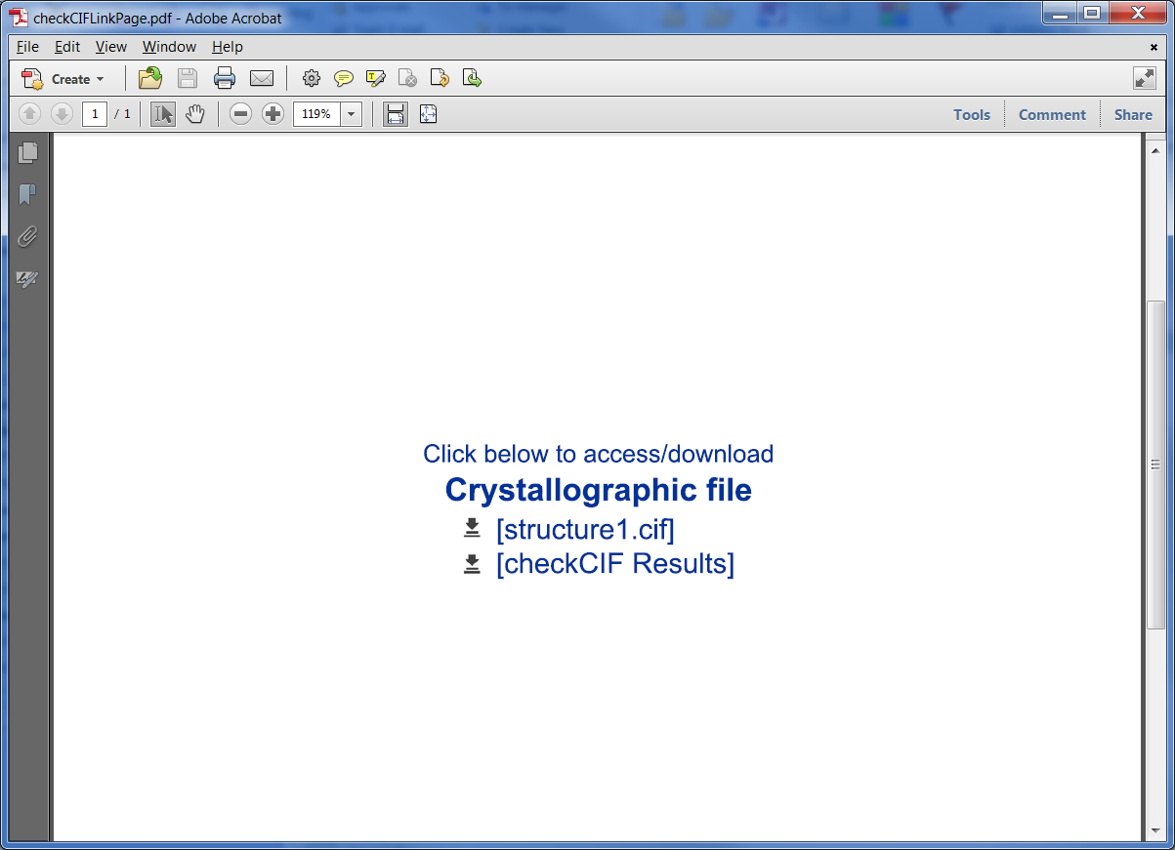

Page Layout #4: Edit Submission Item Type (PolicyManager)

* New ‘Include this Item Type for checkCIF’ checkbox added. Available for selection only when the PDF Handling is set to “Build Hyperlink to the Item into the PDF” and “Companion File (Not Built into PDF)”, and the URL/URI/External Resource drop-down is set to Hidden or Optional.
* Note: the checkboxes ‘Include this Item Type for Artwork Quality Checking’ and ‘Include this Item Type for Reference Checking’ are suppressed if these features are not enabled.

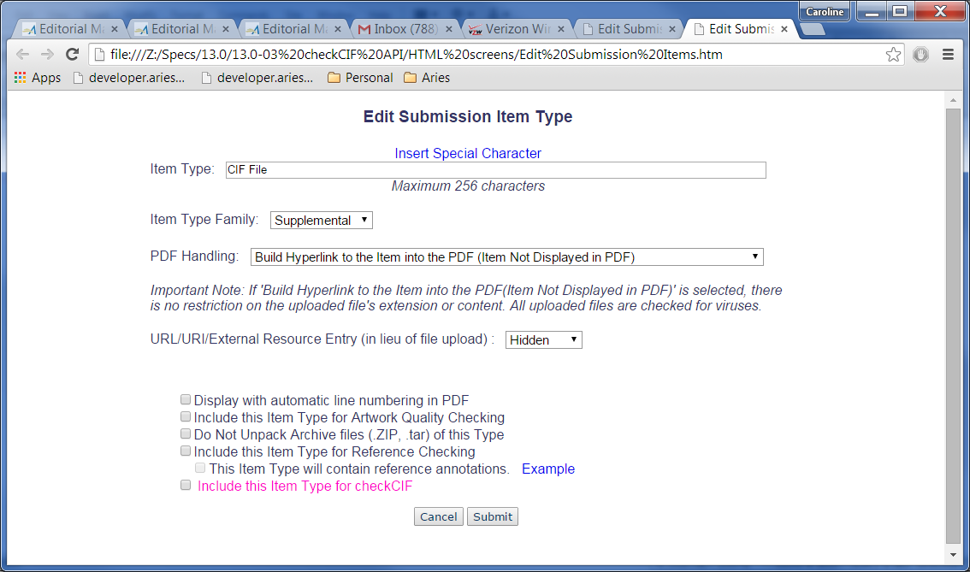

### Details page layouts

The *Select Items to Display* popup is modified by this spec to contain a ‘checkCIF Results’ item. The *Add/Edit Details Page Layout* popup will contain the new ‘checkCIF Results’ item if it has been selected for that layout on the *Select Items to Display* popup (this should be automatic under existing coding, but is shown in this spec for testing purposes).

The checkCIF Results item is not added to any default layout. Publications can add to a custom Details layout.

1. After the custom Details layout is associated with an Editor or Publisher Role, when the Editor/Publisher user views the Details page, the link is suppressed if the user viewing the layout does not have ‘View checkCIF Results’ RoleManager permission.
2. Clicking the checkCIF Results link on the Details page itself pops up the Editor/Publisher version of the checkCIF Results page.

#### Select Items to Display

This popup [selectItemsToDisplay.aspx] is reached when the SysAdmin user clicks the ‘Define Details Page Layouts’ link on the PolicyManager Main Menu, then clicks the ‘Edit’ link next to an existing custom layout, or the ‘Add New Layout’ button to add a new custom layout, then clicks the ‘Select Items to Display’ link on the Add/Edit Details Page Layout popup.

1. A New ‘checkCIF Results *’ item is added to the **Links** section, placed after the ‘Similarity Check*’ item (if this is displayed; otherwise placed in the position the Similarity check item would be displayed – after ‘Additional Manuscript Details’).
   1. This item is displayed only if the publication is configured with ‘Enable checkCIF’ selected in PolicyManager, *Configure checkCIF*; it is suppressed otherwise.
   2. Note the asterisk suffix, denoting that additional RoleManager permissions control whether this item will display to any particular end user on the custom Details page.

Page Layout #5 – Select Items to Display

* checkCIF Results * added (asterisk is included). Shown in pink, to be coded in default font for this page.

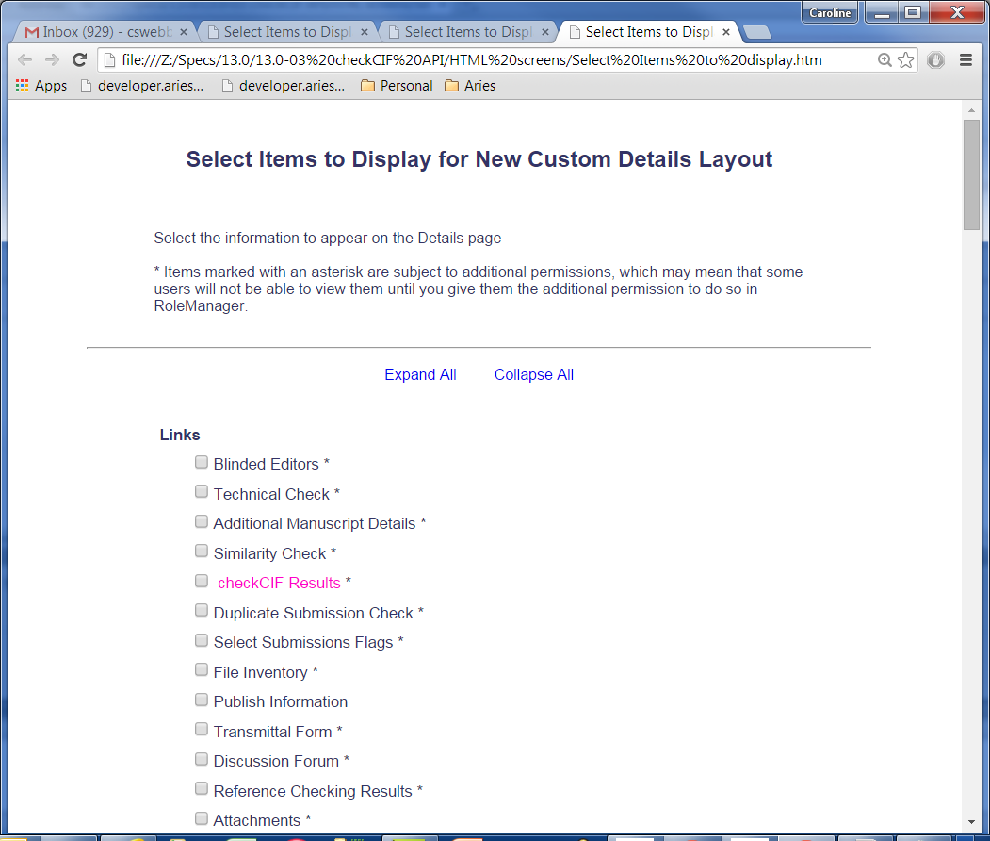

#### Add/Edit Details Page Layout

Per existing coding, when the ‘checkCIF Results’ item is selected on the *Select Items for Display* popup, it is automatically added to the end of the list of items shown on this popup – no coding changes are made in this spec – shown for testing purposes.

Page Layout #6– Add/Edit Details Page Layout

* As per current coding, when a new item has been selected on the ‘Select Items to Display’ page, it is automatically added to the end of the list on the Add/Edit Details Page Layout page, until re-ordered. New item shown in pink, to be coded in default font for the page.

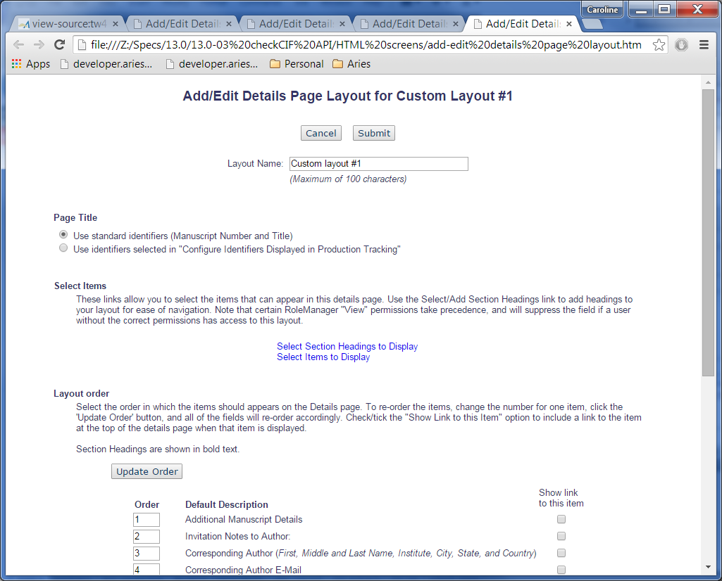

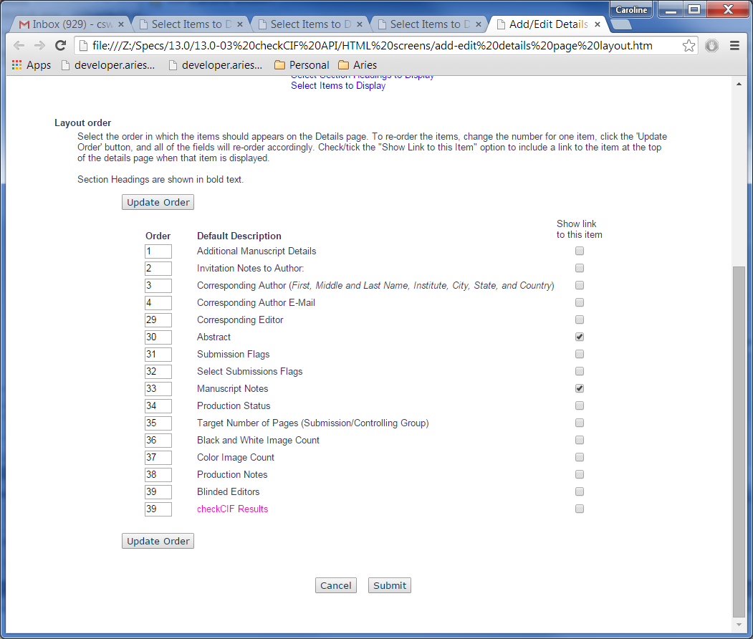

## RoleManager

### Author and Reviewer RoleManager pages

The Author and Reviewer RoleManager pages are updated to examine the setting for the new ‘Enable checkCIF API’ checkbox in PolicyManager, *Configure checkCIF*. If the ‘Enable checkCIF API’ is selected for the journal:

1. ‘View checkCIF Results’ permission is added for all Author and Reviewer Roles, default unselected.
   1. This permission governs whether the ‘View checkCIF Results’ link is displayed for the Author and Reviewer in various folders. See section 2.12.4 and 2.12.5 of this spec.

Page Layout #7: RoleManager – Author Role

* New ‘View checkCIF Results’ permission added. Shown in pink, to be coded in default font for the page.

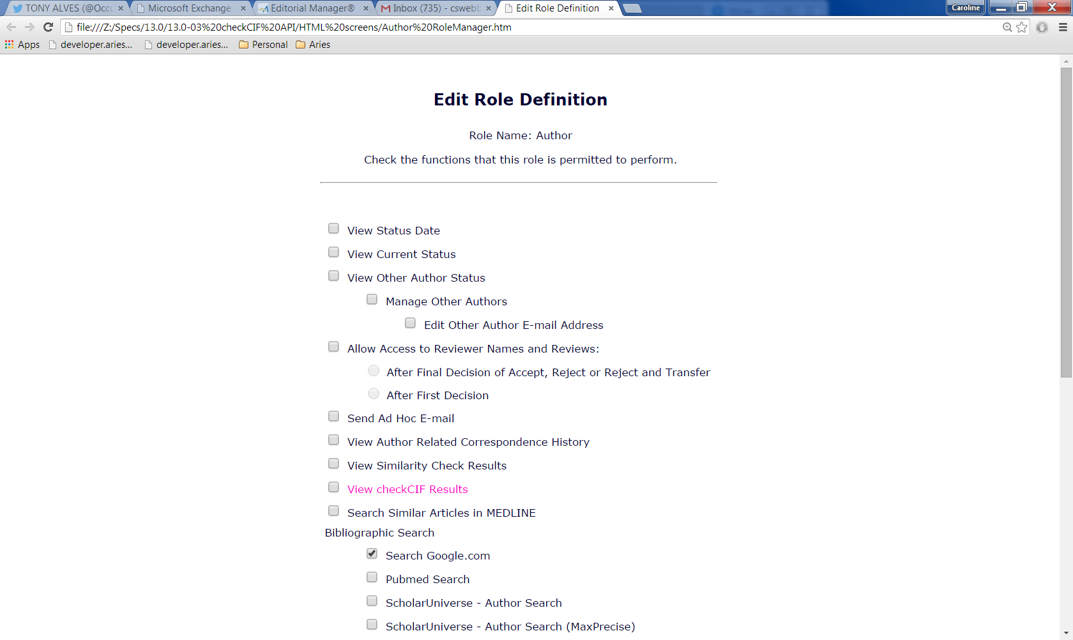

Page Layout #7B – Reviewer Role

* New ‘View checkCIF Results’ permission added. Shown in pink, to be coded in default font for the page.

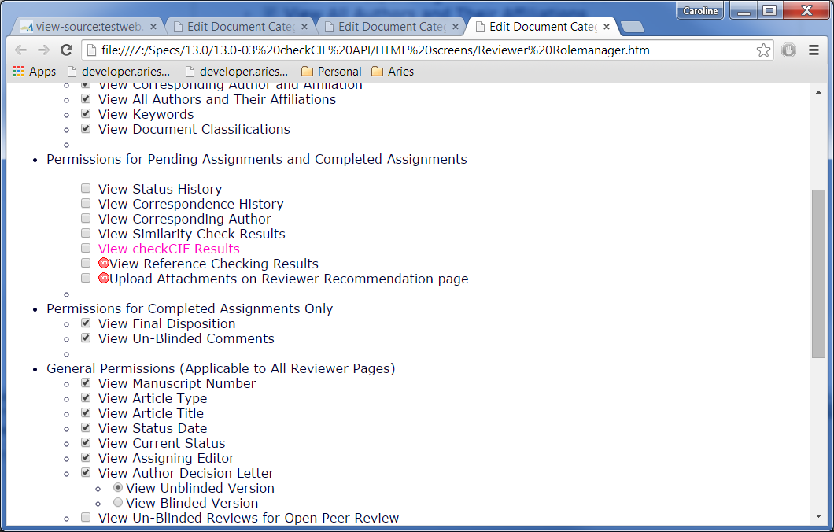

### Editor and Publisher RoleManager pages

The Editor and Publisher RoleManager pages are updated to examine the setting for the new ‘Enable checkCIF API’ checkbox in PolicyManager, *Configure checkCIF*. If the ‘Enable checkCIF API’ is selected for the journal:

1. ‘View checkCIF Results’ permission is added for all Editor and Publisher Roles, default unselected.
   1. This permission governs whether the ‘View checkCIF Results’ link is displayed for the user in various folders and whether the checkCIF Results link is displayed on a a custom details page containing this link.
2. ‘Initiate checkCIF’ permission is added for Editor and Publisher Roles, default unselected.
   1. This permission governs whether the Editor or Publisher can send a file manually to the checkCIF API via a ‘checkCIF: Selected Files’ button on the checkCIF results page.

Page Layout #7C – Editor RoleManager

* New ‘View checkCIF Results’ permission added, default unselected, directly after the ‘View Duplicate Submission Check Results’ permission (or directly after View Similarity Check Results permission for those roles that do not have View Duplicate Submission Check Results permission). This permission is displayed only if the journal has ‘Enable checkCIF API’ selected in PolicyManager, *Configure checkCIF.*
* New ‘Initiate checkCIF’ permission added for Editor Roles only if the ‘Enable checkCIF API’ is selected in PolicyManager, *Configure checkCIF.*
* Partial page shown
* New permissions shown in pink, to be coded in default font.

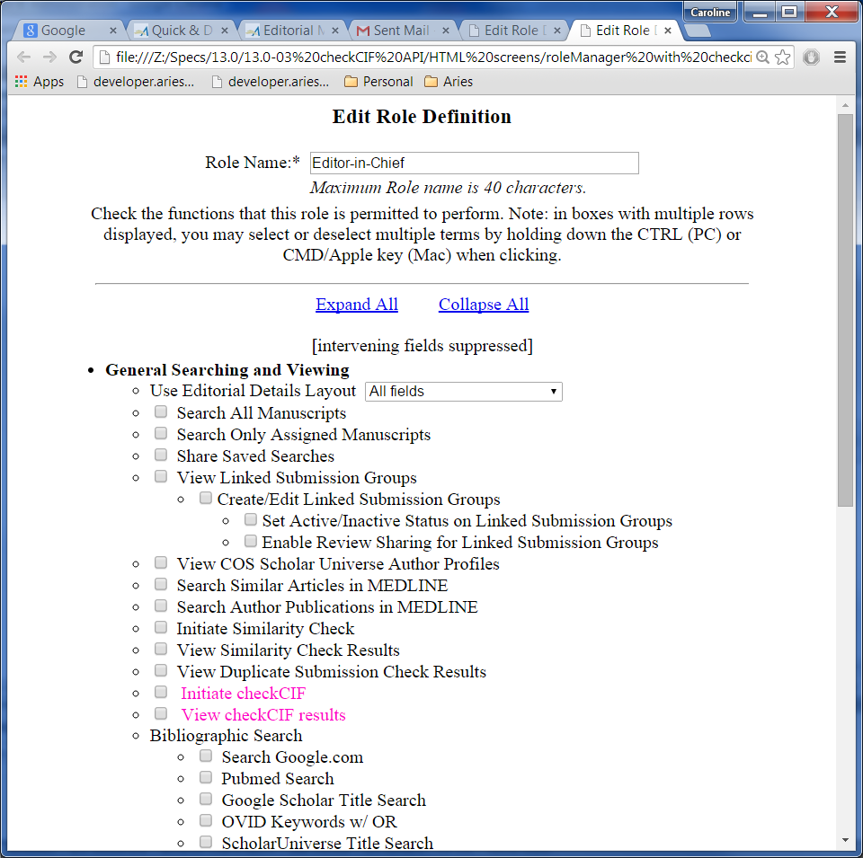

Page Layout #7D: Publisher RoleManager



## Custom Details page

The ‘checkCIF’ label and ‘checkCIF Results’ link will appear on a custom details page if all of the following are true:

1. The checkCIF Results item is selected to appear for this custom layout in PolicyManager, *Details Page Layouts/Add Edit Details Page Layout/ Select Items to Display.*
2. The Editor or Publisher user accessing the Details page has the RoleManager permission ‘View checkCIF Results’.
3. There are one or more files associated with Items configured as ‘Include this Item Type for checkCIF’ that are attached to this revision of the submission. If there are no non-Hidden files configured to go to the checkCIF tool for this revision of the submission, the checkCIF label and checkCIF results link is suppressed.
4. Clicking the checkCIF results link pops up the checkCIF results page (Editor/Publisher version) in an additional popup (similar to the behavior when the user clicks the ‘Add/Edit Submission Flags’ link). Because the link creates a new popup window, the Details popup remains open and the existing alert popup that begins “You are navigating to a new page” is not shown.

Page Layout #8– Custom Details page - checkCIF Results link displayed

* checkCIF label and checkCIF Results link displayed under the conditions described in the text.
* Shown in pink, to be coded in the same font as other text in the same columns on the page.

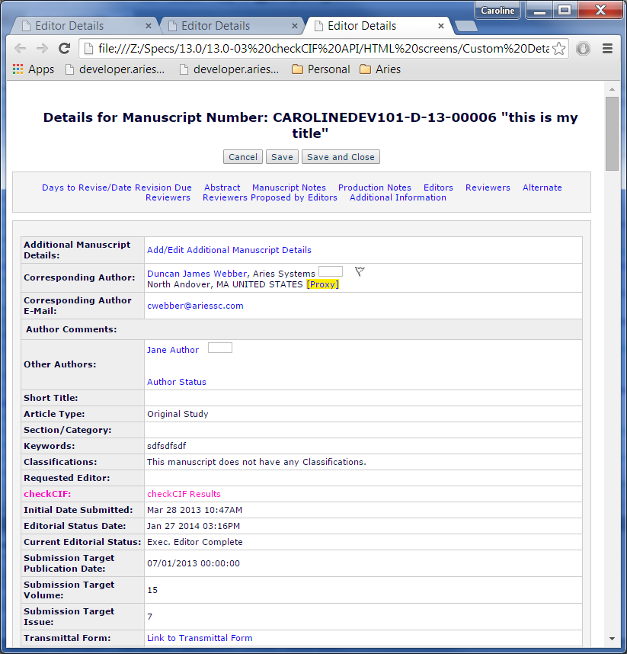

## Technical Check [technicalCheck.asp]

This existing popup is accessed by Editors with the RoleManager permission ‘Perform Technical Check (submission received in ‘New Submissions’ folder)’. It is enhanced to include add links to the checkCIF Results popup under the following conditions:

1. One or more un-hidden files associated with the current revision of the submission are configured as ‘Include this Item Type for checkCIF’ AND are not attached as URL/URI/External Resource items, AND
2. The Editor viewing the Technical Check page has the new ‘View checkCIF Results’ permission.
3. Note: this page does not examine whether at least one file associated with the current revision of the submission has been *sent* to the checkCIF tool, as an Editor performing technical check may be given permission to initiate checkCIF and needs be able to get to the results page where they can select files and manually send them to the checkCIF tool.

When the page logic determines that the checkCIF Results link should be displayed, per bullets 1-3 above:

* 1. It is added to the top and bottom set of links.
  2. It is displayed on the same row as the CrossCheck/iThenticate Results link (note that the CrossCheck/iThenticate Results link may be suppressed, in that case, the checkCIF Results link is directly under the Technical Check History link).
  3. Clicking this link displays the *checkCIF Results* page (section 2.13.3 below) in a pop-up (an additional popup that does not replace the contents of the Tech Check popup – similar to the way the CrossCheck/iThenticate Results link functions).

Page Layout #9– Technical Check popup with checkCIF results link

* Reduce the padding between the top edge of the Technical Check fieldset and the bolded article title inside the fieldset (in this example it is **Test Full Title**) – too much vertical space is being shown.
* Move the hardcoded text “Original Submission”, or “Revision Number [X]” (where [X] is replaced by the revision number) directly under the title (instead of two <br> tags, use only 1 <br> tag.
* ‘checkCIF Results’ link added on the same line as the CrossCheck/Ithenticate results, separated from the CrossCheck/Ithenticate Results by four &emsp; characters, in both the top and bottom sets of links, under the conditions described in the spec.
* Reduce the vertical space between the buttons and the Technical Comments to Author fieldset (reduce from two <br /> tags to one <br /> tag.
* Reduce the vertical space between the View Submission link and the Technical Notes fieldset at the bottom of the page by removing all the <br /> tags and leaving the <p> and </p> tags.
* Reduce the vertical space between the last link and the bottom set of buttons but removing the <br /> tag.
* Note: the instructions shown after the links and before the radio buttons are customizable by the journal and not to be coded.
* New checkCIF Results links shown in pink, to be coded in EM standard font for links.

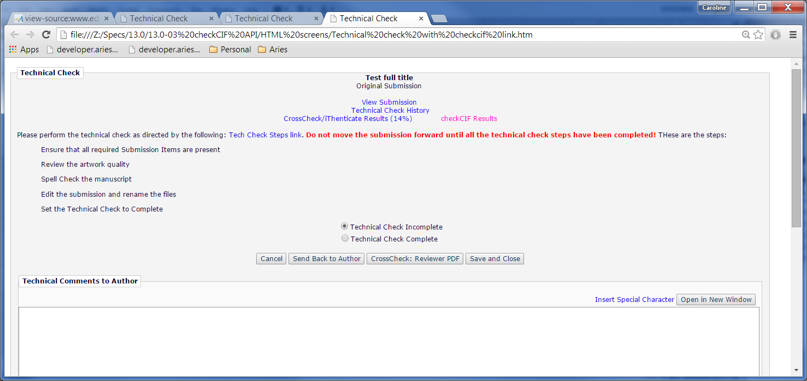

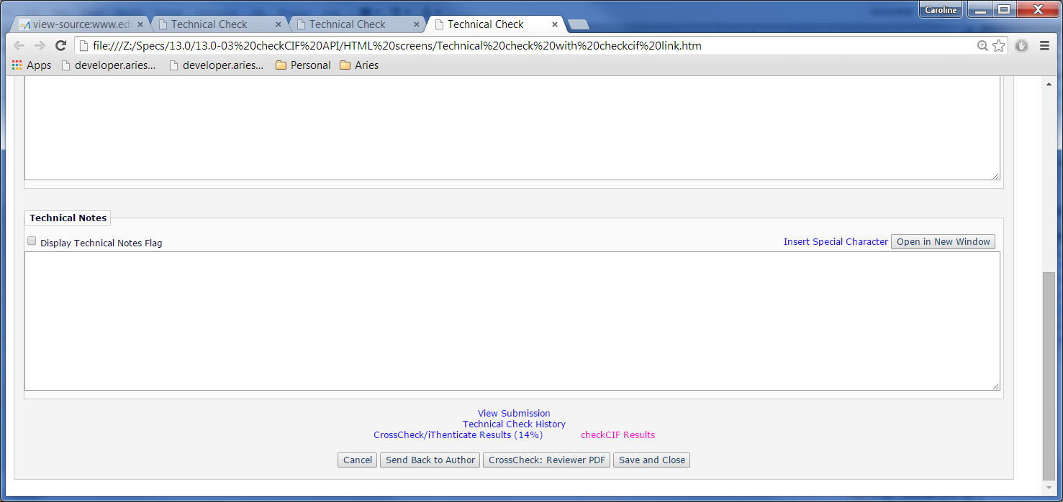

## Create Submission Interface

This existing page [EnterSubmissionMetadata.aspx] is reached:

1. When an Editor with the RoleManager permissions ‘Search People’ and ‘Create Submission’ performs the following steps:
2. Clicks ‘Search People’ from the Production Tasks menu
3. Performs a search, and clicks the hyperlinked search results name from the search results page (to be navigated to the *Search People – Update Information* page).
4. Clicks the ‘Create Submission’ button on the *Search People – Update Information* page.
5. Proceeds through the ‘Enter Metadata’ and ‘Add/Edit/Remove Authors’ steps to arrive at the ‘Attach Files’ step.
6. When an Editor clicks ‘Edit Submission’ link for a submission, then the ‘Edit the submission data only’ link.

New in this spec, if ‘Create Submission’ trigger point is selected on the *Configure checkCIF* page in PolicyManager, when the ‘Submit’ button is clicked on the ‘Attach Files’ page, all files which are associated with the Submission (i.e. not removed, hidden or attached as a URL/URI/External Resource Item) are sent to the checkCIF API under the following additional conditions:

1. The file’s Item Type must be configured as ‘Include this Item Type for checkCIF’ AND
2. The file must not already have a checkCIF results PDF AND
3. The file must not be currently undergoing processing via the checkCIF API

### Create Submission Confirmation Page

This existing page [shortSubmissionConfirmation.aspx] is reached when the Editor clicks the ‘Submit’ button on the ‘Attach Files’ step of the Create Submission page/Edit Submission page discussed in section 2.7.

The ‘checkCIF Results’ link is added to the page, as the first link under the instructional text, in the following circumstances:

1. One or more files currently associated with the current revision of the submission (i.e. not removed and not Hidden) have been sent to the checkCIF tool. Note: it is not necessary for results to have been returned from the tool, and it is not necessary that the files were sent as part of the Create Submission flow (i.e. an Editor using Edit Submission may edit the submission to add a non-cif file and the checkCIF API may not have been triggered at when they finalized their edits, but there may be files associated with the submission that have already been sent to the tool).
2. The Editor who is logged in (or being proxied for) has the RoleManager permission ‘View checkCIF Results’.
3. When clicked, it displays the Editor/Publisher version of the *checkCIF Results* page in a popup. (see section 2.13.3).

Note: this page has 2 layouts – one shown after the Editor clicks the Create Submission button from a people record and submits the submission for the first time, and one shown after an Editor edits a submission using the short submission interface. The checkCIF Results link is added to both layouts under the conditions described above. See page layouts #11 and #11A

Page Layout #10 – Submission Confirmation after Create Submission completed

* checkCIF Results link added under the conditions described in the spec, as the first link shown.
* Note: the other links shown depend on RoleManager permissions. These additional links are unchanged in this specification.
* Page instructions are dependent on whether the user is submitting the submission for the first time, or editing the submission. Page instructions are unchanged in this spec.

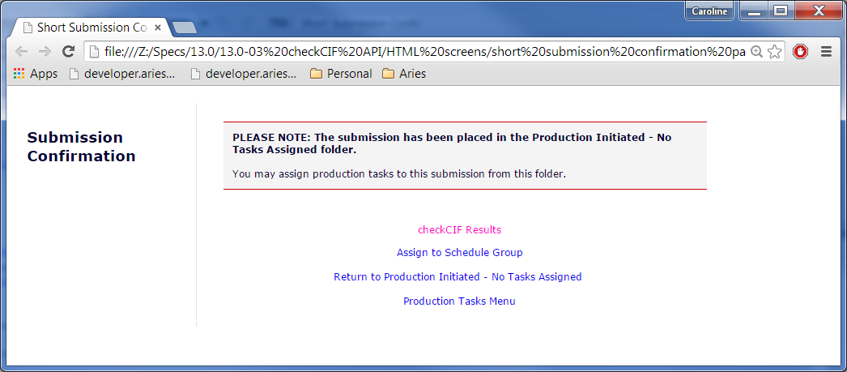

Page Layout #10A – Submission Confirmation after Edit Submission using Short Interface completed

* checkCIF Results link added under the conditions described in the text, as the first link shown. Shown in pink, to be coded as standard EM unvisited link color.
* Note: the other links shown depend on RoleManager permissions. These additional links are unchanged in this specification.
* Page instructions are dependent on whether the user is submitting the submission for the first time, or editing the submission. Page instructions are unchanged in this spec.

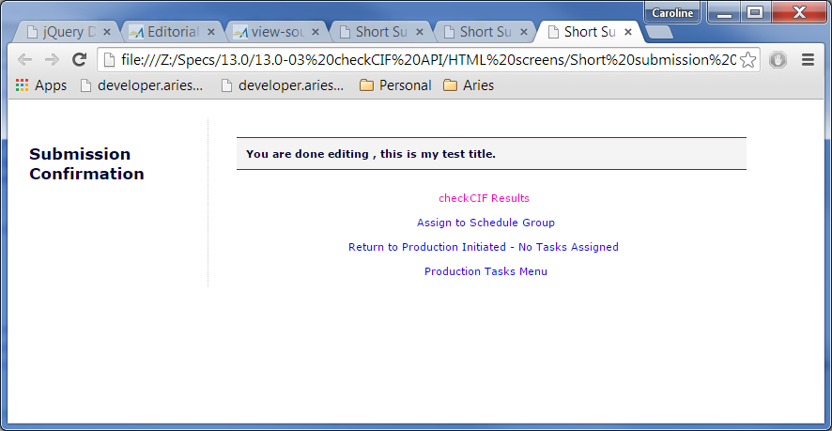

### File Inventory

#### Submission File Inventory [downloadSubFilesList.asp]

This page is accessed by Editors and Publishers with the ‘Download Source Files’ RoleManager permission. For scope reasons, files cannot be sent to the checkCIF tool from this page (like AQC and Reference Checking but unlike CrossCheck). Files *can* be sent/resent from the checkCIF Results page, and a link to this page is added to the File Inventory page in this spec.

1. A new ‘checkCIF Results’ link is added above the Submission Files grid, if both of the following are true:
   1. The user viewing the page has ‘View checkCIF Results’ RoleManager permission AND
   2. At least one non-hidden/non-URL/URI/External Resource Item for the current revision is configured as ‘Include this Item Type for checkCIF’.
   3. Clicking this link does one of the following:
      1. If there is only one non-hidden file associated with the current revision of the submission configured to be sent to the checkCIF tool, and this file has a checkCIF results PDF, the results PDF is downloaded when the user clicks this link. The user is not navigated to a separate interface page.
      2. If there are more than one non-hidden /non-URL/URI/External Resource files associated with the current revision of the submission that are configured to be sent to the checkCIF tool, clicking the link replaces the contents of the File Inventory popup with the checkCIF results popup discussed in section 2.13.3 below. Note: this is similar to clicking the CrossCheck/iThenticate Results link which opens the CrossCheck Results page in the same popup window.
2. The ‘Upload Companion File’ button allows a new Companion File to be uploaded. Doing so triggers the checkCIF API if the Item Type uploaded is configured as ‘Include this Item Type for checkCIF’. Note: this is not dependent on a workflow trigger point; similar to Reference Checking, uploading a companion file will trigger the sending of the file to the checkCIF tool if the file is so configured.
3. The ‘Hide Selected Companion Files’ button and the Hide action link allow one or more Companion Files to be hidden (existing coding, unchanged in this spec). If the user hides the only file that has been sent to the checkCIF tool, the checkCIF Results link is suppressed.
4. When the user clicks either of the ‘Download Selections as Zip File’ buttons, the checkCIF Results PDFs are not included in the download (i.e. no coding change for these buttons on this page).

Page Layout #11 – File Inventory with CrossCheck

* New ‘checkCIF Results’ link added under the conditions described in the spec.
* checkCIF results link added on the same row as the CrossCheck/iThenticate Results link, separated from the end of that link by four &emsp; characters.
* New checkCIF Results link shown in pink, to be coded in the same font as other links.
* Note: if the only checkCIF results PDF is associated with a Hidden Companion File, the checkCIF Results link is suppressed. Business Logic: If the Companion file is Hidden, its associated checkCIF results are not available.
* CrossCheck buttons and link dependent on Similarity Check configuration; unchanged in this spec. If they are not shown, the checkCIF Results link is centered, see page layout #11A

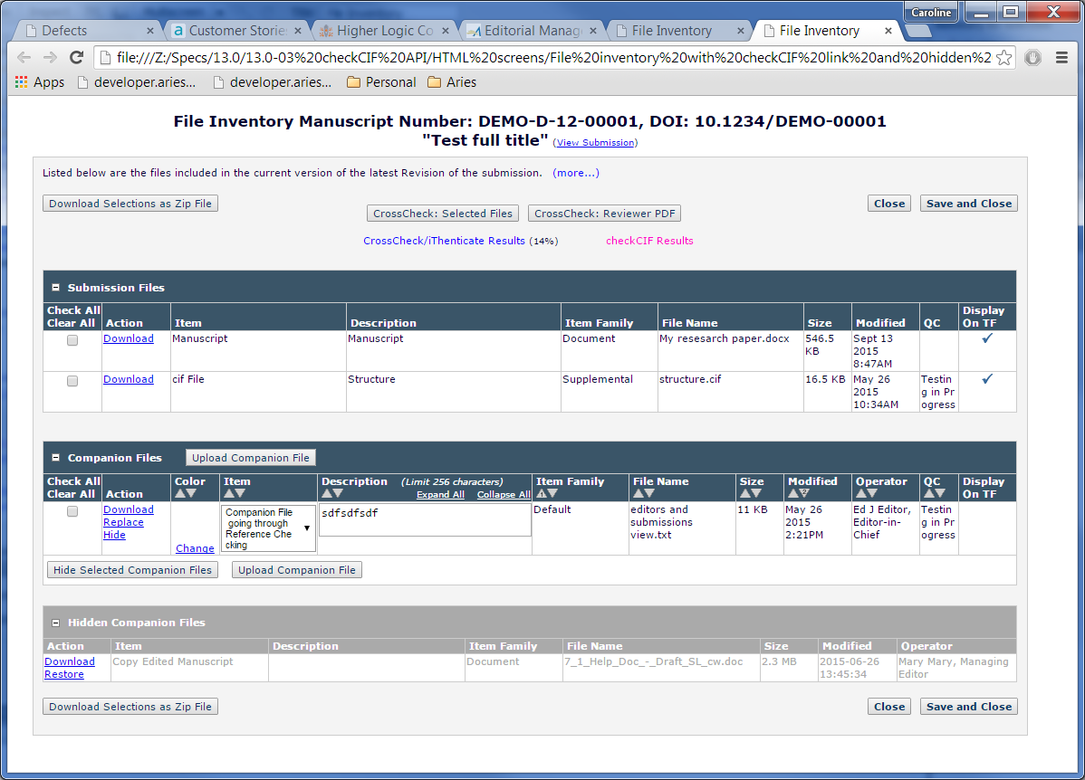

Page Layout #11A – File Inventory page without CrossCheck

* This example shows the *File Inventory* page when the CrossCheck buttons and link are not displayed, but the checkCIF Results link is displayed.
* New checkCIF Results link shown in pink, to be coded in standard EM font for links.

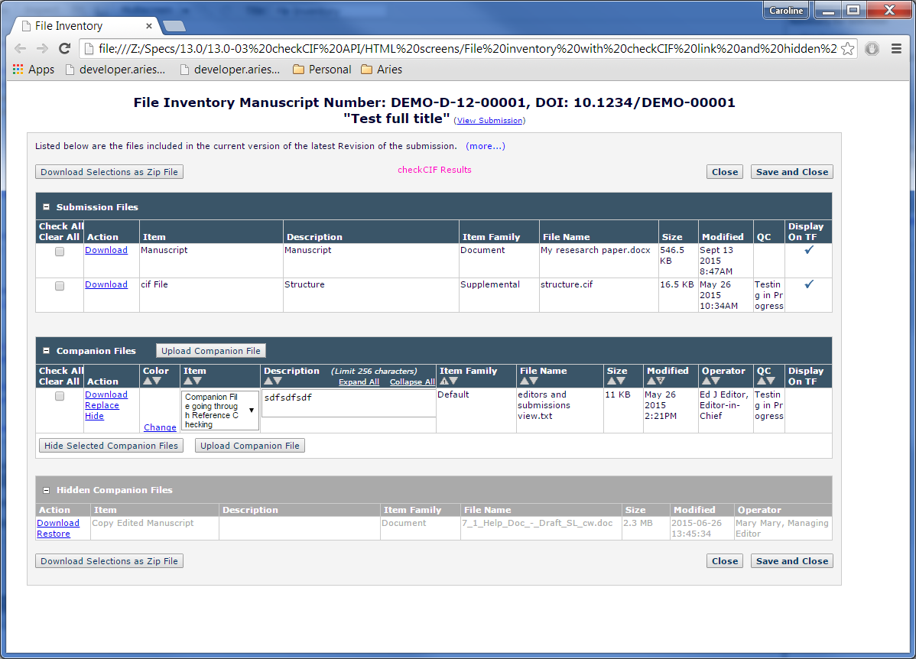

#### Schedule Group File Inventory

This page [ManageScheduleGroups.aspx] is reached from the Production Tasks menu. (The Production Tasks menu is displayed in the interface only when the publication is enabled with ProduXion Manager; i.e. the ‘Enable Production Tracking’ checkbox is selected in Hosting Administration, *Set Journal Features*)*.* An Editor/Publisher with ‘Manage Schedule Groups’ permission clicks the ‘Manage Schedule Groups’ link on the Production Tasks Menu and selects the ‘File Inventory’ link in Action column.

In existing coding, the page has two grids on it:

1. A ‘Companion Files’ grid listing all Companion Files associated with the Schedule Group.
2. Conditionally, a ‘Hidden Companion Files’ grid listing all Companion Files associated with the Schedule Group that have been ‘Hidden’. (A Companion File is ‘Hidden’ when an Editor/Publisher clicks the ‘Hide’ link in the Action column of the Companion Files grid, or has selected the checkbox in the ‘Select’ column of the Companion Files grid and clicked the ‘Hide Selected Companion Files’ button). The Hidden Companion Files grid is displayed only if one or more Companion Files associated with the Schedule Group have been hidden.

New in this spec, the page is redesigned to look similar to the Submission File Inventory page [downloadSubFilesList.asp], and the checkCIF Results link is added, as described below:

1. The page instructions are moved from a separate box at the top of the page into a gray box just above the Companion Files grid. The default view of the instructions is changed from fully expanded with no (more…) or (less…) links, to collapsed, with a standard EM (more…) link. When the (more…) link is clicked, the instructions expand and a standard EM (less…) link is shown. Note: the text of the instructions itself is not changed.
   1. Collapsed instructions and (more…) link: Listed below are the Companion files associated with the Schedule Group. (more…)
   2. Expanded instructions and (less…) link. Listed below are the Companion files associated with the Schedule Group. Click the Download link to download the individual source file. To download a zip file containing multiple items, select the items using the check boxes, and then click the 'Download Zip File' button. The 'Check All' and 'Clear All' links may be used to select or unselect all the files. Additional software (such as WinZip) must be installed on your computer in order to unzip (uncompress) the zip file. You may also select Companion files from associated submissions; files selected in this way will appear both here and in the original Submission File Inventory.   
        
      If a checkbox does not appear in the 'Select' column for a file, the file is no longer available. Click the Download link in the Action column for more information about the file. (less…)
2. A new ‘checkCIF Results’ link is added above the Companion Files grid, on the same row as the buttons, if both of the following are true:
   1. The user viewing the page has ‘View checkCIF Results’ RoleManager permission AND
   2. At least one non-hidden/non-URL/URI/External Resource Item (that is a Companion File associated with the Schedule Group) is configured as ‘Include this Item Type for checkCIF’.
   3. Clicking this link does one of the following:
      1. If there is only one non-hidden Schedule Group Companion file configured to be sent to the checkCIF tool, and this file has a checkCIF results PDF, the results PDF is downloaded when the user clicks this link. The user is not navigated to a separate interface page.
      2. If there are more than one non-hidden /non-URL/URI/External Resource Schedule Group Companion files that are configured to be sent to the checkCIF tool, clicking the link replaces the contents of the Schedule Group *File Inventory* popup with the Schedule Group *checkCIF results* popup discussed in section 2.13.7 below.
3. The ‘Download Zip File’ buttons are renamed to ‘Download Selections as Zip File’, to match the text on the Submission *File Inventory* page, and these two buttons are repositioned on the page to the gray areas above and below the Companion Files grid.
4. Standard EM Expand/Collapse icons ( / ) are added to the Companion Files and Hidden Companion Files grids, mimicking the same grids on the Submission *File Inventory* page. The default display is expanded. When clicked, the icon changes from the – sign to the + sign and collapses the grid in the same way as on the Submission *File Inventory* page.
5. The existing button ‘Upload Companion File’ allows a new Companion File to be uploaded. New in this spec, uploading a new Schedule Group Companion File triggers the checkCIF API if the Item Type uploaded is configured as ‘Include this Item Type for checkCIF’. Note: this is not dependent on a workflow trigger point; similar to Reference Checking, uploading a companion file will trigger the sending of the file to the checkCIF tool if the file is so configured. Note: the same Item type will not be configured for checkCIF and Reference Checking; this would be a misconfiguration.
6. The ‘Hide Selected Companion Files’ button allows one or more Companion Files to be hidden (existing coding, unchanged in this spec). If the user hides the only file that has been sent to the checkCIF tool, the checkCIF Results link is suppressed. This button is repositioned in this spec, to mimic the Submission File Inventory page. The three buttons ‘Hide Selected Companion Files’, ‘Upload Companion File’ and ‘Select Companion Files from Submissions’ are now positioned on the same row.
7. When the user clicks either of the ‘Download Selections as Zip File’ buttons, the checkCIF Results PDFs are not included in the download (i.e. no coding change for behavior of these buttons on this page).
8. The ‘Description’ column has additional text added to the column header, as on the Submission *File Inventory* page. The additional text is: *(limit 256 characters).* The parentheses are included and the text is italicized. Standard EM ‘Expand All’ ‘Collapse All’ links are also added in the column header. As on the Submission *File Inventory* page, clicking these links expands and collapses the textarea boxes in the Description column.
   1. A standard EM (more…) link is shown under the Description if 1) the textarea currently has focus or 2) the textarea does not have focus but the entered text exceeds the rows shown in the textarea (which also causes a scrollbar to appear in the textarea). This existing code for the Submission *File Inventory* popup is extended to the Schedule Group *File Inventory* popup in this spec.
9. The Action column allows the user to ‘Replace’ a Schedule Group Companion File. When the ‘Replace’ link is clicked, the ‘Upload Companion Files for Schedule Group’ popup is displayed [addCompanionFile.aspx].
   1. As with the Submission *File Inventory* page, replacing the file on the Upload Companion Files popup triggers the checkCIF API if the Item selected in the drop-down list on the Upload Companion Files popup is configured to be sent to checkCIF. Note: as with current coding for Reference Checking, the API is trigged when the ‘Upload This File’ button is clicked.

Page Layout #12 – current display of Schedule Group File Inventory

* This layout is shown for reference purposes only. It is changed in this spec.

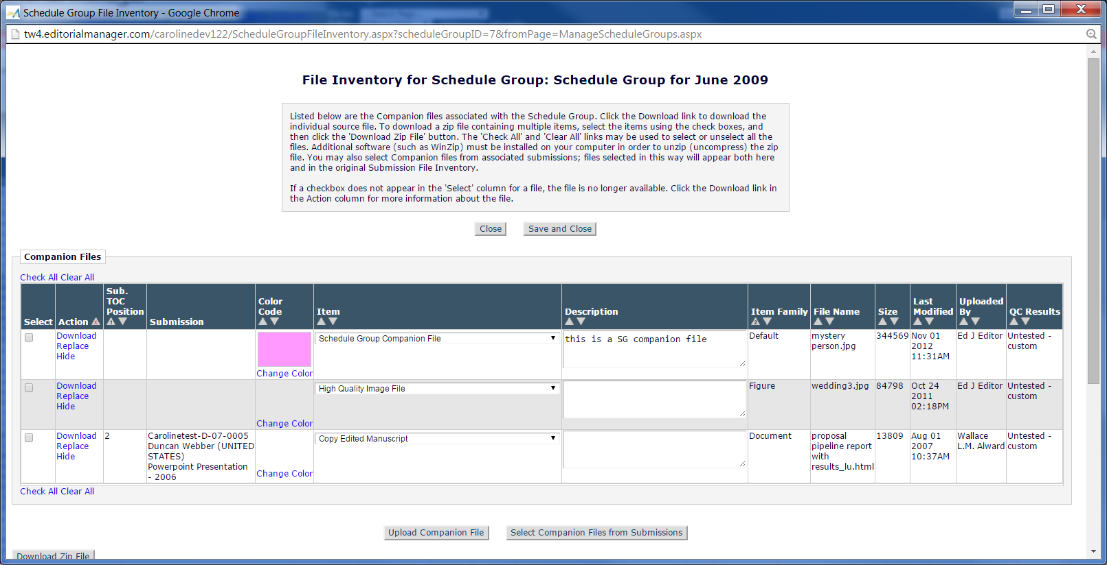

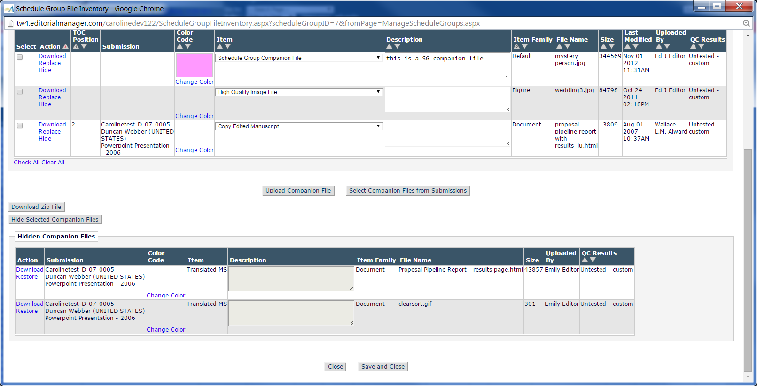

Page Layout #13 – New display of Schedule Group File Inventory page

* Page is redesigned to resemble Submission *File Inventory* page
* Instructions collapsed with (more…) link.
* checkCIF Results link added centered between the “Download Selections as Zip File” and “Close” buttons under the conditions described in the spec – shown in pink, to be coded in standard link color
* Companion Files and Hidden Companion Files grids changed from static to collapsible/expandable with standard EM -/+ collapse/expand icons.
* Buttons repositioned as described in spec.
* Some column headers renamed, and ‘Expand All’ ‘Collapse All’ links and additional text added to ‘Description’ column header (as per Submission File Inventory page).
* (more..) link added under the Description column under conditions described in the spec (same conditions as the Submission File Inventory page).
* No other changes to contents of grids. Note that the Color column has the link ‘Change Color’ on the Schedule Group File Inventory page, and the link ‘Change’ on the Submission File Inventory page. Both links do the same thing. The inconsistent text is retained in this specification since Schedule Group users are familiar with the ‘Change Color’ link text.

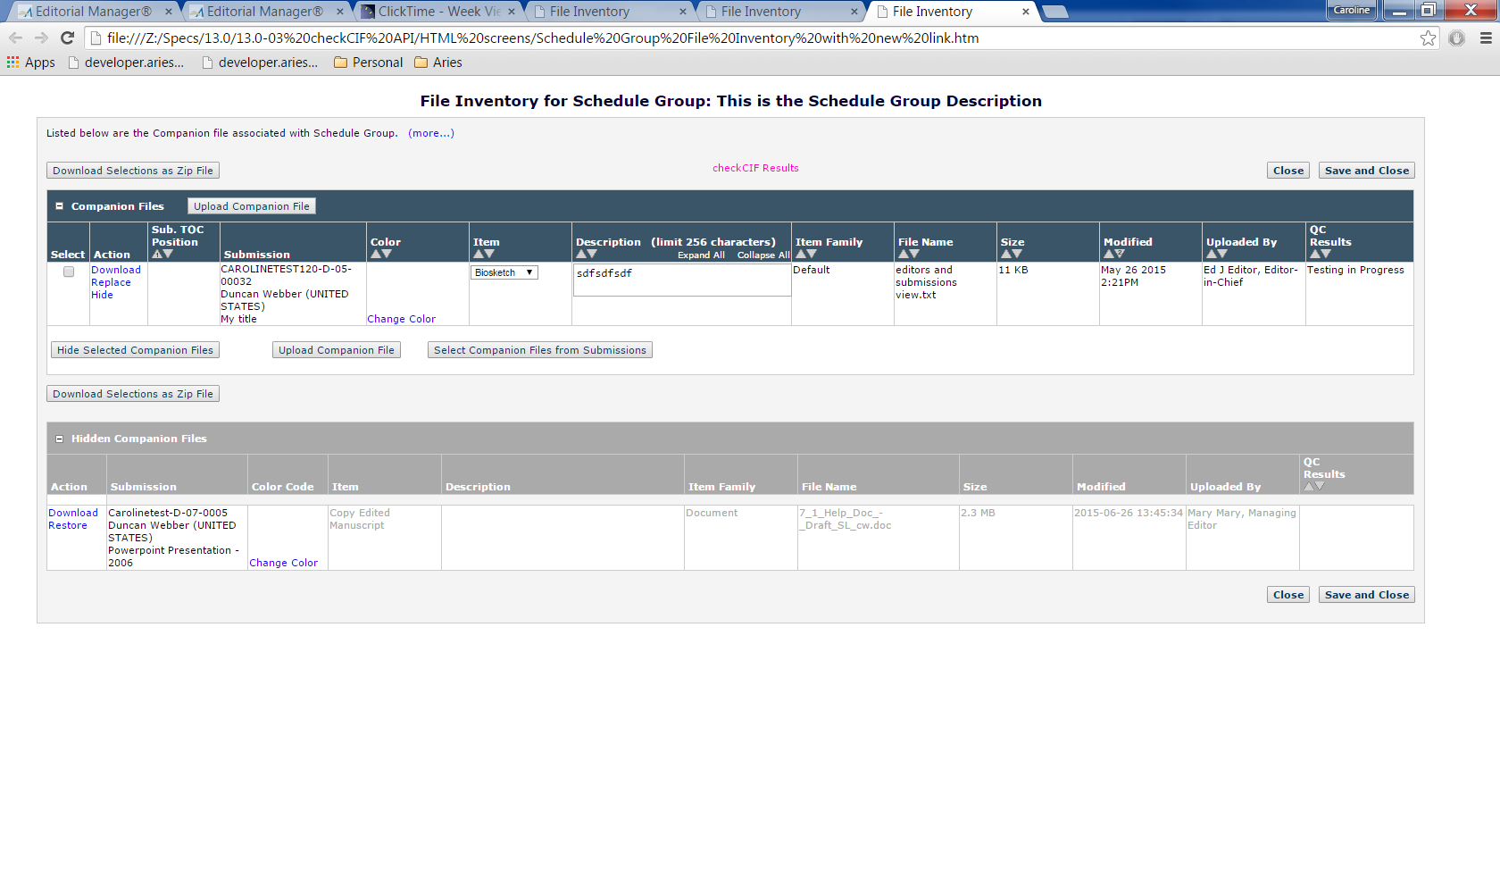

Page Layout #13A New Display of Schedule Group File Inventory page with no Companion Files

* This layout is displayed if no Companion Files have yet been added to the Schedule Group File Inventory.
* The display is changed from the current layout shown in Page Layout #13B to more closely resemble the Submission File Inventory popup.
* The instructions are collapsed with a (more…) link added, and moved inside a div similar to the Submission File Inventory popup.
* The fieldset legend is removed.
* The message “There are no files attached to this Schedule Group” is retained but changed to bold as well as red text.
* The bottom Close button is removed, leaving one Close button. The top close button is on the same row as the instructions, to preserve vertical space.

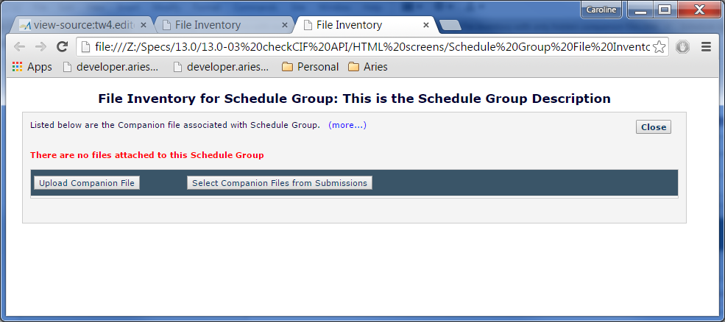

Page Layout #13B – Current Schedule Group File Inventory page with no files

* This layout is changed in this specification to the layout in 13A.
* Shown for comparison purposes only.

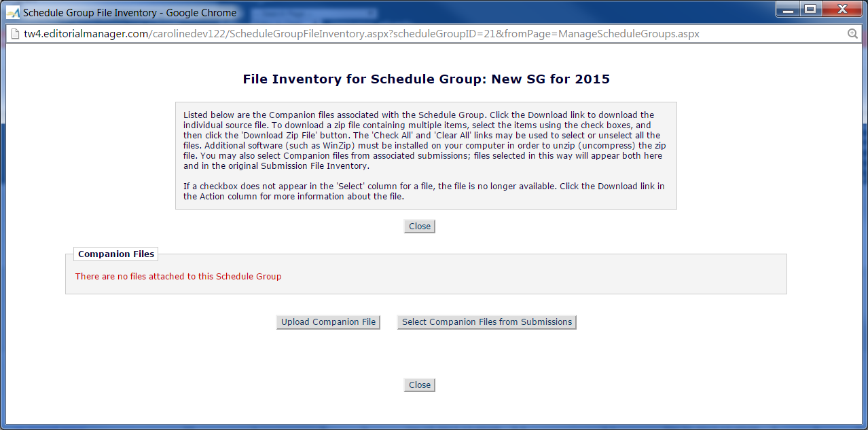

Page Layout #13C Schedule Group File Inventory with only Hidden Companion Files

* This layout is displayed if no Companion Files have yet been added to the Schedule Group File Inventory.
* The display is changed from the current layout shown in Page Layout #13B to more closely resemble the Submission File Inventory popup.
* The instructions are collapsed with a (more…) link added, and moved inside a div similar to the Submission File Inventory popup.
* The fieldset legend is removed.
* The message “There are no files attached to this Schedule Group” is retained but changed to bold as well as red text.
* The checkCIF results link is not shown, even if the Hidden Companion File has results. The results are only available for non-Hidden Companion Files.

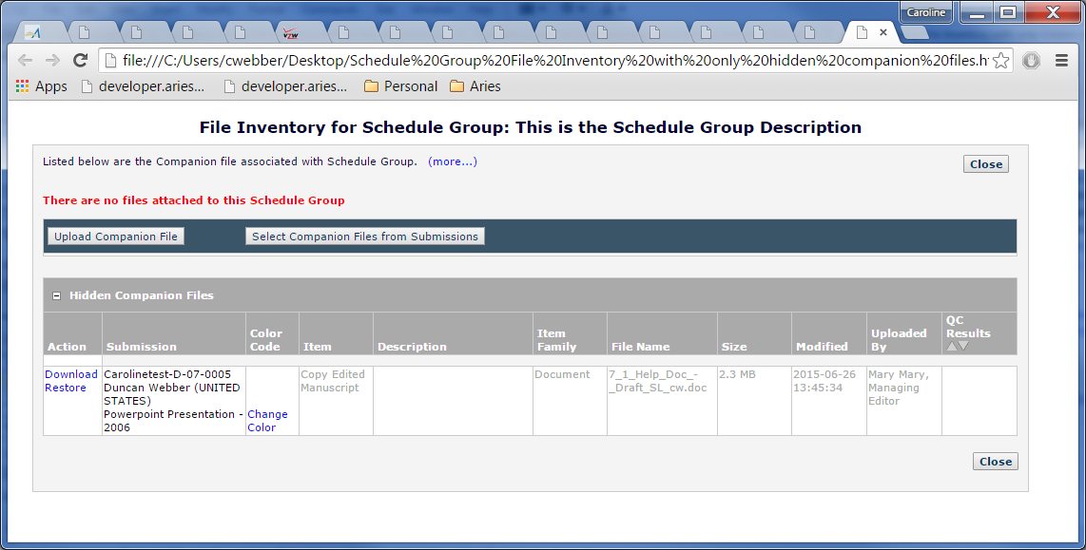

Page Layout #13D – Current Schedule Group File Inventory page with only Hidden Companion Files

* This layout is changed in this specification to the layout in 13C.
* Shown for comparison purposes only.

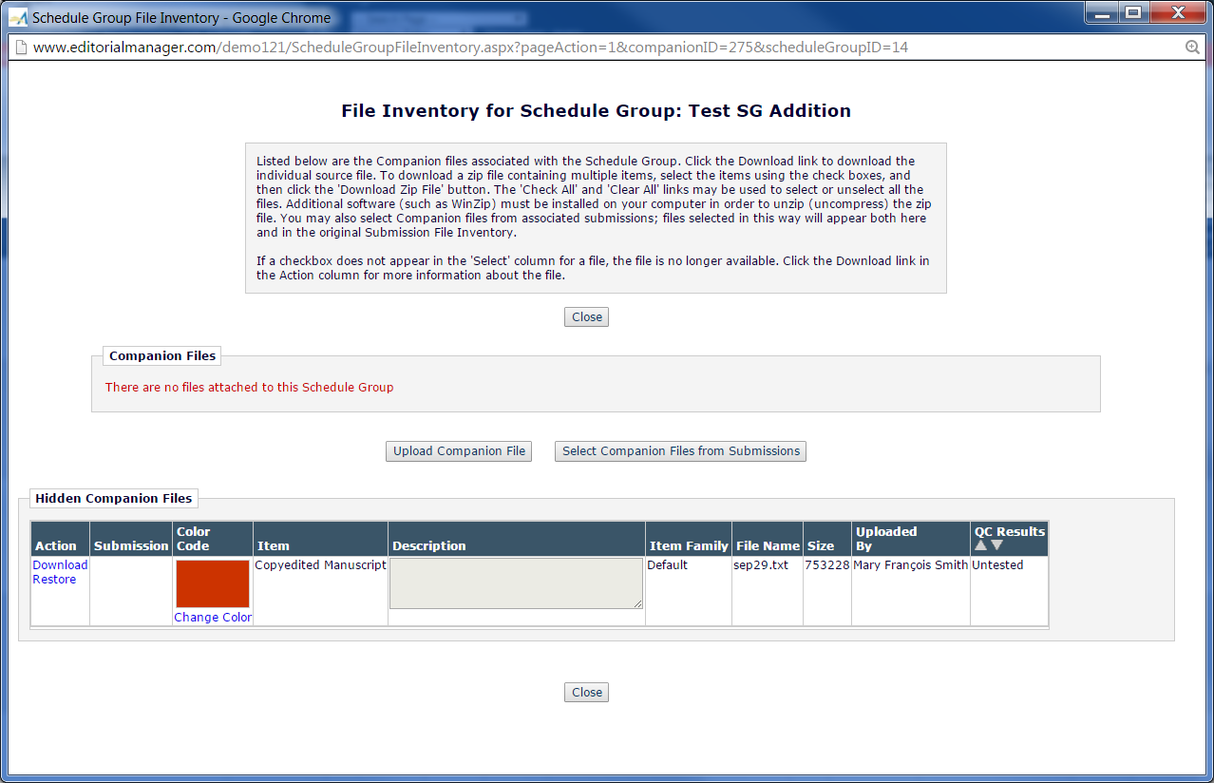

## Search Submissions

Editors and Publishers with ‘View checkCIF Results’ RoleManager permission are displayed a new ‘checkCIF Results’ link in the *Search Submission Results* Action column, for submissions where:

1. At least one non-hidden/non-URL/URI/External Resource file from the current revision of the submission is configured as ‘Include this Item Type for checkCIF’.
2. Note: the link must be displayed in both the interactive power grid and traditional grid. Only the traditional grid is shown in this screen shot.
3. Clicking this link opens the submission *checkCIF Results* popup in a separate popup window.

Page Layout #14 – Search Submissions –Search Results

* checkCIF Results link added under the conditions described in the spec.
* Shown in pink, to be coded in the default font used for links.

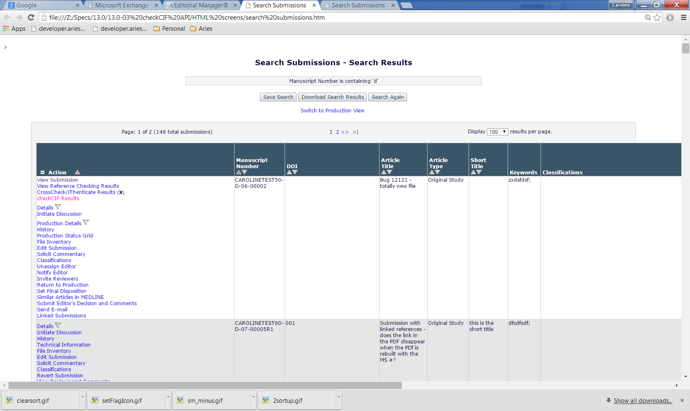

## Transmittal Form

Displaying the checkCIF results PDFs on the Transmittal Form is a future enhancement. See section 24 of this spec for a suggested future layout.

## Upload Companion Files for Submission or Schedule Group

This existing page [addCompanionFile.aspx] is reached in one of the following ways:

1. When a user assigning a Schedule Group Production task clicks the ‘Upload New Companion File’ button on the *Assign Schedule Group Production Task* page
2. When a user assigning a Submission Production task clicks the ‘Upload New Companion File’ button on the *Assign Production Task* page.
3. When a user clicks the ‘Upload New Companion File’ button on the Submission File Inventory popup, or clicks the ‘Replace’ link in the Action column of the Companion Files grid on this popup.
4. When a user clicks the ‘Upload Companion File’ button on the Schedule Group File Inventory popup, or clicks the ‘Replace’ link in the Action column of the Companion Files grid on this popup.

There is no change to the display of this popup in this spec, however there are changes to the logic in this spec:

1. If an Item is configured with ‘Include this Item Type for checkCIF’, uploading a Companion file of this Item Type and clicking the button ‘Upload This File’ automatically triggers the sending of this file to the checkCIF API.
2. As per current coding, after the file has been uploaded, the *Upload Companion Files* popup closes automatically, and the underlying page refreshes. New in this spec, the checkCIF Results link may now be displayed on the underlying page.

Page Layout #15 – Upload Companion Files

* Shown for testing purposes only.
* No change to layout in this spec; change to logic behind the Upload this File button.
* Note: the page header text depends on what page the user is on when they invoke the page. In this example, the user was on either the Schedule Group File Inventory page or the Assign Schedule Group production task page, because the Schedule Group description is shown in the page header. This is existing coding, unchanged in this spec.

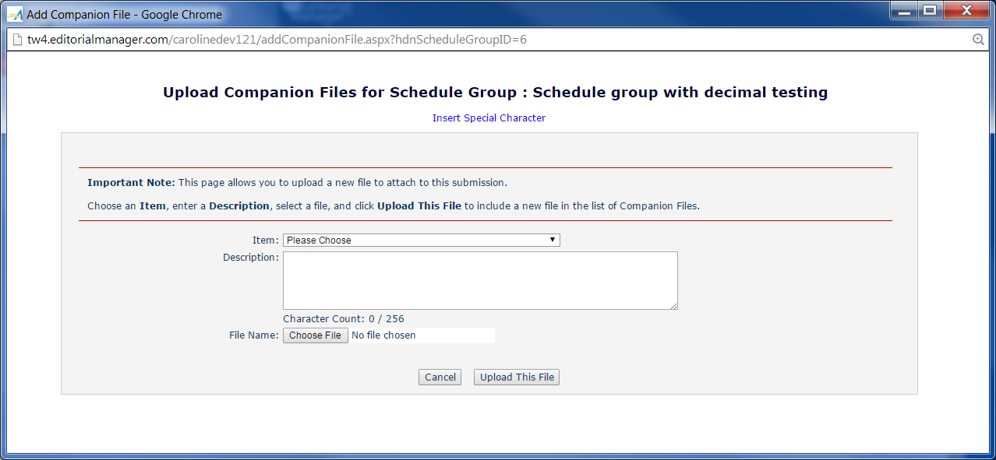

## checkCIF results link and Results pages

### checkCIF Results Link - Editor Facing pages

The ‘checkCIF Results’ link is added to the same folders as the CrossCheck Results link, below the CrossCheck Results link. Note: the link displays only for Editors with ‘View checkCIF Results’ RoleManager permission, and if one or more non-hidden/non-URL/URI/External Resource files associated with the current revision of the submission are configured to be sent to the checkCIF tool. Note that results PDFs do not need to have been returned for the link to be displayed, but at least one file needs to be configured to be sent to the tool).

The checkCIF results link has two possible behaviors:

1. If only one file (whether Submission File or Companion File) associated with the current revision of the submission is configured to go to the checkCIF tool, and this file has a checkCIF results PDF associated with it, clicking the link downloads that file’s checkCIF results PDF without displaying an additional interface page to the user.
2. If there are multiple files associated with the current revision of the submission that are configured to go to the checkCIF tool, clicking the link navigates the Editor user to the Editor/Publisher version of the checkCIF Results page described in section 2.13.3.

List of Editor folders displaying the new ‘checkCIF Results’ link under the conditions described above:

* *New Submissions*
* *Revised Submissions*
* *New Submissions requiring assignment*
* *Revised Submissions requiring assignment*
* *View All Assigned Submissions*
* *Direct-to-Editor New Submissions*
* *Direct-to-Editor Revised Submissions*
* *New Invitations (note, this covers submissions assigned under Suggest Editor functionality introduced by 8.0-27)*
* *New Assignments*
* *Production Initiated – No Tasks Assigned*
* *View All Submissions in Production*
* *Group by Editors I Assigned*
* *Group by Editor with Current Responsibility*
* *Group by Manuscript Status*
* *Submissions out for Revision*
* *My Assignments with Final Disposition*
* *All Submissions with Final Disposition*
* *Search Submissions (Action Column – both the Editorial view and Production view)*
* *Search Proposals (Action Column)*
* *Search Submissions (from the Proposal Menu)*

Note: The link is also available from the *Details* page (if configured to appear on the custom details page) and from *File Inventory*, so it does not need to be added to every possible editor folder. See section 24 for possible additional folders which could be added in the future.

Note: adding this link to Proposals menu folders is a future enhancement. It is added to Search Proposals Results and Search Submissions results (from the Proposals menu) in this spec.

### checkCIF Results link – Publisher facing pages

The checkCIF Results link is added to the following Publisher-facing folders, if the logged in Publisher user has the permission ‘View checkCIF Results’ selected for their Publisher Role, and at least one file associated with the current revision of the submission has been sent to the checkCIF tool:

* *Accepted Submissions*
* *Production Initiated – No Tasks Assigned*
* *View All Submissions in Production*
* *Search Submissions (Action Column – both the Editorial view and Production view)*

Note: The link is also available from the *Production* *Details* page (if configured to appear on the custom details page, the user has ‘View checkCIF Results’ permission, and there are one or more files associated with the current revision of the submission that are configured to go to the checkCIF tool) and from *File Inventory (if the user has the ‘View CheckCIF results permission)*, so it does not need to be added to every possible Publisher folder. See section 24 for possible additional folders which could be added in the future.

The checkCIF results link has two possible behaviors:

1. If only one file (whether Submission File or Companion File) associated with the current revision of the submission is configured to go to the checkCIF tool, and this file has a checkCIF results PDF associated with it, clicking the link downloads the checkCIF results PDF without displaying an additional interface page to the user.
2. If there are multiple files associated with the current revision of the submission that are configured to go to the checkCIF tool, clicking the link navigates the Editor user to the Editor/Publisher version of the checkCIF Results page described in section 2.13.3.
3. As mentioned above, if the current revision of the submission does not include any non-hidden files configured to go to the checkCIF tool, the checkCIF Results link is suppressed.

### Submission-related checkCIF Results popup for Editors/Publishers

A new submission-related *checkCIF Results* popup window is available for Editors and Publishers with the new ‘View checkCIF Results’ RoleManager permission. It is accessed via the new ‘checkCIF Results’ link in the Editor folders listed in section 2.13.1 above and Publisher folders listed in section 2.13.2 above, and Search Submissions, File Inventory and Technical Check (similar to the ‘CrossCheck/iThenticate Results (x%)’ link). It will be similar to the AQC Results page shown below. *Management team question: should we show the page even if no files have yet been sent to the tool and allow manual sending if the user has the ‘Initiate checkCIF’ permission?*

1. The page header is ‘checkCIF Results – Submission [Manuscript number]’ , followed by the Article Title in double quotes (this is similar to the Artwork Quality Results page).
2. The page instructions are configured on the *Configure checkCIF* page in PolicyManager. They are either the default tokenized instructions or customized intructions (which are not tokenized).

[Note: a hardcoded branding message and icon may be added to the instructions – waiting on IUCr for details.]

1. Two grids are shown (similar to the Artwork Quality Checking Results page):
   1. A ‘Submission Files’ grid contains all submission files associated with the current revision of the submission, and configured as ‘Include this Item Type for checkCIF’.
      1. Any files attached as URL/URI/External Resources are excluded.
   2. A ‘Companion Files’ grid contains all non-hidden Companion files associated with the current revision of the submission [note: the COMPANION_FILES table has a REVISION field listing the revision for which the file was uploaded, and an ‘Revision carryover flag’ INCLUDE_IN_REV. If the REVISION value is less than the current revision, but the INCLUDE_IN_REV is TRUE, the file should be displayed. The logic on the AQC Results page should be examined to see if it can be used as a guide], and configured as ‘Include this Item Type for checkCIF’. Logic to be confirmed in tech spec.
   3. If there are only Companion Files configured to go to checkCIF, the Submission Files grid is suppressed. If there are only Submission Files configured to go to checkCIF, the Companion files grid is suppressed.
2. Both the Submission and Companion Files grids contains the following columns:
   1. Select column header and checkbox.
      1. This column is displayed only if 1) The Editor viewing the page has ‘Initiate checkCIF’ RoleManager permission and 2) there are one or more Items that are associated with the current revision of the submission that are configured as ‘Include this Item Type for checkCIF’ , and have either 1) not been sent to the checkCIF tool or 2) have been sent but have an error returned from the API (and thus need to be retried).
      2. Any Items that have checkCIF results PDFS or have the status ‘Testing in Progress’ are not eligible to be re-sent to the checkCIF tool (since the results will not vary), and the checkbox for those items is suppressed.
   2. Item Type (the Item Type name of the .cif file as configured on the Edit Submission Item Type page).
   3. Item Description (the Item description associated with the uploaded .cif file).
   4. File Name (of the .cif file, not the results file)
   5. Size (of the .cif file, not the results file)
   6. Date Tested – the date the file was most recently sent to the checkCIF tool, in Journal Defined date format. Note: for files with PDF results, this date is never updated as the file is never resent to the tool once it has results.
   7. Actions – a Download link, allowing the user to Download the .cif file.
   8. checkCIF results – one of the results terms discussed in bullet 5.
3. The checkCIF results column contains one of the following:
   1. If the Item has not yet reach a workflow trigger point, and has not been manually sent to the tool, the phrase ‘Not yet tested’ is shown in orange font (the same font color used for the ‘Untested’ status on the AQC results page).
   2. If the Item has been sent to the checkCIF tool but nothing has been returned from the tool for this Item (or an asynch job has been created to sent this Item to the tool, and results or an error status have not yet been returned, even if it has not been actually sent yet), the string ‘Testing in progress’ is shown in green text (the same font color used for the ‘Pass’ status on the AQC results page).
   3. If the asynch processor reports that the API has returned an error status, the hyperlinked string ‘checkCIF Error’ is shown in red text (the same font color used for the ‘Error’ status on the AQC results page). Clicking the string pops up the error message returned by the tool in a jquery alert box (similar to the coding on the CrossCheck/iThenticate Results page). See section 2.13.6 of this spec for a list of typical error messages that will be returned from the tool. Note: the Author/Reviewer version of this page does not provide access to the error message.
      1. The Title of the jquery alert box is “checkCIF Error”. The standard EM red alert triangle is re-used from the Add/Edit/Remove author page and resized if necessary.
      2. The text in the alert box varies, and is shown in the body of the jquery alert box, without [ ]. (The square brackets denote text to be replaced). The red warning triangle needs to be aligned with the title bar text.

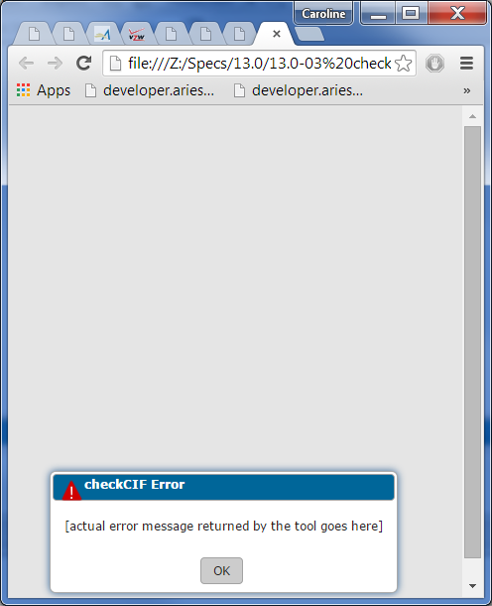

* 1. If the API has returned the results PDF, the hyperlinked text ‘Completed’ is shown (using the same font color as the Completed string on the CrossCheck/iThenticate Results page). Clicking the hyperlink downloads the PDF of the results as configured in the user’s browser. Note: this must also work on a mobile device, providing that the mobile device has been configured by its user to handle PDFs.

1. ‘checkCIF: Selected Files’ button:
2. The button is displayed only if one or more of the files on the page has an error status or has not yet been tested, and the user viewing the page has an Editor or Publisher Role with the RoleManager permission ‘Initiate checkCIF’.
   1. The button is grayed out/disabled until one or more checkboxes in the ‘Select’ column have been selected.
   2. When clicked:
      1. The selected files are sent to the checkCIF tool via the API asynchronously, and the user is presented with a popup jquery box with the following text: The selected files are being sent to the checkCIF tool for processing. This may take several minutes to complete. When results have been returned, you can use the 'Completed' link to view the results PDF for each file.

(This text is similar to the alert box text shown on the File Inventory page when the CrossCheck: Selected Files button is clicked):

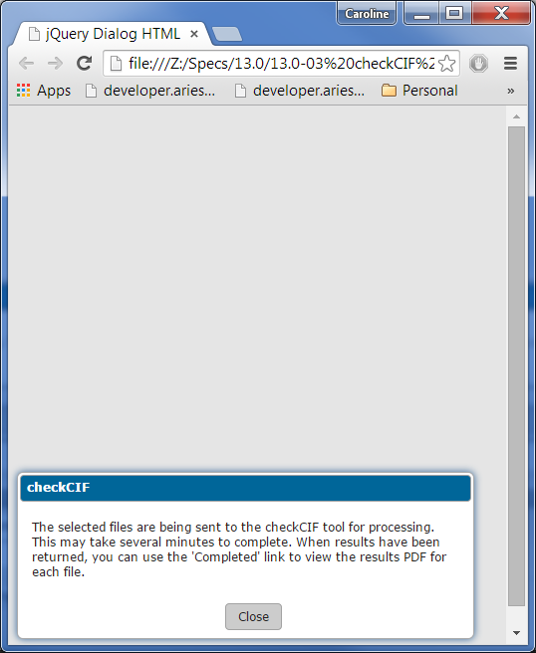

* + 1. The *View checkCIF Results* page is refreshed to show ‘Testing in Progress’ status for the re-submitted file(s), and the ‘checkCIF: Selected Files’ button disappears, unless there are additional files that can still be selected. Note the user may want to manually refresh the window to see the new results quickly.

1. Close button: When the ‘Close’ button is clicked (on the page) and the ‘checkCIF: Selected Files’ button is displayed on the page, the following jquery dialog box is displayed:
   1. Title bar: yellow warning triangle with exclamation point to be re-used from EM mobile and added to the Warning title bar (resized if necessary), followed by the text “Warning”
   2. Content of dialog box: One or more of the cif files was not checked or is in an error status. To send these files to the checkCIF tool, click the 'Return to Results Page' button below and then select the file(s) using the checkboxes and click the 'Selected File: checkCIF' button. To close this results page, click the 'Leave Results Page' button below.

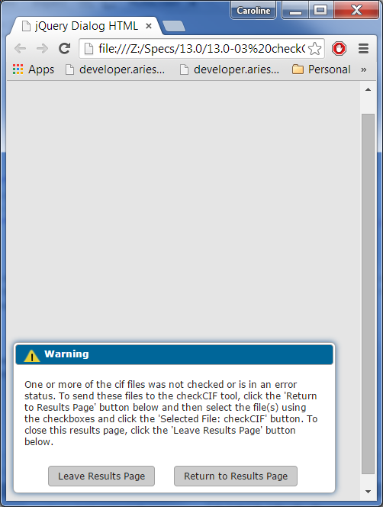

* 1. If the user clicks the ‘Leave Results page’ button on the dialog box, the dialog box is closed, and the *View checkCIF Results* pop-up window is closed. The user is returned to the calling page (the page they were on when they clicked the ‘View checkCIF results’action link).
  2. If the user clicks the ‘Return to Results Page’ button on the dialog box, the dialog box is closed and the user remains on the *View checkCIF Results* page.

1. Unlike the AQC feature, the status terms are not configurable by the journal.
2. The instructions are configurable by the journal on the *Configure checkCIF* page (see section 2.3.1.1).

Page Layout #16 – Submission checkCIF Results for Editors/Publishers with Initiate checkCIF RoleManager permission

1. The ‘Select’ column is shown because there are files that are in error status or have not yet been sent to the checkCIF tool, and the user has ‘Initiate checkCIF’ RoleManager permission. Checkboxes are shown for files in an error status or ‘Not yet Tested’ status, but not for files that are in the status ‘Testing in Progress’ or ‘Completed’.
2. The ‘checkCIF: Selected Files’ button is shown because the select column is available and the user has the RoleManager permission ‘Initiate checkCIF’.
3. The checkCIF Error text is a hyperlink to a jquery popup containing the error message.
4. The ‘Completed’ text is a hyperlink to the PDF of the results from the checkCIF tool.
5. Note: if there are files configured to be sent to the checkCIF tool and associated with the current revision of the submission (or non-Hidden Companion Files), but none of the files have yet been sent to the tool, the page is still reachable by an Editor/Publisher. In this case, all files listed will have available checkboxes in the ‘Select’ column and will have the status “Not yet tested”.

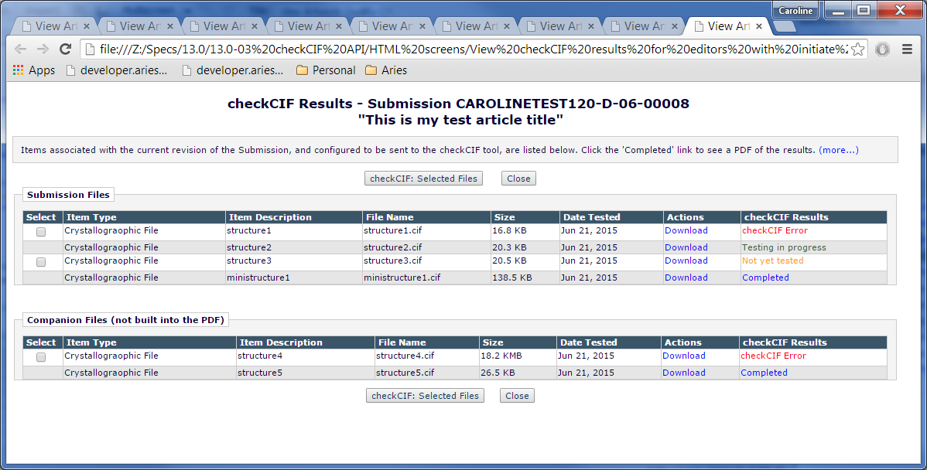

Page Layout #16A: Submission checkCIF Results for Editors/Publishers without Initiate checkCIF permission

* Select column suppressed.
* This version of the page shows the expanded display of the instructions; the default display is collapsed.
* ‘checkCIF: Selected Files’ button suppressed
* Download links will download the cif file
* Completed links download the checkCIF Results PDF
* checkCIF Error text is a hyperlink to a jquery alert box that displays the actual error text returned from the tool.
* The ‘Close’ buttons need to be moved closer to the fieldset (on both the top and bottom) – currently there is too much vertical space between the button and the fieldset (there is currently padding of 15 px between the button div and the fieldset).
* The text in all the columns should wrap except checkCIF results and Actions.
* Note: if there are files configured to be sent to the checkCIF tool and associated with the current revision of the submission (or non-Hidden Companion Files), but none of the files have yet been sent to the tool, the page is still reachable by an Editor/Publisher. In this case, all files listed will have the status “Not yet tested”.

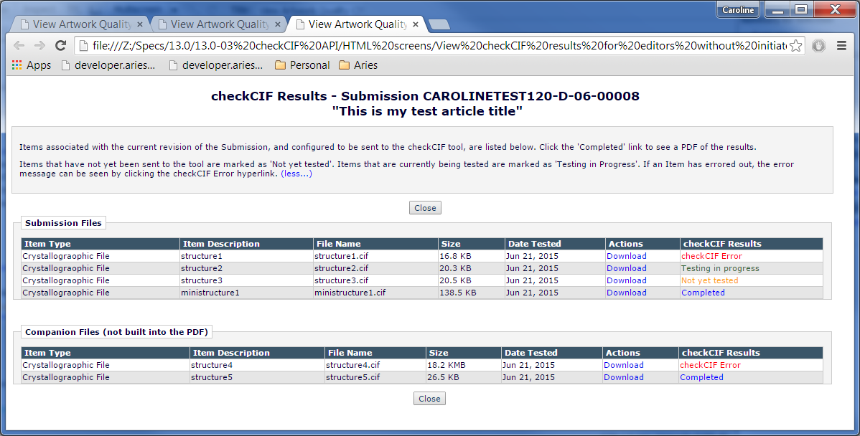

### checkCIF results link – Author facing pages

The checkCIF results link is added to the following Author-facing pages, if all of the following are true:

1. The Author Role has the permission ‘View checkCIF Results’ selected in RoleManager.
2. The submission has one or more files that are associated with the current revision, and have been sent to the checkCIF tool (note: it is not necessary for results to have been returned; the results page will show a ‘Testing in Progress’ status for files that do not yet have results, or an error status for files that have errored). Note: this is different than the logic for Editor folders. The Author should not be shown the results link if a file has not yet been sent to the tool.
3. The link is added after the existing View Reference Checking Results link, if this link is shown. If this link is not shown, it is added in the row where the View Reference Checking results would be shown.
4. Author Main Menu folders – the ‘View checkCIF Results’ link is placed in the Action column, under the ‘View Reference Checking Results’ link (if this link appears – if this link does not appear, placed in the position that the View Reference Checking Results link would appear).
   1. *Submissions Sent Back to Author [authorSubmissionsSentBack.asp]*
   2. *Submissions Waiting for Author's Approval [auth_ndauthApprove.asp]*
   3. *Submissions Being Processed [auth_pendSubmissions.asp]*
   4. *Submissions Needing Revision [auth_revSubmissions.asp]*
   5. *Revisions Sent Back to Author [authorRevisionsSentBack.asp]*
   6. *Revisions Waiting for Author's Approval [auth_RevisionsNeedingApproval.asp]*
   7. *Revisions Being Processed [auth_RevisionsBeingProcessed.asp]*
5. Author page:
   1. *Author’s Decision page [process_submission_decision.asp] (displayed after the Author approves the PDF from the Submissions Waiting for Author’s Approval or Revisions Waiting for Author’s Approval page)*
6. When clicked, the link does one of three things:
   1. If there is only one file in the current revision that has been sent to the checkCIF tool, and a results PDF has been returned for that file, the results PDF is downloaded when the link is clicked (i.e. in this case the *View checkCIF Results* page is bypassed in the interface. TBD in the tech spec if the Author is navigated to that page behind the scenes in the code before the results PDF is downloaded).
   2. If there is only one file in the current revision that has been sent to the checkCIF tool, and a results PDF has not yet been returned for that file, or the API has returned an error message, the Author is navigated to the ‘View checkCIF results’ page Author/Reviewer layout, where they see the ‘Testing in Progress’ status or the ‘checkCIF Error’ status for the file.
   3. If there are multiple files in the current revision that have been sent to the checkCIF tool, the Author is navigated to the ‘View checkCIF results’ page, Author/Reviewer version, where they can click the ‘Completed’ link to obtain results PDFs for each file, and/or see the ‘Testing in Progress’ or ‘checkCIF Error’ statuses
7. Author/Editor PDFs also contains a link to the checkCIF results for each individual file configured to go to the checkCIF tool as described in section 2.3.3 above.

### checkCIF results link – Reviewer facing pages

The checkCIF results link is added to the Action column of the following Reviewer-facing pages, if all of the following are true:

1. The Reviewer Role has the permission ‘View checkCIF Results’ selected in RoleManager.
2. The submission has one or more files that are associated with the current revision, and have been sent to the checkCIF tool (note: it is not necessary for results to have been returned; the results page will show a ‘Testing in Progress’ status for files that do not yet have results, or an error status if the checkCIF tool has returned an error ). This is different from the logic used for Editor and Publisher folders; Reviewers should not see a results link if a file has not yet been sent to the tool.

The link is added after the existing ‘View Reference Checking Results’ link, if this link is shown.

* Reviewer Main Menu folders:
  + *Pending Assignments* [reviewer_current.asp]
  + *Completed Assignments* [reviewer_complete.asp] folders.

#### checkCIF Results page - Authors/Reviewers Version

The checkCIF results page displayed to Authors and Reviewers is the same as the one displayed for Editors/Publishers with the following exceptions:

1. Authors/Reviewers do not have the ‘Initiate checkCIF’ permission in RoleManager, so will not see the ‘Select’ column or the ‘checkCIF: Selected Files’ button.
2. The red text string ‘checkCIF Error’ is not a hyperlink.

Page Layout #17 – Author/Reviewer version

1. Page instructions are the default instructions unless they have been customized on the Configure checkCIF page in PolicyManager. If the instructions have been customized, the customized instructions are shown.
2. ‘checkCIF: Selected Files’ button suppressed for Authors/Reviewers.
3. Select column suppressed for Authors/Reviewers.
4. There is no <br /> tag between the Close button and the Submission Files fieldset.
5. Submission Files fieldset suppressed if there are no Submission Files associated with the current revision of the submission and configured as ‘Include this Item Type for checkCIF’.
6. The checkCIF Error string is shown in red text, but is not a hyperlink.
7. Other statuses shown in colors as described in the spec.
8. Companion Files fieldset suppressed if there are no non-Hidden Companion Files associated with the current revision of the submission and configured as ‘Include this Item Type for checkCIF’.
9. Note: neither Hidden Companion Files nor any checkCIF Results associated with Hidden Companion Files are displayed on this page.

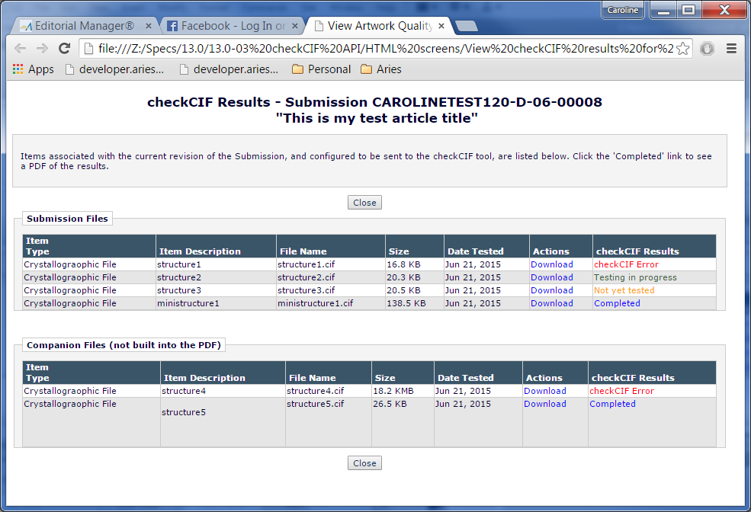

### Error Messages

Errors or deficiencies relating to the .cif structure itself are reported by the tool and included in the PDF returned to EM, so they will not display with a ‘checkCIF Error’ status in the checkCIF Results page.

Errors that occur because the process timed out, an incorrect username/password was sent, or the tool could not handle the file, will generate error message strings returned via the API. These will be accessible to Editors/Publishers on the checkCIF results page, by clicking on the red hyperlinked “checkCIF Error” string. The error message will pop up in a jquery alert box as described in section 2.13.6.

Note: the checkCIF Error string shown on the Author and Reviewer version of the page is not a hyperlink.

<passcode_message> - examples (variables preceeded by $)

 <passcode_message>Process failed: Incorrect password for user $userid </passcode_message>

or

<passcode_message>Process failed: UserID and password not given

</passcode_message>

=============================================================

<upload_message> - example

<upload_message>Upload error. A problem occurred when trying to upload the file $filename please try again.</upload_message>

=============================================================

<v.cif_message> - a stream of text giving specific information on the errors in the .cif syntax.

e.g.

<v.cif_message>ERROR: Value missing at line 67

ERROR: Number of loop elements not multiple of packetsize at line 427

</v.cif_message>

=============================================================

<output_pdf_message>No output file generated. Please try again later.

</output_pdf_message>

### Schedule Group-related checkCIF results popup

A new Schedule Group-related checkCIF Results popup window is available. It is reached when an Editor/Publisher with ‘View checkCIF Results’ permission clicks the ‘checkCIF results’ link from the *Schedule Group File Inventory* page.

1. Note: if only one Schedule Group Companion File is configured to be sent to the checkCIF tool, and that file has a checkCIF results PDF, clicking the checkCIF results link from the *Schedule Group File Inventory* page directly downloads that results PDF without navigating the user visibly to the *checkCIF Results* popup page.
2. The results popup *is* shown if only one Schedule Group Companion File is configured to be sent to the checkCIF tool, if any one of the following are true: 1) the file has not yet been sent, 2) the file has been sent and is still being tested (has a ‘Testing in Progress’ status), or 3) the file has been sent and has an Error status.
3. There is no e-mail merge field deep link to the checkCIF results page for a Schedule Group.
4. There is no Author/Reviewer view of the page, only an Editor/Publisher view of the page, (because Authors/Reviewers have no visibility to Schedule Groups). The display of the Editor/Publisher View depends on whether the Editor/Publisher has the ‘Initiate checkCIF’ permission as described in bullet 4 below.
5. The page header is “checkCIF Results – [Schedule Group Description]” – where [Schedule Group Description] is replaced with the Schedule Group description text. (Square brackets indicate text to be replaced and are not shown).
6. The page instructions are configured on the *Configure checkCIF* page in PolicyManager. They are either the default tokenized instructions or customized intructions (which are not tokenized).

[Note: a hardcoded branding message and icon may be added to the instructions – waiting on IUCr for details.]

1. For Editors/Publishers without ‘Initiate checkCIF’ permission, a Close button is shown on the top and bottom of the popup. Clicking the button Closes the popup and returns the user to the underlying page or popup.
2. If the Editor/Publisher has ‘Initiate checkCIF’ RoleManager permission, two ‘checkCIF: Selected Files’ buttons may – one above and one below the Companion Files grid (see conditions below – these are the same conditions as on the submission *checkCIF Results* popup). The buttons have the same logic as the buttons of the same name on the submission *checkCIF Results* popup.
3. The buttons are displayed only if one or more of the Companion files on the page has an error status or has not yet been tested, and the user viewing the page has an Editor or Publisher Role with the RoleManager permission ‘Initiate checkCIF’.
   1. The buttons are grayed out/disabled until one or more checkboxes in the ‘Select’ column have been selected.
   2. When clicked:
      1. The selected files are sent to the checkCIF tool via the API asynchronously, and the user is presented with a popup jquery box with the following text (This is the same text as on the submission checkCIF Results popup): The selected files are being sent to the checkCIF tool for processing. This may take several minutes to complete. When results have been returned, you can use the 'Completed' link to view the results PDF for each file.



* + 1. When the Close button is clicked on the jquery alert box, the Schedule Group *checkCIF Results* popup refreshed to show the ‘Testing in Progress’ status for the re-submitted file(s), and the ‘checkCIF: Selected Files’ button disappears, unless there are additional files that can still be selected. Note the user may want to manually refresh the window to see the new results quickly.

1. A ‘Companion Files’ grid is shown. The grid displays information about all non-Hidden Schedule Group Companion Files where the Item Type is configured as ‘Include this Item Type for checkCIF’. (Unless there is a misconfiguration, all of the Items in the grid will be .cif files.) The checkCIF results PDF (if available) is not displayed as a row in the grid but instead is downloadable from the checkCIF Results column. (Note: Schedule Groups only have Companion Files in their file inventories, so unlike the submission checkCIF Results popup, there is no ‘Submission Files’ grid). It consists of the following columns (similar to the Schedule Group File Inventory page and the checkCIF results for Submission page):
   1. Select column header and checkbox.
      1. This column is displayed only if 1) The Editor/Publisher viewing the page has ‘Initiate checkCIF’ RoleManager permission and 2) there are one or more non-Hidden Companion Files associated with the Schedule Group that are configured as ‘Include this Item Type for checkCIF’ , and have either 1) not been sent to the checkCIF tool or 2) have been sent but have an error returned from the API (and thus need to be retried).
      2. Any Items that have checkCIF results PDFS or have the status ‘Testing in Progress’ are not eligible to be re-sent to the checkCIF tool (since the results will not vary), and the Select checkbox for those items is suppressed.
   2. Sub. TOC Position column (read-only), not sortable.
   3. Submission column containing the Manuscript Number, Corresponding Author Name and country, and Submission Full title (as on the Schedule Group File Inventory page). Note that his column will be empty if the Companion File is not associated with a submission.
   4. Color column (read-only), contains a block of color if a color has been associated with the Companion file. No ‘Change color’ link is shown.
   5. Item Type column, containing the read-only Item Type name as configured on the *Edit Submission Item Type* page.
   6. Item Description column, containing the read-only Item Description as a label (not as a textarea).
   7. File name column, containing the file name of the .cif file.
   8. Size column containing the file size of the .cif file per standard EM size display.
   9. Date Tested – contains the date the file was sent to the tool, in journal-defined date format. If it has never been sent to the tool (this would be unusual), it is empty.
   10. Actions column – contains a ‘Download’ link. Clicking this link downloads the .cif file. (To download the checkCIF results PDF, the user must click the ‘Completed’ link in the checkCIF Results column.)
   11. checkCIF Results column – same display as the submission checkCIF results popup – contains one of the following checkCIF status terms:
2. If the Item has not yet been tested, and has not been manually sent to the tool, the phrase ‘Not yet tested’ is shown in orange font (the same font color used for the ‘Untested’ status on the AQC results page; this text is not a hyperlink). Note: this would be unusual, as all Companion Files configured wiwth ‘Include this Item Type for checkCIF’ should be sent to the tool when uploaded. However, this situation could occur if a publication configures an Item Type as a Companion File and also for checkCIF, but there are already Companion Files associated with this Item Type present in the publication.
3. If the Item has been sent to the checkCIF tool but nothing has been returned from the tool for this Item (or an asynch job has been created to sent this Item to the tool, and results or an error status have not yet been returned, even if it has not been actually sent yet), the string ‘Testing in progress’ is shown in green text (the same font color used for the ‘Pass’ status on the AQC results page. This item text is not a hyperlink).
   * 1. If the asynch processor reports that the API has returned an error status, the hyperlinked string ‘checkCIF Error’ is shown in red text (the same font color used for the ‘Error’ status on the AQC results page). Clicking the string pops up the error message returned by the tool in a jquery alert box (similar to the coding on the CrossCheck/iThenticate Results page). See section 2.13.6 of this spec for a list of typical error messages that will be returned from the tool.
        1. The Title of the jquery alert box is “checkCIF Error”. The standard EM red alert triangle is re-used from the Add/Edit/Remove author page and resized if necessary.
        2. The text in the alert box varies, and is shown in the body of the jquery alert box, without [ ]. (The square brackets denote text to be replaced). The red warning triangle needs to be aligned with the title bar text.



* + 1. If the API has returned the checkCIF results PDF, the hyperlinked text ‘Completed’ is shown (using the same font color as the Completed string on the CrossCheck/iThenticate Results page). Clicking the hyperlink downloads the PDF of the results as configured in the user’s browser. Note: this must also work on a mobile device, providing that the mobile device has been configured by its user to handle PDFs.

1. Close button: When the ‘Close’ button is clicked (on the page) and the ‘checkCIF: Selected Files’ button is displayed on the page (indicating that there is a file configured to go to the tool but results have not yet been received), the following jquery dialog box is displayed:
   1. Title bar: yellow warning triangle with exclamation point to be re-used from EM mobile and added to the Warning title bar (resized if necessary), followed by the text “Warning”
   2. Content of dialog box: One or more of the cif files was not checked or is in an error status. To send these files to the checkCIF tool, click the 'Return to Results Page' button below and then select the file(s) using the checkboxes and click the 'Selected File: checkCIF' button. To close this results page, click the 'Leave Results Page' button below.



* 1. If the user clicks the ‘Leave Results page’ button on the dialog box, the dialog box is closed, and the Schedule Group *checkCIF Results* pop-up window is closed. The user is returned to the calling page (the page they were on when they clicked the ‘checkCIF results’link).
  2. If the user clicks the ‘Return to Results Page’ button on the dialog box, the dialog box is closed and the user remains on the Schedule Group *checkCIF Results* popup.

1. Unlike the AQC feature, the status terms are not configurable by the journal.
2. The instructions are configurable by the journal on the *Configure checkCIF* page (see section 2.3.1.1).

Page Layout – checkCIF Results for Schedule Group

* Columns based on the Schedule Group File Inventory page and the checkCIF Results for submission page.
* There are only Companion Files in a Schedule Group, so there is no Submission Files fieldset.
* Select column and checkCIF: Selected Files buttons shown only if Editor/Publisher has permission to ‘Initiate checkCIF’, and only if there is at least one file in the status Testing in Progress, checkCIF Error or Not yet tested.
* Only Editors/Publishers can see this layout. Authors/Publishers have no access to Schedule Group pages.

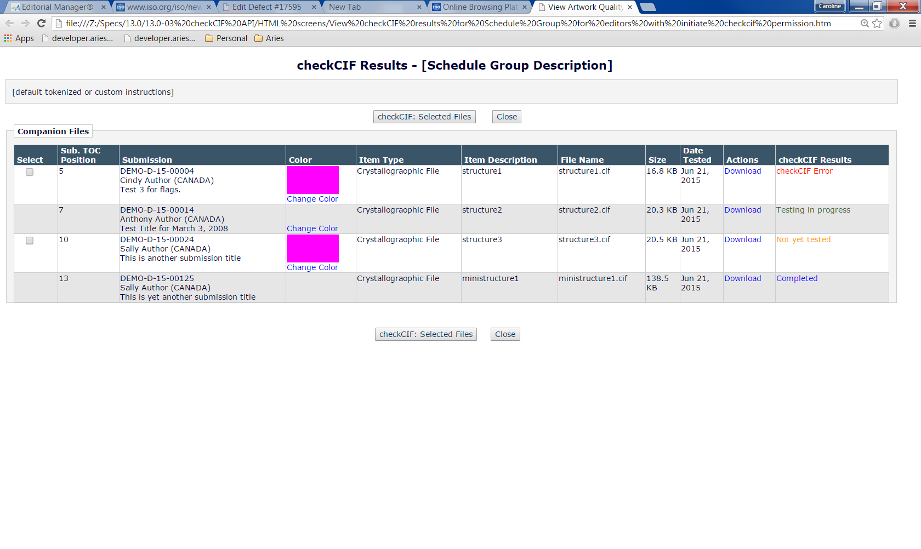

## Trigger point logic

The pages that contain the available trigger points are updated to send non-hidden/non-URL/URI/External Resource files associated with the current revision of the submission and configured as ‘Include this Item Type for checkCIF’ to the API version of the tool if 1) the file has not yet been sent to the tool, OR 2) the file has been sent but no results have been returned (because the file timed out, OR 3) the file errored out on the first try.

Refer to the technical spec for Reference Checking for a complete list of pages that are affected.

In addition, when a Companion File configured as ‘Include this Item Type for checkCIF’ is uploaded manually, the file is also sent to the checkCIF API. Refer to section 2.12 of this specification for more information.

## AdminManager

### File Transfer Statistics results page

This existing *File Transfer Statics* [results] page [admin/getFileStatistics2.asp] is reached when a SysAdmin user clicks the View File Transfer Statistics link on the AdminManager Main Menu to navigate to the *File Transfer Statistics* selection criteria page, then selects a date range and clicks the Submit button on the selection criteria page.

1. The results page is modified in this specification to include a grid capturing the number and size of files sent to, and received from, the checkCIF tool during a specified date range.
   1. The date range is specified on the *File Transfer Statistics* selection criteria page [admin/getFileStatistics.asp]. The selection criteria page is unchanged in this specification.
2. Logic that records file traffic must be enhanced to capture file traffic generated by the checkCIF API added in this specification. The traffic to and from the tool is counted. *Engineering note: if it is difficult to divide into a ‘to’ bucket and a ‘from’ bucket, the traffic can be combined into one statistic – please contact Product Management in this case to obtain a revised screen shot.*

Page Layout #18 – File Transfer Statistics (results page)

* New ‘checkCIF Transfers’ grid added. Shown in pink, to be coded in default font.

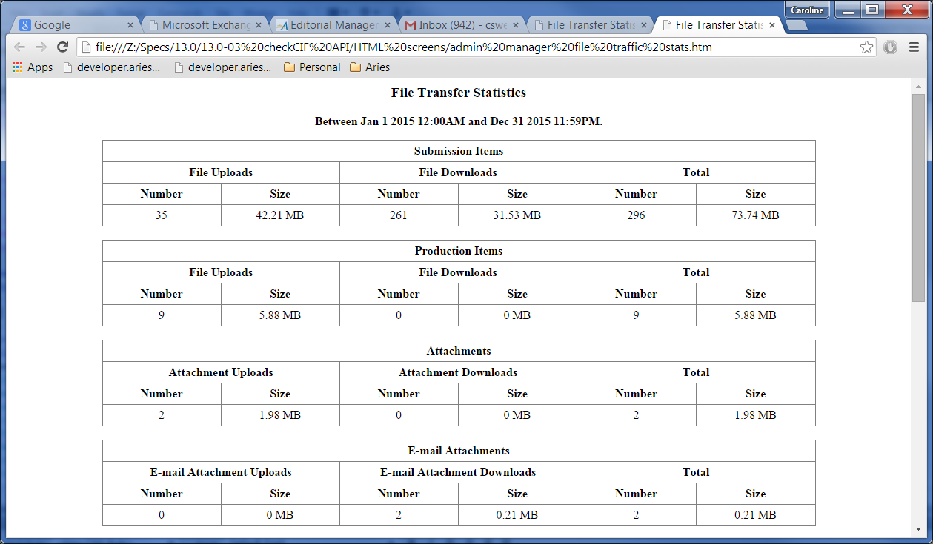

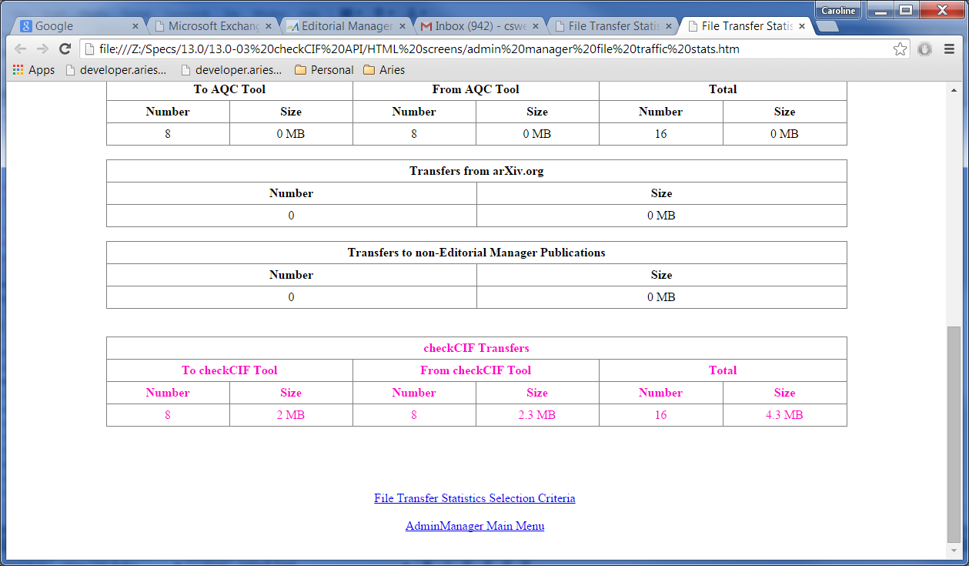

## EMIA (Editorial Manager Internal Administration)

### Quick and Dirty Reports – Setup

This page [qdStats72.asp] is reached when an Aries internal user clicks the ‘Quick and Dirty Statistics (7.2)’ link from the Editorial Manager Internal Administration (EMIA) main page.

1. A new ‘checkCIF Requests and Traffic’ checkbox is added. This reflects an additional column added to the results to display the volume of data transferred to the checkCIF tool and received back from the checkCIF tool.

Page Layout #19 – Quick and Dirty Statistics selection criteria page

* checkCIF Requests and Traffic checkbox added, shown in pink, to be coded in default font.

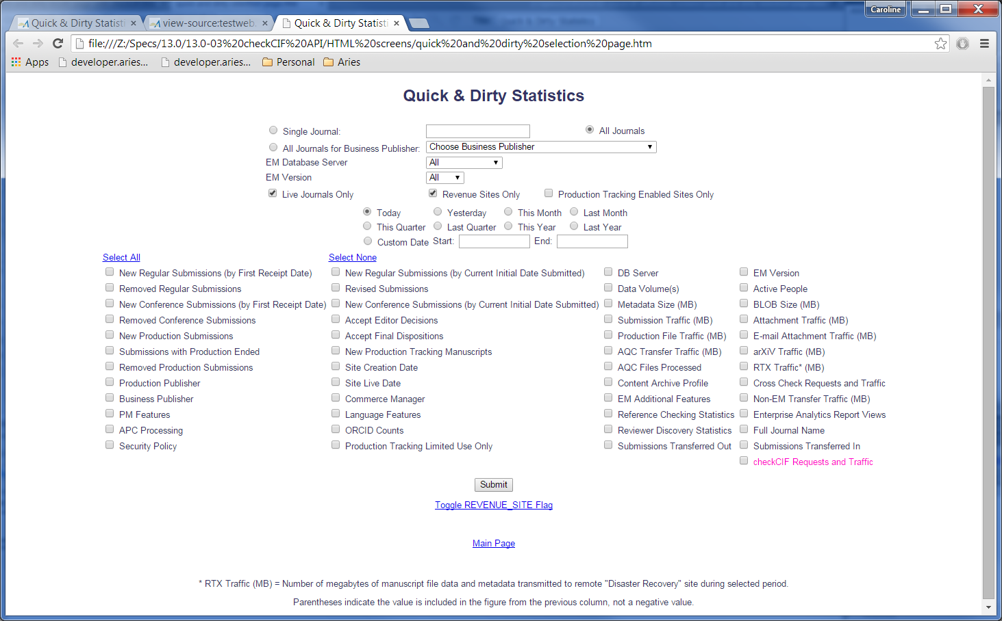

### Quick and Dirty Reports – Results

1. If the user has selected the new ‘checkCIF Transfer Traffic’ checkbox:
   1. Three columns) are inserted into the results.
      1. The first column is headed ‘checkCIF Enabled’ – displays 1 for true and 0 for false. Note: the checkCIF feature is enabled in PolicyManager, Configure checkCIF, and is set to selected by the upgrade script. A Grand Total is displayed for this column at the bottom of the results. Note: this is shown by default if the user has selected ‘checkCIF Requests and Traffic’ on the selection criteria page – i.e. there is no output selector on the criteria page for this column.
      2. The second column is headed ‘checkCIF API File Transfers’.
         1. This displays a count of the individual files transferred to checkCIF via the API in the time period.
         2. This is the same calculation used for the ‘Number’ column in the AdminManager>File Transfer Statistics report (section 2.16.1).
         3. A Grand total is displayed for this column.
      3. The third column is headed ‘checkCIF API Traffic MB’.
         1. This contains the total amount of data transferred automatically to and from checkCIF by EM (whether in response to an API call from a trigger point, or uploading a Companion File, or clicking the Re-send button on the checkCIF results page, for the publications and time period defined in the report setup page. Note: manual triggering of files to checkCIF uses the API, so both manual and automatically triggered checkCIF transfers are counted in the same “bucket”.
         2. This is the original file size and encoding used in the API transfer - the same calculation as used for the ‘Size’ column in the AdminManager>File Transfer Statistics report (section 2.16.1).
         3. This is expressed in the same units as all other traffic results in this report.
         4. A grand total is displayed for this column.

Page Layout #19A – Q&D Report Results

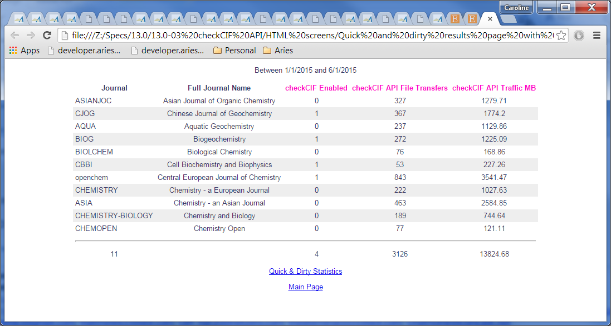

## Hosting Administration

No impact. This feature is not configured in HA.

# Database Impact

## DB Content Changes

To be added once tech spec is received.

## UDB Impact

*Considerations: Do new fields need UDB-Only DB Content?*

# Multi-Lingual Considerations

Error messages returned from the tool are in English, and are not tokenized.

* Default instructions for the checkCIF results page are tokenized.
* Page instructions on the Configure checkCIF PolicyManager page are tokenized.

# Performance Processing Impact

*Consideration guidelines:*

* *1,000,000 submissions per year*
* *5,000,000 people records*
* *NOTE: Expectation that all testing be on PONECLONE*

## Performance Requirements

### Data Server

### Web Server

### Network

### Client Machine

## Engineering Assessment

### Engineering Test Results

# Merge Field Impact

A new %CHECKCIF_RESULTS_PDF% merge field is added, for use with submission-related e-mails. Its behavior is similar to the %VIEW_REVIEWER_PDF% merge field and the %REFERENCE_QC_RESULTS_ALL% merge field. This merge field is used to provide the recipient with a direct link to the checkCIF results for a submission. There is no deep link merge field related to the checkCIF results for a Schedule Group.

1. If there is only one file associated with the current revision of the submission that is configured as ‘Include this Item Type for checkCIF’, and this file has a checkCIF results PDF, clicking this deep link from the e-mail automatically downloads the checkCIF results PDF for that file, without navigating the user to the EM system (similar to the behavior of the link created for the %VIEW_REVIEWER_PDF% merge field).
2. If there is more than one file associated with the current revision of the submission that is configured as ‘Include this Item Type for checkCIF’, clicking the link from the populated merge field navigates the user to a window where the checkCIF results page is displayed (similar to the behavior of the %REFERENCE_QC_RESULTS_ALL% merge field). The user is not logged in and there is no navbar or buttons to login to the system.
   1. If there are no results PDFs available, the page instructions are suppressed and the message “No results are available.” is shown. See page Layout #20
      1. The manuscript # is listed in the page header. If there is no manuscript number yet associated with the submission, the manuscript number is suppressed. The article title is shown in double quotes.
   2. If there are one or more results PDFs available, the Items associated with the current revision of the submission

Page Layout #20 – no results available

* The warning message is shown in <div class="warningbox" style="padding-top:10px; text-align: center;">
* No navbar is shown
* No buttons are shown in the window.

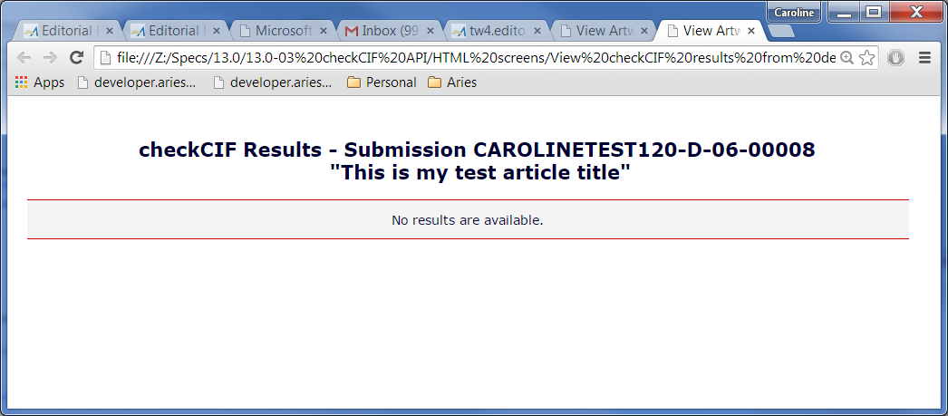

Page Layout #20A – multiple files configured to be sent to checkCIF tool

* This version of the window is shown if there are multiple submission items associated with the current revision of the submission and at least one item has a checkCIF results PDF (i.e. the checkCIF Results column contains “Completed”)
* Same as the Author/Reviewer version of the page accessed from with EM except:
  + No navbar is shown
  + No buttons are shown in the window.
  + The ‘Action’ column providing access to the source file is suppressed.
* The Completed link downloads the Results PDF

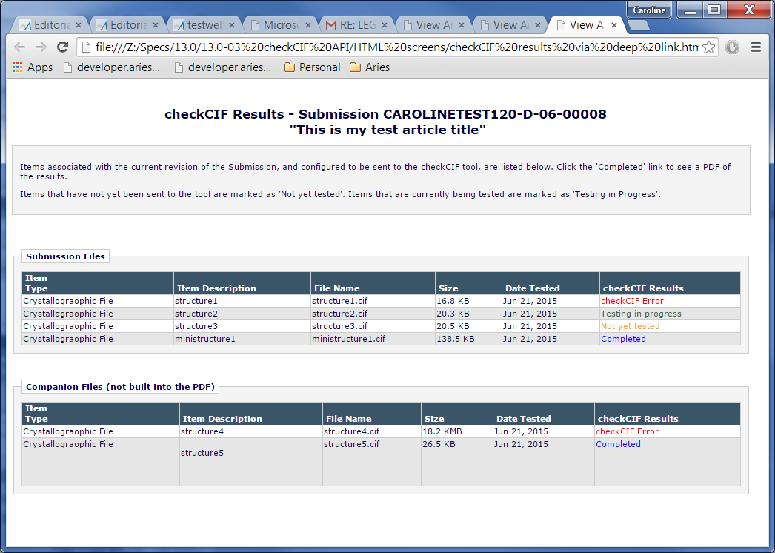

|  |  |  |  |  |  |  |  |  |  |
| --- | --- | --- | --- | --- | --- | --- | --- | --- | --- |
| Merge Code | Spec Introduced | Description | Information Pulls From | Workflows | Merge into Customize? | Merge into Preview? | Merge into  Letter? | Special Formatting? | Special Rules |
| **%CHECK_CIF_RESULTS_PDF%** | 13.0-03 | This merge field has 2 behaviors: 1) if only one file associated with the current revision of the submission is configured to be sent to the checkCIF tool, and this file has a checkCIF results PDF, the link downloads the checkCIF results PDF. Or 2) if there are multiple files associated with the current revision of the submission configured to go to the checkCIF tool, provides a standalone window displaying the checkCIF results page (Author/REviewer view, without navbar or buttons). The user is not logged in. | Deep link created that leads to the checkCIF results page for that submission; if a single file is configured to go to the tool and has results, directly downloads the results PDF without making the results page visible to the end user | All submission-related letters. Same as %REFERENCE_QC_RESULTS_ALL% | NO | In Preview mode, it returns a version of the link to use when previewing a letter. The link text is retrieved from the DEEPLINK_TYPE table, but the href value is ‘#’ so that it looks like a link but is a no-op if the user clicks it. A DEEPLINK record should not be created for a letter preview. | Yes | In an HTML Formatted letter appears as the hyperlinked text View checkCIF Results | Displays as *** in CC and BCC letters |

# Upgrade Script Impact

The API URL, username and pw for the API must be added. A different username and password is used on testweb and QA vs. production sites. Production sites should be enabled with the production username and password as obtained from the IUCr.

* Default instructions are added on upgrade.
* Enable checkCIF checkbox selected at upgrade.
* Workflow trigger point “Original PDF Building by Author” selected at upgrade.

# Site Cleanout

When submissions are cleaned out of a site, the checkCIF Results PDFs must be removed from the BLOB database, and all metadata pertaining to the checkCIF results must be removed from the journal metadata database.

Existing coding removes the .cif files and metadata pertaining to the .cif files.

# Report Implications

## Canned Reports

## General Data Export

## Custom Reports

## Enterprise Analytics Reporting

*Describe any or all of the following:*

* *New tables to be added to the Data Sources tab*
* *New views to be added to the data sources tab*
* *New standard EAR reports, and which category they fall into*
* *Impact on scheduling or emailing of EAR reports*

## Cross-Publication EAR

# Hosting Documentation Impact

# Portal (IJRS,etc.) Impact

# Sys Admin Audit Trail

*Any changes made to the PolicyManager, RoleManager, ActionManager and AdminManager code should include invocation of the Audit Trail code module to ensure that appropriate data about administration changes are recorded to the Audit Trail.*

# Import/Export Impact

*Should consist of elements/data 1) that would need to be added to the generic Aries Export schema/XML and/or 2) available for Aries import and added to the “Select Fields for Import” page and Aries Import schema and script.*

## Transmittal Impact

None. Including the checkCIF Results PDF in a transmittal is a future enhancement.

## Aries Export Impact

## Aries Import Impact

# Transfer Impact

When a submission is transferred EM to EM using the direct database to database transfer, .cif files will be transferred per existing coding. New in this spec, any checkCIF results PDFs associated with the transferred .cif files are also transferred.

# Cross-Publication Impact

*Anything not covered in the reporting section (i.e. journal acronym change, cross-pub login, consideration for additional use cases, etc.)*

# Documentation and Training

# Operations’ Considerations

## Journal Rename

If a journal is renamed, the journal name sent in the API message will change. Statistics held by the IUCr may need to be combined with those under the journal’s prior name. Customer service should ask the journal to inform IUCr.

## Journal Redirects

There must be no impact from a journal redirect.

# Utilities

*Consider any or all of the following with Engineering consultation:*

* *UDB Utility*
* *Upgrader*
* *IJRS Sync Tool*
* *Deleter*
* *Cloner*
* *Migrator*
* *Translation Utility*

# Audit/Monitor/Diagnostics

*Used when going out to a 3rd party system to detect if the system is up. Add to an existing “Tembria dashboard”; indicate who should get e-mail notices if 3rd party goes down.*

The checkCIF API is a third part system, so must be added to the Tembria dashboard.

# Journal Configuration

## Hosting Administration – Set Journal Features

1. One existing checkbox must be enabled:
   1. Enable Author Supplementary Materials (to allow Authors to upload files in .cif format).
      1. Currently files in .cif format cannot be uploaded into EM journals, unless the submission Item they are associated with is a Companion File or a file in the Supplementary Family.
      2. A Submission Item can only be assigned to the Supplementary Family if the ‘Enable Author Supplementary Materials’ checkbox is selected on the *Set Journal Features* page.

## PolicyManager

### Configure checkCIF

1. Ensure that the ‘Enable checkCIF’ checkbox is selected.
2. Ensure that one or more workflow trigger points are selected.
3. Configure customized instructions (if desired).
4. Submit the page.

### Add/Edit Submission Item

1. To have the .cif file downloadable from the PDF via a link: Configure a Submission Item in the Supplemental family, give it a PDF handling method of “Build Hyperlink to file in PDF’, and select the new ‘Include this Item Type for checkCIF’. Note: if this checkbox is not visible, ensure that the ‘Enable checkCIF API’ feature is selected in PolicyManager, Configure checkCIF.
2. A .cif file can also be configured for use as a Companion file, which is not built into the PDF, but are typically used for Production. To configure an Item Type as a companion file, select ‘Companion File (not built into PDF)’ from the drop-down list, and also select ‘Include this Item Type for checkCIF’.

## RoleManager

1. Configure each desired role with the new RoleManager permission ‘View checkCIF Results’. Note: if this permission is not visible, ensure that the ‘Enable checkCIF API’ feature is selected in PolicyManager, *Configure checkCIF*.
2. Configure desired Editor/Publisher Roles with the new RoleManager permission ‘Initiate checkCIF’.

# Style Sheet impact

No new styles added.

# Deployment Considerations

## Associated Revenue Model

## Sales and Marketing Rollout Anticipation

## Customer Service Rollout Preparation

## Release Target

Version 13.0.

# Possible Future Development

1. The checkCIF Results link maybe be added to:
   1. The *Invite Reviewers* and *Submit Editor’s Decision* page..
   2. The following Editor folders:
2. Submissions Sent Back to Author for Approval
3. Submissions needing Approval by Editor
4. Incomplete Submissions
5. Editors Invited – None yet Assigned
6. Submissions with Rescinded Decision
7. Submissions with Required Reviews Complete
8. Submissions Requiring Additional Reviewers
9. Submissions with One or More Late Reviews
10. Submissions with Active Discussions
11. Reviewers Invited – No Response
12. Submissions Under Review
13. My Assignments with Decision
14. My Assignments with Final Disposition
15. Any folder under Subordinate Editor’s Pending Assignments
16. The checkCIF results PDF may be available:
    1. On the transmittal form, as selectable items for Editorial Transmittal.
    2. For Submission Production Task Assignment.
    3. For Schedule Group Production Task Assignment.

### Possible Future Development - Add/Edit Submission Production Task

Note: this section was moved from current to Future Development in version 7 of this spec.

To allow automatic assignment to occur, Submission Tasks must be configured to be automatically assigned by selecting the existing checkboxes ‘Assign Automatically when Production is initiated (if this is the first task in the workflow)’ or ‘Assign Automatically when all Trigger Tasks are completed (if configured in the workflow)’, AND ‘Automatically Select Files for Assignment’ AND selecting one or more Item Types from the multi-selector box of Item types associated with the ‘Automatically Select Files for Assignment’ parameter.

New in this spec, a new checkbox labelled ‘Automatically assign checkCIF results PDFs when .cif file is assigned’ is indented under ‘Automatically Select Files for Assignment’, if the publication has ‘Enable checkCIF’ selected in PolicyManager. Note: at upgrade all journals have ‘Enable checkCIF’ selected.

1. The checkbox is grayed out/disabled unless the ‘Automatically Select Files for Assignment’ checkbox is selected.
2. When the ‘Automatically Select Files for Assignment’ checkbox is selected, the ‘Automatically assign checkCIF Results PDF….’ Checkbox is available for selection, but not default selected.
3. When this new checkbox is selected, checkCIF results PDFs are automatically included in the Assignment Files for the task when it is assigned and the file that was sent for CIF checking itself is an Assignment File.
   1. If the task is FTP’ed and this new checkbox is selected, and the .cif file is an Assignment file, the checkCIF results PDF for each .cif file is included in the zip file FTP’ed to the recipient FTP server.
   2. Note: it is possible there is no checkCIF results PDF associated with the .cif file. This is not an error condition and coding should take this into account.
4. Validation is added to the Submit button as follows:
   1. If the new ‘Automatically Assign checkCIF Results PDFs….’ Checkbox is selected, but none of the Item Types selected in the multi-selector box are configured as ‘Include this Item Type for checkCIF’, this is a configuration error and the SysAdmin user is presented with an alert box with the following text (note: horizontal lines not included in the alert text):

Please select at least one type of file that is configured to be sent to the checkCIF tool under the 'Automatically Select Files for Assignment' Option, or unselect the checkbox 'Automatically Assign checkCIF Results PDFs when .cif file is assigned'.

OK

See section 2.10 of this spec for more information about the Submission Production Task Assignment process.

Page Layout #21 – Add/Edit Submission Production Task Assignment

* Checkbox and label added: Automatically assign checkCIF results PDFs when .cif file is assigned
* Checkbox default unselected, and grayed out/disabled unless the ‘Automatically Select Files for Assignment’ checkbox is selected.

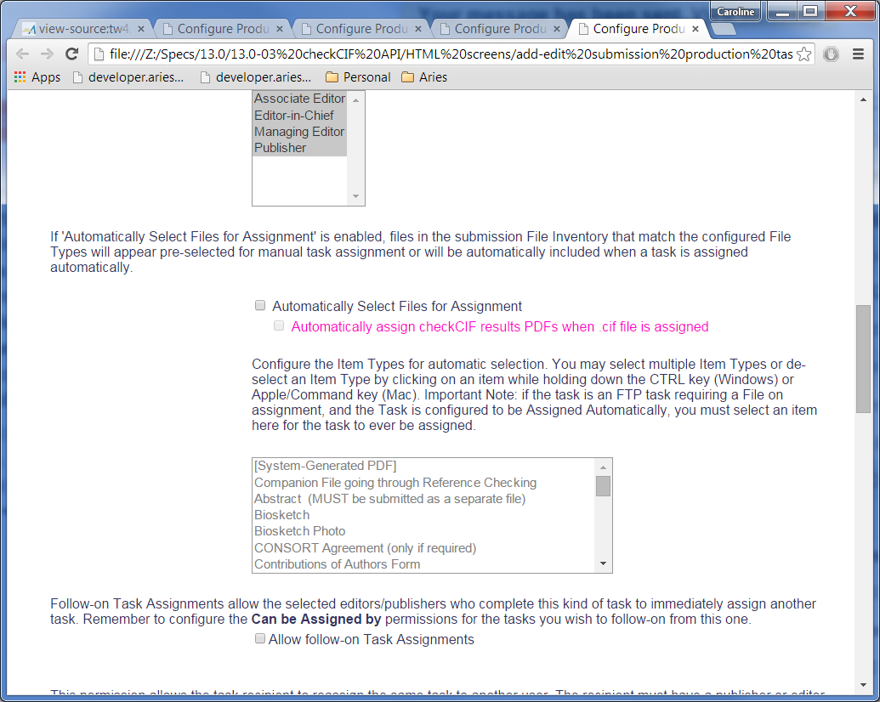

### Batch Assign Production Task

This existing page [BatchAssignSubmissionTaskCustomize.aspx] is reached (in current coding) when:

1. An Editor searches for submissions from ‘Search Submissions’ on the Production Tasks menu, or switches to the Production View when searching submissions from the Editor Main Menu [on a site with Production Tracking enabled].
2. Selects one or more submissions using the checkboxes in the leftmost column, then clicks the Batch Assign Production Task button to be navigated to the *Batch Assign Production Task* page [BatchAssignSubmissionTask.aspx].
3. Selects a task from the Production Task: drop-down, and a person from the Task Assigned to: drop-down and clicks the ‘Proceed with Selected Task’ button.
4. Expands the Assignment Files grid by clicking the + sign for each Submission listed in the Allow Download column (or alternatively clicking the ‘Expand All’ link above that column).

New in this spec, similar to new coding added by this spec for the *Assign Production Task and Assign Schedule Group Production Task* pages:

1. If a .cif file is shown in the Assignment Files grid, its associated checkCIF results PDF (if any) is shown as a sub-row of the parent .cif file, in italicized text.
   1. The File Name displays as returned from the checkCIF tool (unless it needs to be renamed, TBD in the tech spec).
   2. If a checkCIF Results PDF is present for one or more .cif files in the grid, the QC results column is displayed; existing logic is modified as follows:
      1. In addition to existing examination of AQC and Reference Check configurations, the logic must also examine whether there is a checkCIF Results PDF associated with any file in the grid – if yes, the QC Results column header is displayed. Therefore the QC Results column can now be displayed even if Reference Checking and AQC are not enabled for the journal, as long as there are one or more .cif files with checkCIF results PDFs displayed in the grid.

Note: Schedule Group tasks cannot be batch assigned.

Page Layout # 22 – Batch Assign Submission Production Task

* Partial page shown (expanded Assignment Files grid)
* checkCIF results information shown as a sub-row of its parent .cif file.
* Text relating to the checkCIF results file shown in pink and italicized; to be coded in EM Standard italicized font.
* The checkCIF Results string shown in the QC Results column is hardcoded (and tokenized).

### Add/Edit Schedule Group Production Task

There is no change to the PolicyManager page *Add [or Edit] Schedule Group Production Task* in this spec. Business Logic: There is no ability to automatically assign Schedule Group Production tasks; therefore all Assignment File selection for a Schedule Group task is manual, and no configuration options are needed to automatically select a checkCIF results PDF, since the .cif file itself cannot be automatically selected. If the ability to create workflows and automatically select assignment files for Schedule Group Tasks is added in the future, checkCIF results PDFs must be considered.

There *is* a change to the manual assignment of Companion Files for Schedule Group Tasks (see section 2.11 of this spec).

### Add/Edit Article Type

1. To display the .cif file on the Transmittal Form, the checkbox ‘Publisher Gets File’ must be selected under ‘Submission Item Parameters’, for each Item Type to be displayed on the transmittal form.

## Possible Future Development - Assign Submission Production Task

In current coding, when a Submission Production Task is assigned, the assigning Editor can select ‘Assignment Files’ to be made available to the task assignee, for download within the system or for FTP within a zip file. The Assignment files are selected from a list of Submission Files and Companion Files associated with the submission. If a file has been processed through Reference Checking, it may have some associated ‘marked-up’ or ‘cleaned-up’ Word results files associated with it. These ‘marked-up’ and ‘cleaned-up’ files are not available in the ‘Submission Files’ grid, because the Author or Editor can elect to completely replace the original submission file with the referenced-checked file as part of the editorial workflow.

New in this spec, the PDF results file returned from the checkCIF tool is listed in the Submission Files grid and/or Companion files grid, associated with its related .cif file, and is available for selection as an Assignment File.

1. The checkCIF results PDF is not separately selectable as an Assignment file - i.e. the parent .cif file must be selected first.
   1. If the parent .cif file is not selected, the checkCIF Results PDF checkbox is grayed out and disabled.
   2. The checkCIF results file is not automatically selected when the parent .cif file is selected.
   3. If the parent .cif file has been selected, and the checkCIF Results PDF is then (manually) selected, and the user then unselects the parent .cif file, the checkCIF results PDF checkbox is automatically unselected, nulled out and grayed out. (i.e. unselecting the parent .cif file also unselects and disables the checkbox for the checkCIF results PDf associated with that file).
2. If the .cif Companion file is Hidden, using the ‘Hide’ link, the associated results PDF is also Hidden.
   1. Current coding on this page suppresses hidden Companion Files on this page (instead of showing them in a ‘Hidden Companion Files’ grid). This coding is unchanged in this spec, and the associated checkCIF results PDF is also suppressed on the page. If the results PDF was selected using the checkbox, the checkbox is cleared when the parent .cif file is Hidden.
3. When a new Companion File (configured as ‘Include this Item Type for checkCIF’) is uploaded using the ‘Upload New Companion File’ button, the Companion file is added to the Companion files grid along with its results file (if available).
   1. The checkCIF API is automatically triggered on the *Upload Companion File*  popup (see section 2.12 for information on the ‘Upload Companion Files’ page).
4. If one or more checkCIF results PDFs are displayed in a grid, the QC Results column is displayed in that grid. This is new coding adding by this spec; current coding displays this column only if files have Reference Checking or AQC results.
   1. The ‘QC Results’ column displays the hardcoded text ‘checkCIF Results’ for the checkCIF results files. Note: existing coding displays the text “N/A”, Tested, etc. relating to AQC results and Reference Checking Results. The text relating to Reference Checking and AQC results is unchanged in this specification. The same file will not have both checkCIF results and other quality results. Note: the default text N/A shown when a file has not gone through AQC is suppressed for the checkCIF Results PDFs.
5. For automatic task assignment, a new checkbox is added to the *Add/Edit Production Task* page to allow the journal to configure whether the results PDF is sent along with the .cif file if the .cif file is sent automatically (see section 2.3.5 of this spec).

potential design layout.

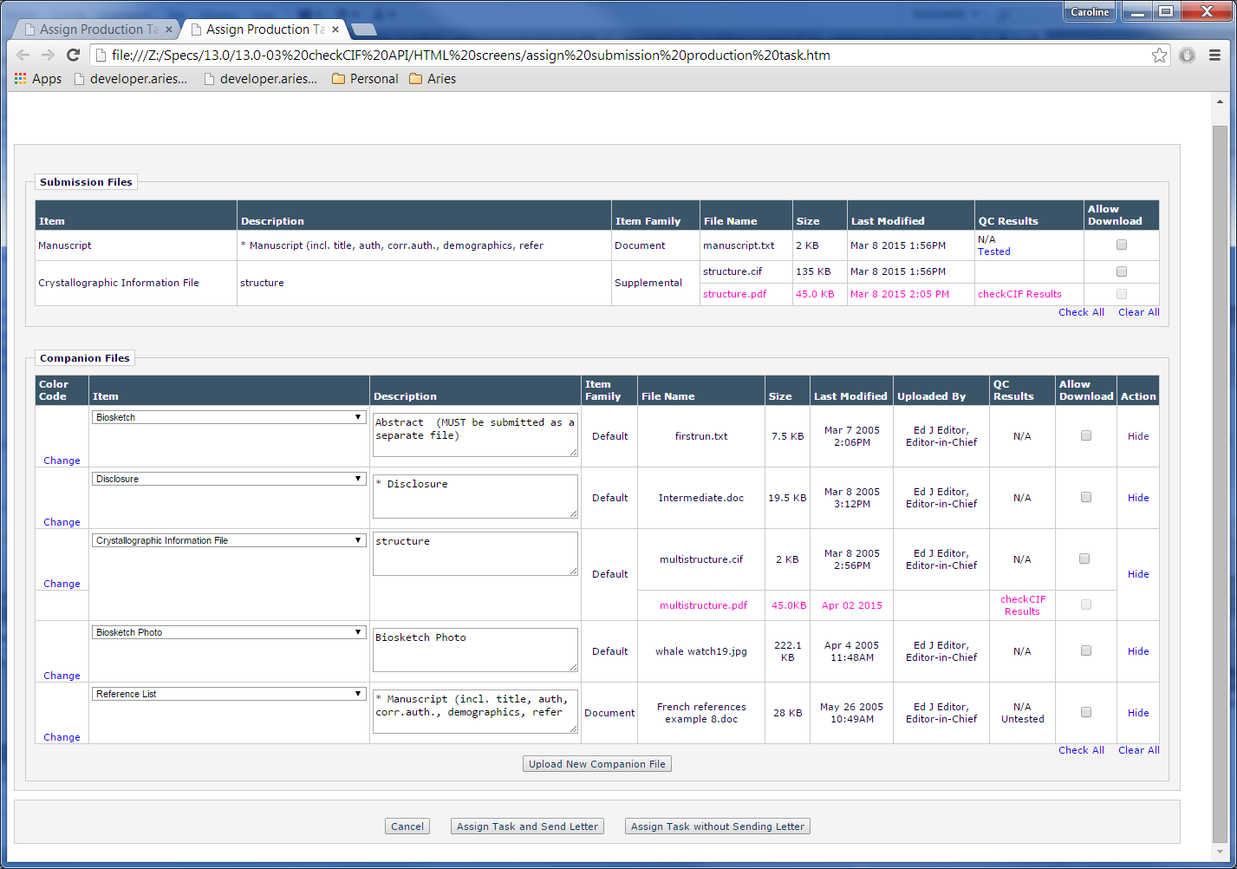 Page Layout #23 – Assign Submission Production Task

* Partial page shown.
* The file information for the checkCIF Results PDF is shown directly underneath the name of the related .cif file in the Submission Files and/or Companion Files grid (shown in pink, to be coded in default font – not a link). Note: in the page layout the tag rowspan="2" was used in the table.
* A checkbox is added to the ‘Allow Download’ column in the row related to the checkCIF Results PDF. It is default unselected, and is not automatically selected when the related .cif file is selected. When selected, the checkCIF results PDF is included as an Assignment File (and FTP’ed if the task is configured for FTP).
  + The checkbox for the checkCIF Results PDF is unselected/grayed out/disabled until the parent .cif checkbox is selected, when it changes to selectable (but unselected until the user manually selects it).
  + If the user unselects the parent .cif file, the checkCIF Results PDF returns to unselected/grayed out/disabled.
* The QC results column is displayed if a checkCIF results PDF is shown in the grid, with the hardcoded text “checkCIF Results” in the row related to the checkCIF Results PDF.

## Possible Future Development – Assign Schedule Group Production Task

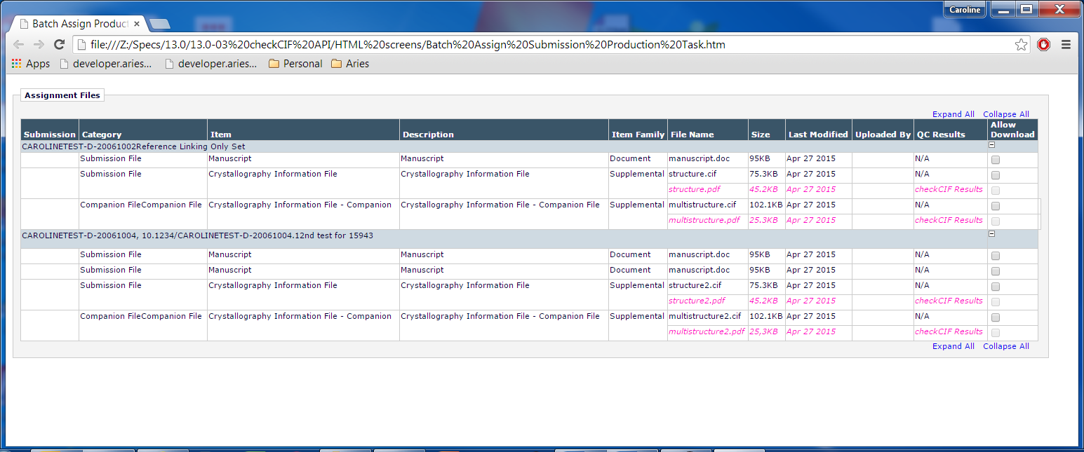

## Possible Future Development – Transmittal Form

In current coding, a file is displayed on the transmittal form if 1) it is a submission file associated with the current revision of the submission, or 2) it is a Companion file associated with the submission [Companion files are not associated with specific revisions of the submission], and 3) its Item Type has the ‘Publisher Gets File’ checkbox selected on the *Edit Article Type* page, for the Article Type associated with the submission.

Two variants of a file containing references (a “marked-up” and “cleaned-up” file) may be returned by the Reference Checking tool (depending on Reference Checking configuration). If returned, they are available on the Transmittal Form and listed in the same cell as the reference checked file. The column ‘Include Item in Transmittal’/(alternate column name ‘Include Item in Publisher Zip File’) contains checkboxes to allow the transmittal (or inclusion in the Publisher Zip file) of all three files – the original Reference Checked File, the Cleaned-up Item and the Marked-up Item. (See screen shot below for an example). Note: the checkboxes are displayed only under certain conditions, unchanged in this spec. If the transmittal form cannot be released by the user, checkmarks are displayed instead.

This current coding relating to Reference Checking results files can be used as a model for the checkCIF results PDF returned by the checkCIF tool and associated with a base file configured as ‘Include this Item Type for checkCIF’.

Page Layout #24 – Transmittal Form with Reference Checking Results

* Current coding – the ‘cleaned-up’ and ‘marked-up’ reference checking results files associated with the original Word file are downloadable from the same ‘Actions’ cell as the original base file.
* A checkbox is displayed in the ‘Include Item in Publisher Zip File’ / ‘Include Item in Transmittal’ column for each file – the original file and the two results files.

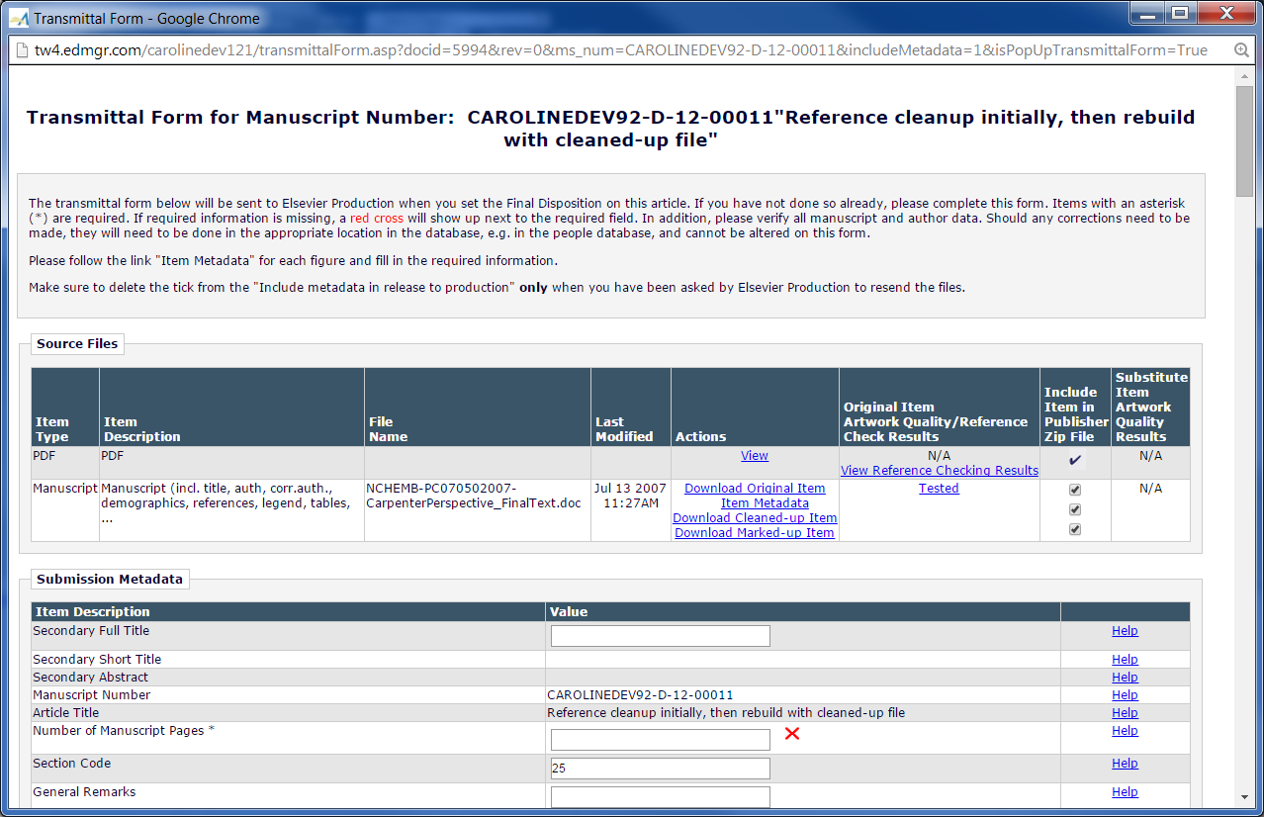

Per current coding for Submission Items sent through Reference Checking, extended to .cif files in this spec:

1. .cif files whose Item Type is selected as ‘Publisher Gets File’ for the Article Type associated with the submission are displayed on the Transmittal Form (in either the Source Files or Companion Files section, depending on the PDF Handling choice on the Edit Submission Item Types page).
2. A checkbox is displayed in the ‘Include Item in Publisher Zip File’/ ‘Include Item in Transmittal’ column for the .cif file. It is default selected. Note: if the user viewing the transmittal form cannot release it under current logic, the checkboxes are replaced by checkmarks – existing coding extended to the checkCIF results files and results PDFs in this spec.
3. The .cif file is downloadable via the existing ‘Download Original Item’ link (existing coding).
4. New coding: ‘Download checkCIF Results’ listed as a separate link underneath the Download Original Item link for the .cif file (if the Item has a results PDF). Clicking this link downloads the results PDF for the file.
5. An checkbox for the checkCIF results PDF associated with the .cif file is displayed in the ‘Include Item in Transmittal/Include Item in Publisher Zip File’ column, default selected. Note: if the user viewing the transmittal form cannot release it under current logic, the checkboxes are replaced by checkmarks – existing coding extended to the checkCIF results PDF in this spec.
6. If the .cif file’s Item Type is configured for Item Metadata, an ‘Item Metadata’ link is displayed. The Item metata is not downloadable via separate link, but in some cases is included in the XML file created for an editorial transmittal.

Page Layout #25 – Transmittal Form

* Download checkCIF Results link added for Items that have a results PDF from the tool. When clicked, downloads the results PDF.
* Checkbox added to the ‘Include Item in Transmittal/Include in Publisher Zip File’ column, default selected, for the results PDF, if a checkbox is shown for the .cif file. Note: if there is no results PDF, this checkbox is not displayed. If a checkmark is shown for the .cif file, a checkmark is also shown for the results PDF (if it exists). Note: the alignment in the screenshot is not correct – the checkbox should be on the same row as “Download checkCIF results”, not on the same row as “Item Metadata”.
* Note: if the Companion Files grid is shown, and the cif file is a Companion File, the same links and checkbox (or checkmark) are shown for each CIF file and CIF results file as in the Source Files grid.
* New link shown in pink, to be coded in default link font for the page.

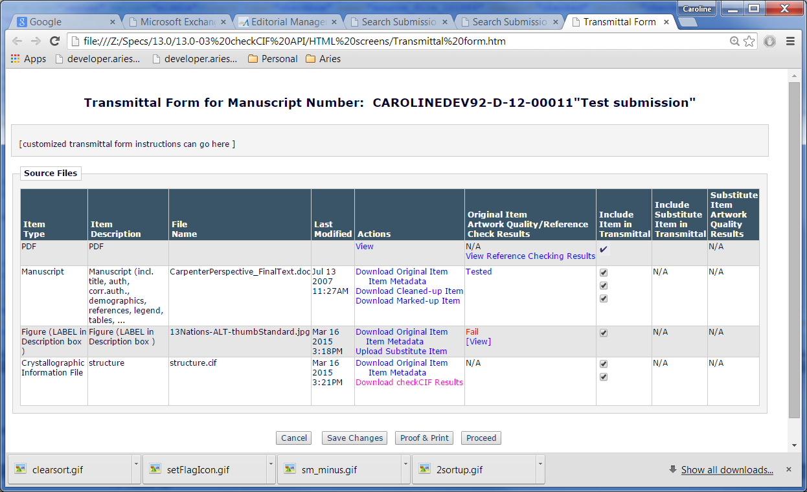

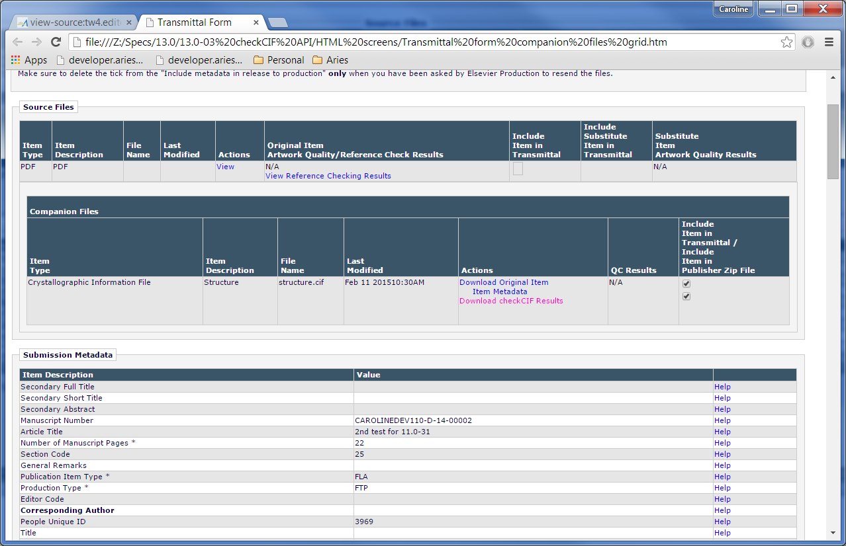

### Transmittal Form Proof and Print page

As per existing coding, no download links or checkboxes are shown on this page, therefore there are no changes to this page in this spec. The .cif file will appear on this page if it is configured to appear on the Transmittal Form (Publisher gets File = TRUE).

1. If Item metadata is configured to appear for the .cif file, it is shown inline on the Poof and Print page (existing coding).
2. The checkCIF Results PDF does not appear on this page.
3. If the QC Results column is shown (this depends on whether AQC is enabled for the journal), the text N/A is not shown for the .cif file, as the user may confuse the presence of AQC results with checkCIF results.

Page Layout # 25A – Transmittal Form Proof and Print

* checkCIF Results PDF not shown (per current coding for Marked-up and Cleaned-up Reference checked files)
* Item metadata configured for .cif file shown inline (per current coding for all other Items)

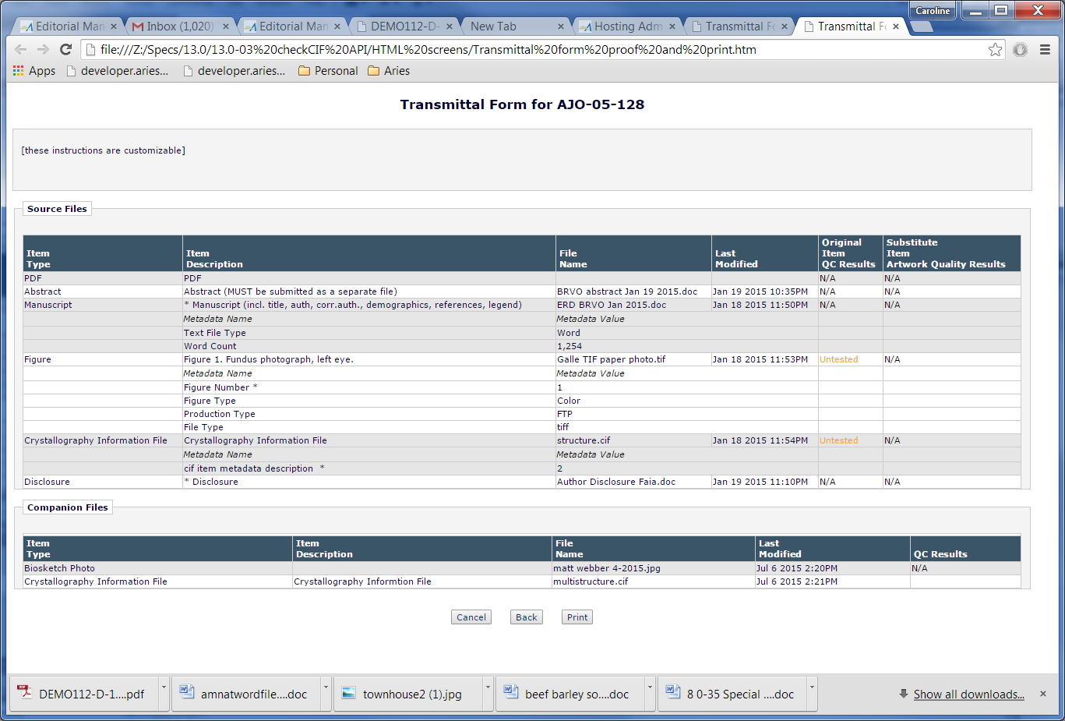

### Possible Future Development – E-mail Attachments

The existing ‘Add/Change Attachments’ popup is reached when a user in the process of customizing a letter clicks the ‘Add Change Attachments’ button on any of the *Customize Letter* pages where this button is displayed, and expands the section ‘Add Files from Submission Inventory’.

1. New in this spec, the checkCIF results PDFs are added below their associated Submission Item, with their own ‘Select’ checkbox.
   1. The following columns are shown for each checkCIF results PDF that is associated with a Submission Item shown on the page (note: the submission item may be a Submission File, Companion File, or Schedule Group Companion File):
      1. Select (contains a checkbox unselected by default)
      2. File Name (as returned from the checkCIF tool – typically the name of the .cif file with a .pdf extension instead of a .cif extension – if this causes a conflict with the separate PDFs built for the EM system PDF this file can be renamed (TBD in tech spec).
      3. Size [of the results PDF file]
      4. Last Modified date [of the results PDF file, in journal-defined date format]
   2. If there is no results PDF for the .cif file, the entire results PDF row is suppressed, but the row containing the .cif file is retained.

Page Layout #25– Add/Change Attachments

* checkCIF results PDF information shown indented and in italics under each .cif file, where a results PDF is present
* New information shown in pink, to be coded in standard EM italic font.
  + File name is variable and reflects the actual results PDF name [note: if this conflicts with an EM PDF file, it may be renamed on its return from the API, TBD in the tech spec]. Indented and shown in italics.
  + Description is hardcoded as ‘*checkCIF results’*, indented and shown in italics.
  + Item column is empty. This is not an EM Submission Item so has no Item Type.
  + Size and last modified reflect the actual size and return date of the checkCIF results PDF. Shown in italics. Date uses the Journal Defined date format (as with other dates on the page).

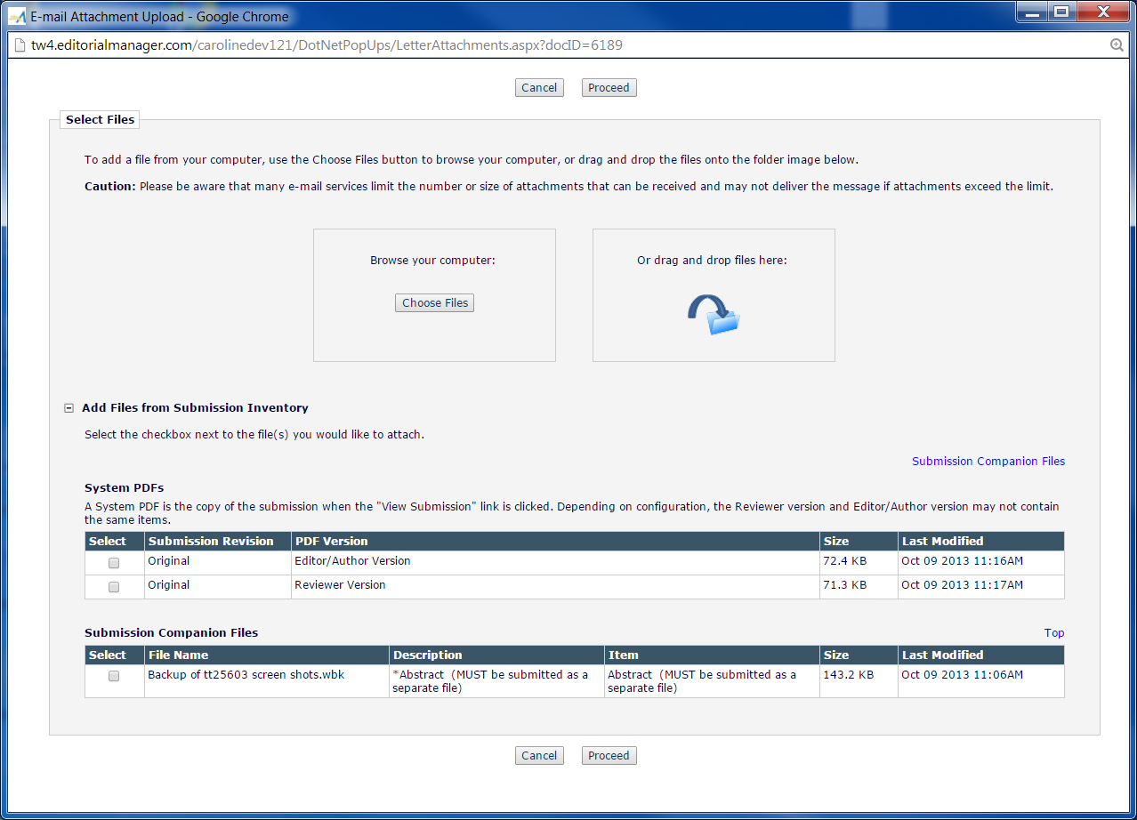

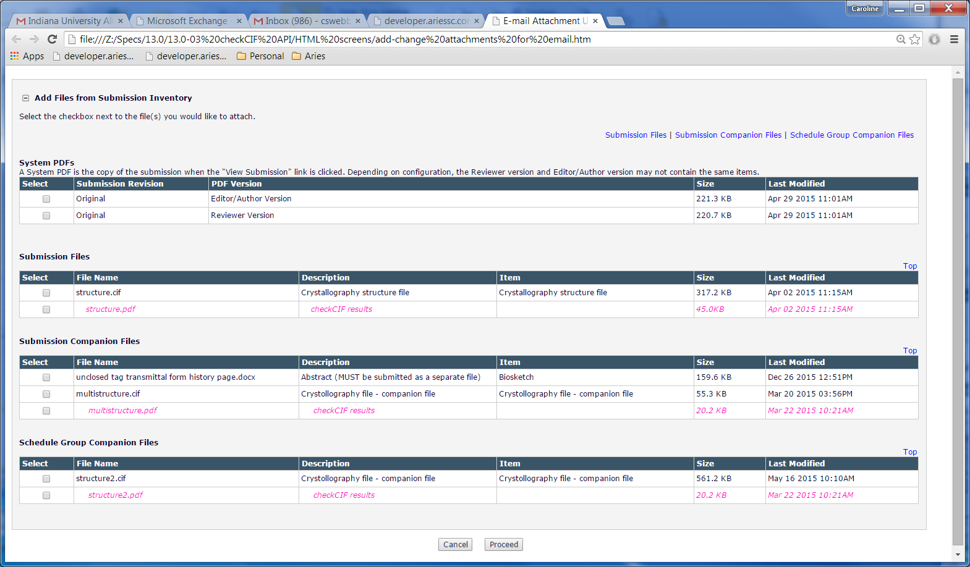

### Assignment Files

This existing page, [viewAssignmentFiles.asp], is reached when the recipient of a Production Task clicks the ‘Assignment Files’ link from the *Production Tasks Assigned to Me* folder. New in this spec:

1. If a checkCIF results file has been selected as an Assignment file, and its associated .cif file has also been selected as an Assignment file, the first three columns in the Assignment files table are shown as merged cells for the two rows, and the last 4 columns contain individual data for each file, matching the way the files are shown on the Assign Production Task page.
2. If a .cif file has been selected as an Assignment File, but its associated checkCIF results PDF is not selected as an assignment file, the .cif file is shown without a subrow (as per current coding, unchanged in this spec)
3. Separate Download links are shown for each file.
   1. Clicking the Download link for the .cif file downloads only that file, and not the checkCIF Results file.
   2. Clicking the Download link for the checkCIF Results PDF downloads that PDF, and does not also download the parent .cif file.
4. Clicking the Download Zip File button (top or bottom) includes the checkCIF Results PDF in the downloaded zip file.
5. The logic determining whether or not to show the QC Results column is updated in this spec. In addition to existing logic showing the column if AQC is enabled for the journal, the column is shown if there is a checkCIF PDF results file.
   1. “checkCIF Results” is placed in the same row as the checkCIF Results PDF file. Note: the text N/A is not shown for the checkCIF Results file or the .cif file.

Page Layout # 26 – Assignment Files for Task Assignee – both .cif and checkCIF results PDF selected

* checkCIF results row added as a sub-row of the .cif row, if both the .cif and associated checkCIF results PDF were selected as assignment files.
* The text in the QC Results column is hardcoded as checkCIF results, for the checkCIF results PDF sub-row.

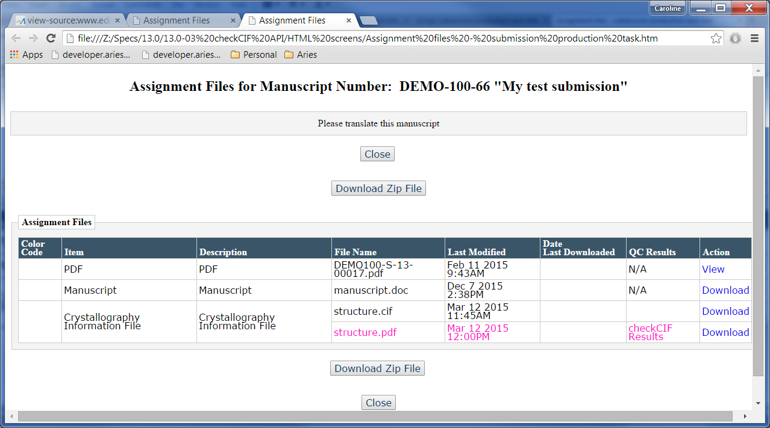

### Production Task Assignment Files

This existing popup, [ProdTaskAssignFilesSummary.aspx] is reached when an Editor/Publisher clicks the ‘Assignment Files’ link from the *Assign Production Task* page or the *History* page.

New in this spec:

1. If a .cif file is listed in the Assignment Files grid, and the associated checkCIF Results PDF was also selected as an Assignment file, the checkCIF results PDF is added as a sub-row of the .cif row (page layout uses rowspan="2" tag).
2. The logic determining whether or not to show the AQC Results column is updated in this spec. In addition to existing logic showing the column if AQC is enabled for the journal, the column is shown if there is a checkCIF PDF results file.
   1. The ‘AQC Results’ column header is changed to “QC Results”, and the hardcoded text “checkCIF Results” is placed in the same row as the checkCIF Results PDF file. Note: the text N/A is not shown for the checkCIF Results file or the .cif file.

Page Layout #27 – for Editors/Publishers who are not the task assignee

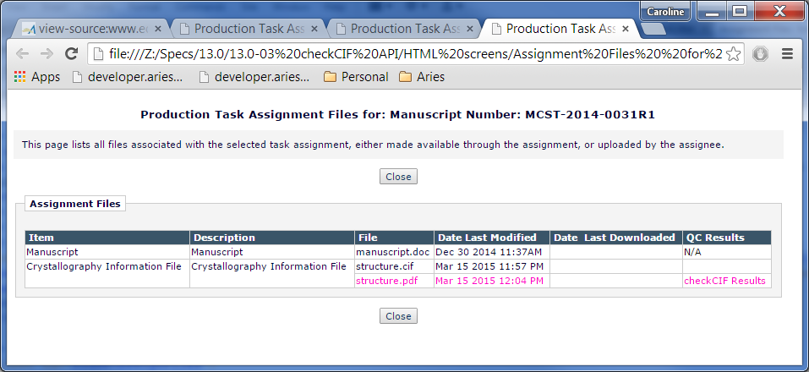

## Assign Schedule Group Production Task

In current coding, when a Schedule Group Production Task is assigned, the assigning Editor can select ‘Assignment Files’ to be made available to the task assignee, for download within the system or for FTP out within a zip file. The Assignment files are selected from a list of Companion Files associated with the Schedule Group. If a file has been processed through Reference Checking, it may have some associated ‘marked-up’ or ‘cleaned-up’ results files associated with it. These ‘marked-up’ and ‘cleaned-up’ files are not available in the ‘Submission Files’ grid, because the Author or Editor can elect to completely replace the original Companion File with the results file as part of the workflow.

New in this spec, the PDF results file returned from the checkCIF tool, and associated with a Companion File that appears in the grid, is listed in the Companion Files grid and is available for selection as an Assignment File.

1. If the Companion file is Hidden, using the ‘Hide’ link, the associated results PDF is also Hidden. The checkbox indicating its selection as an Assignment File is cleared/nulled out.

Page Layout #28 – Assign Schedule Group Production Task

* Partial page shown.
* The name of the checkCIF Results PDF is shown directly underneath the name of the related .cif file in the Submission Files and/or Companion Files grid (shown in pink, to be coded in default font – not a link). Note: red box is not coded.
* A checkbox is added to the ‘Allow Download’ column directly under the checkbox for the .cif file, default unselected/disabled/grayed out until the parent .cif file is selected. When the checkCIF results PDF is selected, it is included as an Assignment File (and FTP’ed in the zip file if the task is configured for FTP).

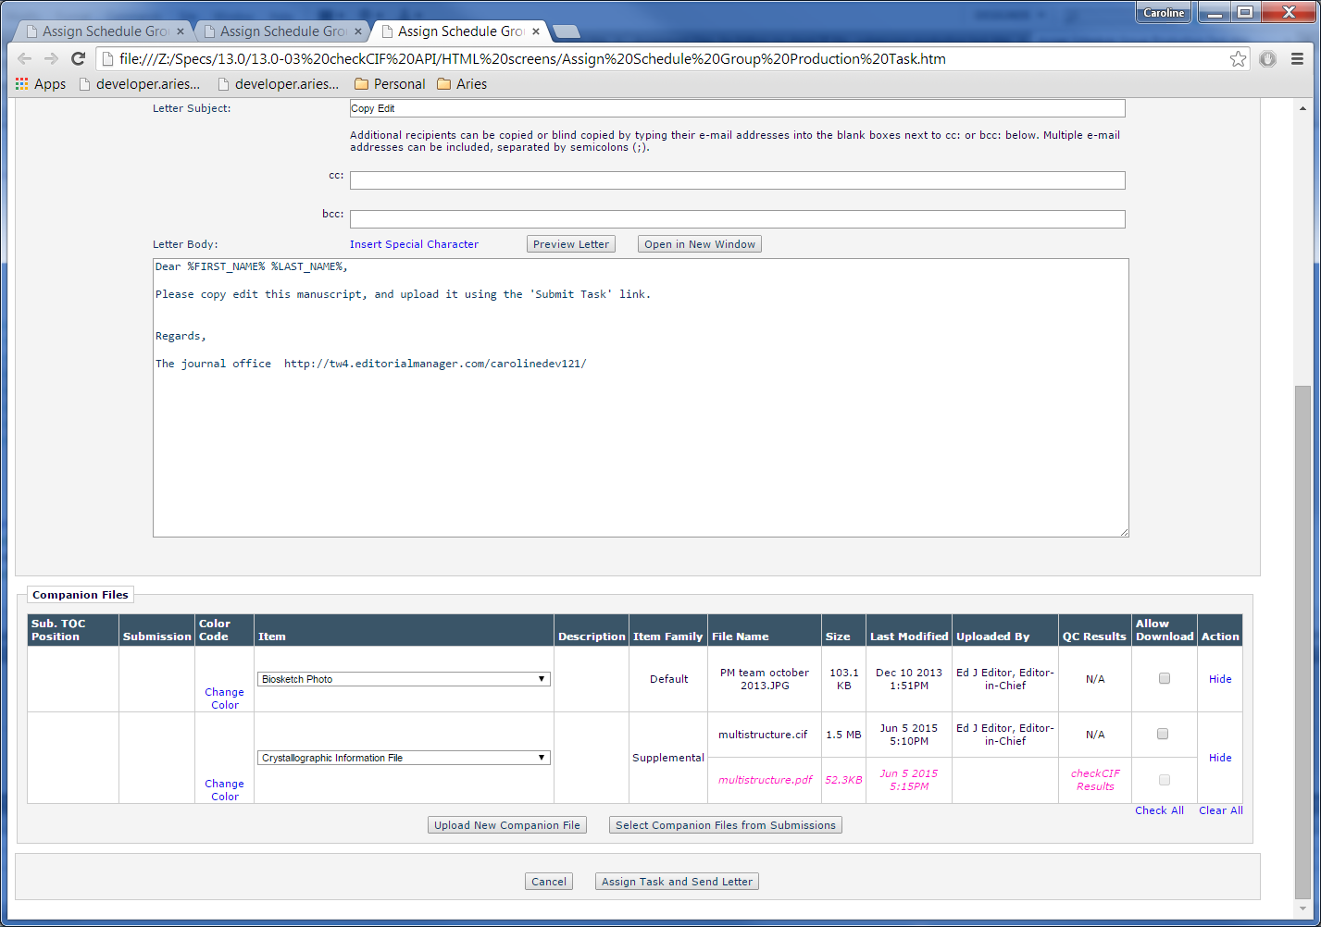

### Select Companion Files from Submissions

This existing page [Select AssocCompanionFiles.aspx] is reached when a user assigning a Schedule Group Production task clicks the ‘Select Companion Files from Submissions’ button on the Assign Schedule Group Production Task page discussed in section 2.11.

There is no change to the display of this page in this specification, however, when a Companion file is selected from this page and added to the Companion Files grid on the *Assign Schedule Group Production Task* page, any results PDFs associated with the added Companion file are also displayed in the grid.

* The results PDF is not displayed on the *Select Companion Files from Submissions* page.

Page Layout # 29 – Select Companion Files from Submissions

* Shown for testing purposes only.
* No change to layout in this spec.
* checkCIF Results PDFs are not shown on this page.

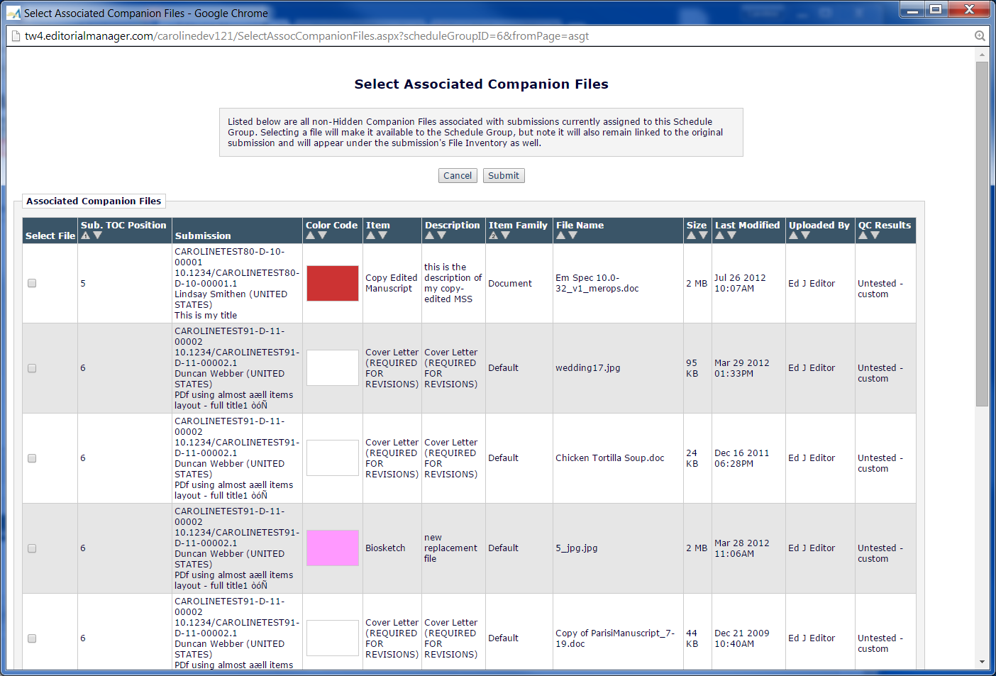

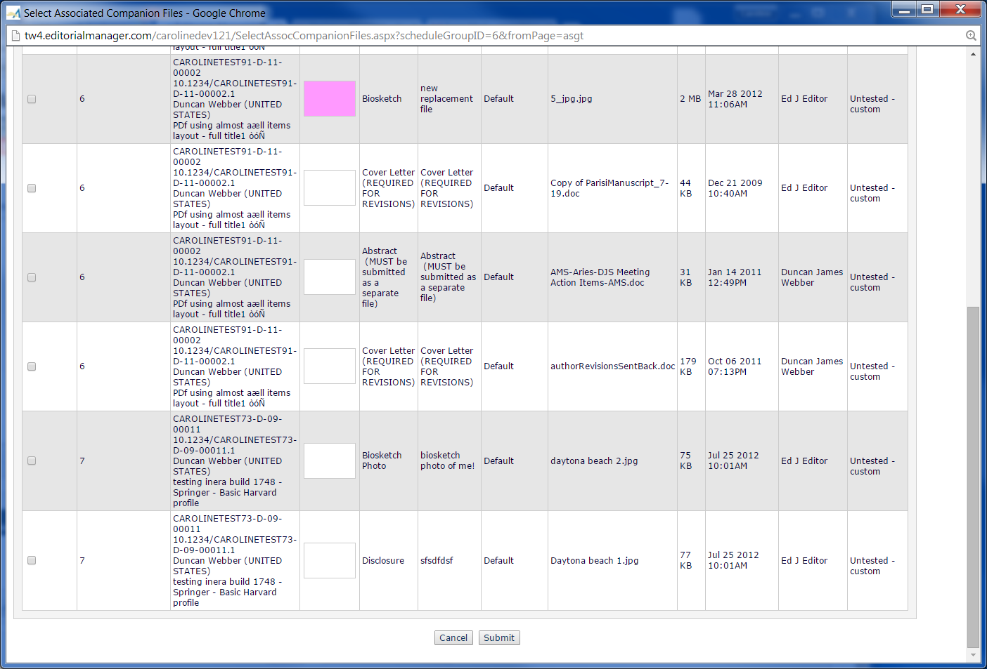

# Mobile Considerations

*Functional considerations for smartphones and tablets (if applicable)*

# Use Cases and Test Scenarios

## Regression Test Cases

On a site that is not enabled for the checkCIF feature:

1. As a SysAdmin user, go to RoleManager and click each Role in turn.
   1. Ensure that the ‘View checkCIF results’ and ‘Initiate checkCIF’ permissions are not displayed on the pages for any Role.
2. As SysAdmin, go to Edit Submission Items in PolicyManager.
   1. Enter an Item type name into the ‘New Item Type’ text entry box and click the ‘Add New Item Type’ button to add a new Submission Item Type.
   2. Ensure the SysAdmin is navigated to the ‘Add New Submission Item Type’ page, and ensure the new ‘Include this Item Type for checkCIF’ checkbox is not shown.
   3. Submit the page and ensure there is no error. Ensure the tester is navigated back to the ‘Edit Master Submission Items’ page in PolicyManager.
   4. Click the Edit link next to a Submission Item type and ensure the tester is navigated to the Edit Submission Item Type page, and ensure the new ‘Include this Item Type for checkCIF’ checkbox is not shown.
   5. Submit the page and ensure there is no error. Ensure the tester is navigated back to the ‘Edit Master Submission Items’ page in PolicyManager.
3. As an Editor, navigate to all the folders listed in section 2.13.1 of the spec [Editor Folders], as well as perform ‘Search Submissions’ and ensure that the new checkCIF Results link is not displayed.
4. As an Author, submit a manuscript, and ensure the new checkCIF results link is not shown.
5. As an Editor, invite a Reviewer for a submission. As the Reviewer, accept the review invitation and go into the Pending Assignments folder, and ensure the checkCIF Results link is not shown.

## Specification Test Cases

Before testing, verify with engineering that the API URL, test username and test pw have been entered in the testweb SMDB so that the API will be called. The upgrade script must add the appropriate information to QA and production SMDBs. Note that QA sites will have the test username/pw, and production sites must have the production username/pw. The URL is the same in both cases.

Note: Sample .cif files which can be used for testing are available here: \\badger\owa shared\Specs\13.0\13.0-03 checkCIF API\Sample CIF files provided by the IUCR

Configuration Use Cases:

1. The tester enables the feature in PolicyManager, Configure checkCIF.
   1. Go to PolicyManager, *Configure checkCIF*
   2. Ensure that the new ‘Enable checkCIF’ checkbox is displayed in the position called for in the spec and is default selected by the upgrade script.
   3. Ensure that the workflow trigger point ‘Original PDF Building by Author’ is selected (by the upgrade script).
   4. Submit the page.
   5. Ensure there is no error, and the user is navigated to the confirmation page described in the spec.
      1. Ensure the navigation links call for in the spec are present on the confirmation page.
   6. Re-enter the page by clicking the ‘Configure checkCIF’ link from the confirmation page, and ensure the 2 checkboxes are still selected.
   7. Ensure that the instruction grid is shown, allowing the user to configure customized instructions for the View checkCIF Results page.
      1. Ensure the default instructional text is shown, as described in the spec, and that it is tokenized.
      2. Click the Insert Special Character link and ensure the special characters are shown in a separate popup, not a jquery popup within the same window.
      3. Click the View Default Instructions link and ensure the default instructions are shown as called for in the spec.
      4. Add some text to the instructional text box, then click the Revert to Default Instructions link and ensure the instructions are reverted to the default instructions without saving the rest of the page.
      5. Select all trigger point checkboxes and submit the page.
      6. Ensure there is no error, and that the confirmation page called for in the spec is shown, with the navigation links.
      7. Ensure that each navigation link on the confirmation page works properly (this will involve submitting the Configure checkCIF page multiple times).
2. A restricted SysAdmin user does not see the new *Configure checkCIF* page.
   1. As an Unrestricted SysAdmin user, go to AdminManager Main Menu and click the ‘Configure Restricted System Administration Access Rights’ link.
   2. Ensure the SysAdmin user is navigated to the page of the same name in AdminManager.
   3. Ensure that a checkbox for the new Configure checkCIF page appears on the AdminManager page under the correct PolicyManager section, and ensure the checkbox is default unselected.
   4. Select the checkbox next to Configure checkCIF and Submit the page and ensure there are no errors.
   5. As an Editor with Restricted SysAdmin (RoleManager, System Administration Functions, Restricted Access radio button selected), go to the PolicyManager main menu.
   6. Ensure that the restricted Editor does not see the Configure checkCIF link.
3. A SysAdmin user configures a Submission Item Type in the Supplemental Family as ‘Include this Item Type for checkCIF’. For purposes of testing, this is referred to as Submission Item Type A.
   1. Go to the PolicyManager Main Menu, and click the link ‘Edit Submission Items’. Ensure the tester is navigated to the Edit Submission Items page.
   2. Enter an Item type name (such as checkCIF Item A) into the ‘New Item Type’ text entry box and click the ‘Add New Item Type’ button to add a new Submission Item Type.
   3. Ensure the SysAdmin is navigated to the ‘Add New Submission Item Type’ page:
      1. Ensure that the checkbox ‘Include this Item Type for checkCIF’ is visible, disabled and grayed out.
      2. Set the Item Type Family to Supplemental. Note: if this choice is not available, the ‘Enable Author Supplementary Materials’ checkbox needs to be selected in HA, *Set Journal Features.*
      3. Set the PDF Handling drop-down to ‘Build Hyperlink to the Item into the PDF (Item not displayed in PDF)’
      4. Set the URL/URI/External Resources parameter to Hidden
      5. Ensure the new ‘Include this Item Type for checkCIF’ checkbox is now available for selection (no longer disabled/grayed out). Select the checkbox. Do not select the checkboxes for Artwork Quality Checking, Do not Unpack, or Reference Checking.
      6. Submit the page and ensure there is no error and the user is navigated back to the *Edit Submission Items* page.
4. A SysAdmin user configures an additional Submission Item Type in the Default Family as ‘Include this Item Type for checkCIF’, and as a Companion File. For purposes of testing, this is referred to as Submission Item Type C [for Companion File].
   1. Go to the PolicyManager Main Menu, and click the link ‘Edit Submission Items’. Ensure the tester is navigated to the *Edit Submission Items* page.
   2. Enter an Item type name (such as checkCIF Companion File) into the ‘New Item Type’ text entry box and click the ‘Add New Item Type’ button to add a new Submission Item Type.
   3. Ensure the SysAdmin is navigated to the ‘Add New Submission Item Type’ page:
      1. Set the Item Type Family to Default
      2. Set the PDF Handling drop-down to ‘Companion File (not built into PDF)’
      3. Set the URL/URI/External Resource parameter to Hidden
      4. Ensure the new ‘Include this Item Type for checkCIF’ checkbox is displayed. Select the checkbox. Do not select the checkboxes for Artwork Quality Checking, Do not Unpack, or Reference Checking.
      5. Submit the page and ensure there is no error and the user is navigated back to the Edit Submission Items page.
5. A SysAdmin user edits an existing Submission Item Type in the Supplemental Family as ‘Include this Item Type for checkCIF’. For purposes of testing, this is referred to as Submission Item Type B.
   1. Go to the PolicyManager Main Menu, and click the link ‘Edit Submission Items’. Ensure the tester is navigated to the Edit Submission Items page.
   2. Click the Edit link next to an existing Submission Item Type in the Supplemental family.
   3. Ensure the SysAdmin is navigated to the ‘Edit Submission Item Type’ page:
      1. Leave the Item Type Family as Supplemental
      2. Set the PDF Handling drop-down to ‘Build Hyperlink to Item into PDF (Item not displayed in PDF)’
      3. Select the new ‘Include this Item Type for checkCIF’ checkbox (it must be selectable at this point).
      4. Set the URL/URI (etc.) parameter to Required.
      5. Ensure the checkbox ‘Include this Item Type for checkCIF’ is unselected, grayed out/disabled (i.e even though the PDF Handling drop-down is appropriate for ‘Include this Item Type for checkCIF’, the URL/URI parameter does not support this checkbox, so the checkbox must be unselected/ grayed out/disabled).
      6. Change the URL/URI parameter to Hidden.
         1. Ensure the new ‘Include this Item Type for checkCIF’ checkbox is displayed and selectable, and select it.
      7. Change the URL/URI parameter to Optional.
         1. Ensure that the new checkbox remains selected, as Optional is a valid choice for the selected checkbox.
      8. Do not select the checkboxes for Artwork Quality Checking, Do not Unpack, or Reference Checking.
      9. Submit the page and ensure there is no error and the user is navigated back to the Edit Master Submission Items page.
6. A SysAdmin user configures a Submission Item as ‘Include this Item Type for checkCIF’ and sets the URL/URI/External Resource drop-down to Optional. For purposes of testing, this is referred to as Submission Item Type D.
   1. Go to the PolicyManager Main Menu, and click the link ‘Edit Submission Items’. Ensure the tester is navigated to the Edit Submission Items page.
   2. Click the Edit link next to an existing Submission Item Type in the Supplemental family, or add a new type in the Supplemental Family
   3. Ensure the SysAdmin is navigated to the ‘Edit Submission Item Type’ page (or Add Submission Item Type page):
      1. Leave the Item Type Family as Supplemental
      2. Set the PDF Handling drop-down to ‘Build Hyperlink to Item into PDF ((Item not displayed in PDF)’
      3. Set the URL/URI (etc.) parameter to Optional.
      4. Ensure the new ‘Include this Item Type for checkCIF’ checkbox is displayed. Select the checkbox. Do not select the checkboxes for Artwork Quality Checking, Do not Unpack, or Reference Checking.
      5. Submit the page and ensure there is no error and the user is navigated back to the Edit Master Submission Items page.
7. A SysAdmin user configures a custom Details page to have the new checkCIF results link.
   1. From the PolicyManager main menu, click the ‘Define Details Page Layouts’ link.
   2. Ensure the tester is navigated to the *Details Page Layouts* page.
   3. Click the ‘Add New Layout’ button, and ensure the tester is navigated to the *Add/Edit Details Page Layout* page.
   4. Enter a new Layout name such as “checkCIF layout” and click the Submit button. Ensure the page refreshes to show the ‘Select Items to Display’ link.
   5. Click the ‘Select Items to Display link’, and ensure the tester is navigated to the *Select Items to Display* page, with all the Items default collapsed.
   6. Click the ‘Expand All’ link and locate the checkCIF Results item in the position called for in the spec (as long as ‘Enable checkCIF’ is selected in PolicyManager, *Configure checkCIF*).
   7. Select the checkCIF Results item (and some other items) and click the Submit button.
   8. Ensure the tester is returned to the Add/Edit Details Page Layout where the new checkCIF Results item is shown in the order of selected items on the Select Items for Display page).
   9. Re-order the checkCIF Results item by typing a new value in the ‘Order’ box and clicking the ‘Update Order’ button. Ensure it is re-ordered correctly.
   10. Submit the page and ensure the tester is navigated back to the ‘Details Page Layouts’ page, wher the layout is listed with an Edit link.
   11. Repeat the test, editing an existing layout, and ensuring that the new checkCIF Results item is added to the bottom of the list of existing items after selecting it on the Select Items to Display page and being returned to the Add/Edit Details Page Layout page.
8. A SysAdmin user examines the RoleManager permissions.
   1. As SysAdmin, go to RoleManager and click each Role in turn.
   2. Ensure that the new ‘View checkCIF Results’ checkbox is present on the RoleManager pages for each role, in the position called for in the spec, default unselected.
   3. Ensure that the new ‘Initiate checkCIF’ permission is present on the Editor RoleManager pages and Publisher RoleManager pages, in the position called for in the spec, default unselected.

Workflow Use Cases:

1. An Author without ‘View checkCIF Results’ permission submits a manuscript with .cif files in it, and selects the Item Types configured as ‘Include This Item Type for checkCIF’ when uploading those files. Ensure that the site is configured with ‘Original PDF Building by Author’ as a workflow trigger point. Expected results:
   1. The files are sent to the checkCIF API, but the Author does not have visibility to the ‘View checkCIF Results’ link in the Author main menu folders because they do not have the RoleManager permission.
   2. Within the Author/Editor PDF, ensure that the “checkCIF results” link is populated and the Author has visibility to the checkCIF results page as a standalone page when clicking this link, or, if the checkCIF results PDF is available, can download the results PDF. Note: even if the Author is prevented from seeing the results in the interface, they can still see the results via the PDF. This is unlikely edge case.
2. As an Editor without ‘View checkCIF Results’ permission, navigate to all the Editor folders listed in the spec, as well as perform ‘Search Submissions’ from both the Editorial and Proposal menus, and navigate to (submission) *File Inventory* for the submission that contains the .cif file that was processed through the checkCIF tool, and the custom details page configured with the checkCIF results link for that submission and ensure that the new checkCIF Results link is not displayed.
   1. In order to have access to the custom details page that contains the checkCIF results link, the SysAdmin user must select that custom details page from the ‘Use Editorial Details Layout’ drop-down box in Editor RoleManager. However, if the Editor does not also have the ‘View checkCIF Results’ RoleManager permission, or the Details link is clicked for a submission where there are no files associated with the current revision of the submission that are configured to go to checkCIF tool, the checkCIF results link is suppressed when they click the Details link.
3. As an Editor, invite a Reviewer who does not have ‘View checkCIF Results’ permission for the submission that contains the file that was sent through the checkCIF tool. As the Reviewer, accept the review invitation and go into the *Pending Assignments* folder on the Reviewer Main Menu. Expected Results:
   1. The checkCIF Results link is not shown in the folder. Note: the checkCIF results *is* available from the Reviewer PDF.
   2. As Reviewer, submit your review by clicking the Submit Recommendation link in the Pending Assignments folder, and following the Submit Recommendation flow. Once the recommendation has been submitted, click the ‘Completed Assignments’ link from the Reviewer Main menu to access the *Completed Assignments* folder. Ensure that the Vlew checkCIF results link is not displayed in the *Completed Assignments* folder.
4. As a Publisher without ‘View checkCIF’ results permission, navigate to Search Submissions, File Inventory, custom Details page and other places where the View checkCIF Results link would be shown if the Publisher had the permission, and ensure this link is not shown.
5. Give the Author Role and Reviewer Role the ‘View checkCIF Results’ permission in RoleManager, and as Author and Reviewers, look at the submissions where there are one or more files that have been sent to the checkCIF tool and also submissions where no files have been sent to the checkCIF tool. Make sure that both types of submissions are present in all the Author folders (excluding the production task folders) and all the Reviewer Folders, and that the link appears on the appropriate folders as described in the spec.
   1. Ensure that the View CheckCIF Results link is displayed in the folders listed in the spec, for submissions where at least one file has gone to the checkCIF tool. For submissions where no files have yet gone to the checkCIF tool, or there are no non-hidden files configured to go to the checkCIF tool, ensure the link is not shown.
6. Give at least one Editor Role and at least one Publisher Role the ‘View checkCIF Results’ permission in RoleManager, and log in as those roles. Look at the submissions where there are one or more files that have been sent to the checkCIF tool and also submissions where no files have been sent to the checkCIF tool (but are configured for checkCIF), and submissions where there are no files configured for checkCIF. Make sure that all three types of submissions are present in all the Editor folders (excluding the production task folders) and all the Publisher Folders (excluding the Production Task folders).
   1. Ensure that the View CheckCIF Results link is displayed in the folders and pages listed in the spec, (and including the *Technical Check* page accessed via the ‘Technical Check’ link in the Action column of the New Submissions folder) , for submissions where at least one non-hidden file has is configured to go the checkCIF tool (and a trigger point has been reached), and also for submissions where at least one non-hidden file is configured to go to the checkCIF tool but a trigger point has not yet been reached. For submissions where there are no files configured to go to the checkCIF tool, or all the Companion Files associated with the submission and configured to the checkCIF tool have been Hidden, ensure the link is not shown.
   2. Configure the Editor and Publisher Role to have the custom details page that contains the checkCIF results link.
   3. As these Roles, click the Details link (or Production Details link if the custom details page is configured to display for Production Details) and ensure that the checkCIF Results link is displayed on the Details page. Click the link and ensure that one of the following occurs:
      1. If there is only one file that is configured to go to checkCIF associated with the current revision of the submission, and that file has a results PDF, the results PDF is downloaded when the Editor or Publisher clicks the checkCIF Results link from the Details page.
      2. If there are multiple non-hidden files configured to go to checkCIF associated with the current revision of the submission that are, when the Editor or Publisher clicks the checkCIF Results link from the Details page, they are navigated to the Editor/Publisher version of the page where the files are listed with their status (Not yet Tested, Testing in Progress, error status or Completed).
      3. If there are no non-hidden files configured to go to checkCIF associated with the current revision of the submission, the checkCIF Results link is suppressed on the Details page.
7. The file and results links in the Author/Editor and Reviewer PDFs are tested, for a file that is built into the PDF and a PDF of checkCIF results has been returned for that file.
   1. An Author and an Editor view the Author/Editor PDF for a submission that has passed the trigger point ‘Original PDF Building by Author’, including a file configured to go to the checkCIF tool and the results PDF has been returned from the tool.
      1. Ensure that the new PDF page display (with the 2 separate download graphics) is shown.
      2. The PDF has a link to download the checkCIF results. When clicked, it downloads the results PDF directly, without visibly navigating the user to the interface, unless the results are not yet available. If the results PDF is not yet available:
         1. The Author is navigated to the Author/Reviewer version of the checkCIF results page, where they see the status “Testing in Progress” for the file.
         2. The Editor is navigated to the Editor/Publisher version of the checkCIF results page, where they see the status ‘Testing in Progress’ for the file.
   2. A Reviewer views the Reviewer version of the PDF for the same submission (this is the PDF accessible to the Reviewer from the *Pending Assignments* folder).
      1. Ensure that the new PDF page display (with the 2 separate download graphics) is shown.
      2. The PDF has a link to download the checkCIF results. When clicked, it downloads the results PDF directly, without visibly navigating the user to the interface, unless the results are not yet available. If the results PDF is not yet available:
         1. The Reviewer is navigated to the Author/Reviewer version of the checkCIF results page, where they see the status “Testing in Progress” for the file.
8. All workflow trigger points are tested. These tests require that the ‘Enable checkCIF’ checkbox is selected on the Configure checkCIF page in PolicyManager; and that one or more trigger points are selected as stated in the individual test.

Important note: when testing the functionality, new .cif files must be used for each test. EM will not resend a file to the tool if it already has results, even if it associated with a different submission. If the tester runs out of test files, either edit each submission that contains the files and remove them, or ask DBAs to run the cleanout script to remove all the files and the results PDFs.

* 1. Test the “Original PDF Building by Author” trigger point:

1. Expected results: Items configured to go to the checkCIF tool are sent to it when the trigger point is reached.
2. On the Configure checkCIF page, ensure that the checkbox ‘Enable checkCIF’ is selected, also select the ‘Original PDF Building by Author’ trigger point and submit the page.
3. Configure the Author role to have the RoleManager permission ‘View checkCIF Results’.
4. As an Author, click the ‘Submit New Manuscript’ link from the Author Main menu.
5. Selecting an Item configured as ‘Include this Item Type for checkCIF’ from the drop-down on the Attach files page, upload a .cif file, and proceed with building the PDF.
6. Ensure that the link ‘View checkCIF Results’ is shown in the Action column of the *Submissions Waiting for Author’s Approval* folder.
7. Click the View checkCIF Results link and ensure that the results PDF is downloaded (since only one file associated with the submission has been sent to the tool, the results PDF should be downloaded without navigating the Author visibly to the checkCIF results page).
   * + 1. Note: if the file is still being tested, the Author is navigated to the checkCIF results page (Author/Reviewer version), where the file is listed with a “Testing in Progress” status.
8. Repeat the test, but this time, upload two different .cif files.
   * + 1. Ensure that when the Author clicks the checkCIF Results link from the *Submissions Waiting for Author’s Approval* folder, the Author is navigated to the Author/Reviewer version of the checkCIF Results page. Note: in this case, a results PDF cannot be directly downloaded from the link because there is more than one file that has been sent to the checkCIF tool.
       2. Ensure that the two .cif files have either the status “Testing in Progress” or “Completed”. If the status is ‘Completed’, click the status term and ensure the results PDF for the appropriate file is downloaded.
   1. Test the Original PDF Building by Editor trigger point:
      1. Expected results: Items configured to go to the checkCIF tool are sent to it when the trigger point is reached, and not before.
      2. On the Configure checkCIF page, ensure that the checkbox ‘Enable checkCIF’ is selected, also select the ‘Original PDF Building by Editor’ trigger point (and only that trigger point) and submit the page.
      3. Find a submission that is in the Editor’s New Assignments folder (and that does not have files that have been through the checkCIF tool).
      4. Edit the submission by clicking the Edit Submission link. If given the choice to ‘Edit the Submission data only’ or to ‘Edit the submission (and rebuild PDF)’, select the choice ‘Edit the submission (and rebuild PDF)’.
      5. Go to the Attach Files step, select the Item configured as ‘Include this Item Type for checkCIF’ from the drop-down on the Attach files page, upload a .cif file, and proceed with building the PDF.
      6. Go to the Editor Main Menu folder *Submissions Needing Approval by Editor.*
      7. Ensure that the checkCIF Results link is shown in this folder. Click the link.
         1. If the file has been processed through the tool and has the results PDF returned, the PDF should be directly downloaded when the Editor clicks the link, without navigating the Editor to the checkCIF results page.
         2. If the results PDF has not been returned, or an error status has been returned, the Editor should be navigated to the Editor/Publisher version of the checkCIF results page, where either the Testing in Progress or checkCIF error status is displayed. Note: if an error status is shown, ensure that it is a hyperlink to the actual error message.
   2. Test the ‘First Reviewer Invited/Assigned for Original Submission’ trigger point, using Reviewer Invitation.
      1. Expected results: Items configured to go to the checkCIF tool are sent to it when the trigger point is reached, and not before.
      2. As SysAdmin, go to the Configure checkCIF page and select only the ‘First Reviewer Invited/Assigned for Original Submission’ trigger point and submit the page.
      3. As SysAdmin, go to Editor RoleManager and give an Editor role the permission to ‘Invite Reviewers’ under the ‘Reviewer Invitation’ section.
      4. As Author, submit a MS that includes .cif files that are associated with an Item configured to go to the checkCIF tool.
      5. As an Editor with permission to Assign Editor using Single Editor Selection, assign an editor who has the Role configured with the ‘Invite Reviewers’ RoleManager permission to the submission. (The assigned editor is the ‘handling editor’).
      6. As the handling editor, click the Invite Reviewers link from the Editor’s New Assignments folder.
      7. As the handling editor, search for Reviewers and select the ‘Inv.’ Checkbox for a reviewer (the ‘Inv.’ checkbox is displayed in the Reviewer Candidates grid), and proceed with the Reviewer invitation.
      8. Ensure that the .cif files are sent to the tool at this point, because the ‘First Reviewer Invited/Assigned for Original Submission’ trigger point has been reached.
      9. Ensure that the tool returns either an error status or a results PDF for each file.
   3. Test the ‘First Reviewer Invited/Assigned for Original Submission’ trigger point, using Reviewer Assignment.
      1. Expected results: Items configured to go to the checkCIF tool are sent to it when the trigger point is reached, and not before.
      2. As SysAdmin, go to the Configure checkCIF page and select only the ‘First Reviewer Invited/Assigned for Original Submission’ trigger point and submit the page.
      3. As SysAdmin, go to Editor RoleManager and give an Editor role the permission to ‘Assign Reviewers’ under the ‘Reviewer Invitation’ section.
      4. As Author, submit a MS that includes .cif files that are associated with an Item configured to go to the checkCIF tool.
      5. As an Editor with permission to ‘Assign Editor using Single Editor Selection’, assign an editor who has the Role configured in step d iii to the submission (the assigned Editor is the ‘handling editor’).
      6. As the handling editor, click the Invite Reviewers link from the Editor’s New Assignments folder.
      7. As the handling editor, search for Reviewers and click the ‘Asn.’ Checkbox for a reviewer in the Reviewer Candidates grid, and proceed with the Reviewer Assignment.
      8. Ensure that the .cif files are sent to the tool, because the ‘First Reviewer Invited/Assigned for Original Submission’ trigger point has been reached.
      9. Ensure that the tool returns either an error status or a results PDF for each file.
   4. Test the ‘Revised PDF Building by Author’ trigger point.
      1. Expected results: Items configured to go to the checkCIF tool are sent to it when the trigger point is reached, and not before.
      2. As SysAdmin, go to the Configure checkCIF page and select only the ‘Revised PDF Building by Author’ trigger point and submit the page.
      3. As an Author, submit a manuscript that has .cif files associated with an Item configured to be built into the PDF and go to the checkCIF tool. (However, these files will not be sent to the checkCIF tool when the manuscript is initially submitted, because ‘Original PDF Building by Author’ is not a selected trigger point).
      4. As an Editor with permission to assign editors, assign the MS to an editor (the “handling editor” i.e. the editor who is not “handling”/ has responsibility for the paper).
      5. As the handling editor, make a decision in the Revise decision family on a submission, and notify the Author.
      6. As the Author, click the *Submissions Needing Revision* folder on the Author main menu, then click the ‘Submit Revision’ Action link for that submission in the folder.
      7. Navigate to the Attach Files step, make sure that the previously uploaded .cif files associated with the submission are carried forward into the next revision, and then upload one new .cif file that is also associated with an Item that is built into the PDF and configured to go through the checkCIF tool.
      8. As Author, also upload a Companion File (submission Item type C) that is configured to go to the checkCIF tool and build the revised PDF.
      9. Ensure that all of the .cif files are sent to the tool, both the ones uploaded originally for Rev 0 , and the two just uploaded for Rev 1, because the ‘Revised PDF Building for Author’ trigger point has been reached. Especially confirm that the Companion File was sent to the checkCIF tool (even though it is not built into the PDF, it must be sent to the checkCIF tool when the trigger point is reached).
      10. Confirm that the tool has returned PDF results for all the files.
      11. As Author, approve the revision, thus submitting the revised manuscript.
      12. As an Editor who can assign other Editors, reassign to the prior editor.
      13. As the handling editor, make a second revise decision on the manuscript.
      14. As an Author, on the Attach Files step, carry forward all the files from Rev1 into Rev 2 (note that the Companion File will not be visible).
      15. As an Author, upload one new Companion File configured to go to the checkCIF tool and one new file configured to be built into the PDF and also go to the tool, and build the PDF for Rev 2.
      16. Confirm that only the two new files were sent to the tool – the existing files that have results are not resent.
      17. Confirm that the tool returned either an error status or a results PDF.
   5. Test the ‘Revised PDF Building by Editor’ trigger point.
      1. Expected results: Items configured to go to the checkCIF tool are sent to it when the trigger point is reached, and not before.
      2. As SysAdmin, go to the Configure checkCIF page and select only the ‘Revised PDF Building by Editor’ trigger point and submit the page.
      3. As an Author, click the Submit New Manuscript link and attach at least one .cif file that is associated with an Item that is configured to be built into a PDF and to go to the checkCIF tool.
      4. Build and the PDF and approve it. Ensure that the .cif file was not sent to the checkCIF tool (because the trigger point ‘Original PDF Building by Author’ is not selected).
      5. As an Editor who can assign other editors, assign a handling editor.
      6. As the handling editor, make a decision in the Revise decision family.
      7. As the Author, submit the revision, attaching an additional .cif file (selecting the Item configured to be built into the PDF as well as to go to the checkCIF tool).
      8. Ensure that no files were sent to the checkCIF tool because the trigger point has not yet been reached.
      9. As an Editor who can assign other editors, assign a handling editor for the revision (can be the same as the original handling editor).
      10. As the handling editor, click the Edit Submission link in the New Assignments folder. If presented with a choice between ‘Edit the submission data only’ and ‘Edit the submission (and rebuild PDF)’, choose ‘Edit the submission (and rebuild PDF)’.
      11. Navigate to the Attach Files submission step. Without uploading another file, click the Next button, then the ‘Build PDF for my approval’ button.
      12. The PDF must be rebuilt to include the checkCIF results links. Note: in coding previous to this spec, the PDF might not have been rebuilt since cached PDFs could be used, but in new functionality, the PDF must be rebuilt to include the checkCIF results links, unless these are already in the PDF.
      13. Ensure that all the .cif files are sent to the checkCIF tool since the trigger point has been reached.
      14. Ensure that the tool returns results PDFs for all the .cif files.
      15. Click the Edit submission link again, and again choose ‘Edit the submission (and rebuild PDF)’.
      16. On the Attach Files page, upload an additional .cif file and associate it with an Item that is configured to be built into the PDF and to go through the checkCIF tool.
      17. Click the ‘Build PDF for my approval’ button.
      18. Ensure that the additional .cif file is sent to the tool, but that the previously uploaded .cif files are not sent to the tool (because they already have results).
      19. Ensure that either the results PDF or an error message is returned from the tool.
   6. Test the “Author Notified of Editor Decision in the ‘Accept’ Decision Family” trigger point.
      1. Expected results: Items configured to go to the checkCIF tool are sent to it when the trigger point is reached, and not before.
      2. As SysAdmin, go to the Configure checkCIF page and select only the ‘‘Author Notified of Editor Decision in the ‘Accept’ Decision Family” trigger point and submit the page.
      3. As an Author, submit a manuscript with .cif files associated with an Item configured to be built into the PDF and also to go through the tool.
      4. Ensure that the files are not sent to the tool, since the trigger point has not yet been reached.
      5. As an Editor who can assign another Editor, assign a handling editor.
      6. As handling editor, click the Submit Editor’s Decision and Comments link, and select a decision in the Accept decision family from the ‘Decision’ drop-down.
      7. Continue and Notify the Author of the decision.
      8. Ensure that the files are sent to the tool, at the point where the Author is notified.
      9. Ensure that the tool returns either an error status for each file or the results PDFs.
   7. Test the “Author Notified of Editor Decision in the ‘Revise’ Decision Family” trigger point.
      1. Expected results: Items configured to go to the checkCIF tool are sent to it when the trigger point is reached, and not before.
      2. As SysAdmin, go to the Configure checkCIF page and select only the ‘‘Author Notified of Editor Decision in the ‘Revise’ Decision Family” trigger point and submit the page.
      3. As an Author, submit a manuscript with .cif files associated with an Item configured to be built into the PDF and also to go through the tool.
      4. Ensure that the files are not sent to the tool, since the trigger point has not yet been reached.
      5. As an Editor who can assign another Editor, assign a handling editor.
      6. As handling editor, click the Submit Editor’s Decision and Comments link, and select a decision in the Revise decision family from the ‘Decision’ drop-down.
      7. Continue and Notify the Author of the decision.
      8. Ensure that the files are sent to the tool, at the point where the Author is notified.
      9. Ensure that the tool returns either an error status for each file or the results PDFs.
   8. Test the ‘Create Submission’ Trigger point (when used with ProduXion Manager).
      1. Expected results: Items configured to go to the checkCIF tool are sent to it when the submission is created using the Create Submission feature.
      2. Configure the site for Production Tracking in HA, Set Journal Features.
      3. Configure an Editor with the RoleManager permission ‘Create Submission’ (and other ProduXion Manager permissions so that the Editor can see folders on the Production Tasks menu).
      4. On the Configure checkCIF page, select only the trigger point ‘Create Submission’.
      5. Login or proxy as the Editor configured in step i iii.
      6. Click the Search People link on the Production Tasks menu.
      7. On the Search People page, search for a user and then click their hyperlinked name to arrive at their Search People – Update Information page.
      8. Click the Create Submission button in the left column on this page.
      9. Proceed through the Create Submission interface. On the Attach Files page, upload at least one new .cif file associated with an Item configured to go through the checkCIF tool. Note: a PDF is not built for these submissions.
      10. After attaching all the files, click the Submit button on the Attach Files page to generate the submission.
      11. Ensure that the checkCIF Results link is shown on the confirmation page.
      12. Ensure that the .cif files are sent to the checkCIF tool.
      13. Ensure that the checkCIF tool returns either an error status or a results PDF.
   9. Test the ‘Create Submission’ Trigger point (when used with Edit Submissoin).
      1. Expected results: Items configured to go to the checkCIF tool are sent to it when the submission is edited using the Edit submission metadata only feature.
      2. As SysAdmin, Configure an Editor with the RoleManager permission ‘Edit Submission’.
      3. On the Configure checkCIF page, select only the trigger point ‘Create Submission’.
      4. Login or proxy as the Editor configured in step j iii.
      5. Find a submission in an Editor folder (such as New Assignments).
      6. Click the ‘Edit Submission’ link, and when presented with the choices ‘Edit Submission (and rebuild PDF)’ and Edit submission metadata only, select ‘Edit submission metadata only’ to enter the short edit submission interface.
      7. On the Attach Files step, upload at least one new .cif file associated with an Item configured to go through the checkCIF tool. Note: a PDF is not built for when editing in this way.
      8. Click the Submit button on the Attach Files page to finish the edit session.
      9. Ensure that the checkCIF Results link is shown on the confirmation page.
      10. Ensure that the .cif files are sent to the checkCIF tool.
      11. Ensure that the checkCIF tool returns either an error status or a results PDF.
   10. Test the Upload Companion File trigger point, reached from the Submission File Inventory page (note: this is a hardcoded trigger point, not a configured trigger point):
       1. Expected result: Uploading a Companion File that is associated with an Item configured to go to the checkCIF tool triggers the sending of that Companion File to the tool via the API.
       2. As SysAdmin, give an Editor Role the RoleManager permission to ‘Download Source Files’, ‘Download Companion Files’, ‘Upload, Hide and Restore Companion Files’.
       3. As that Editor, click the File Inventory link in one of the folders on the Editor Main menu.
       4. On the [submission] *File Inventory* popup, click the ‘Upload Companion File’ button.
       5. On the *Upload Companion Files* popup, select the Item that is configured to go the checkCIF tool from the Item drop-down, upload a file, then click the ‘Upload This File’ button.
       6. Ensure that the *Upload Companion Files* popup is closed, and that the newly uploaded Companion File is sent to the checkCIF tool via the API.
       7. Ensure that the tool returns either an error status message or the results PDF.
       8. Note: testing the upload of a Companion file from the Schedule Group File Inventory , and testing the upload of a Companion File when submitting a Production Task are separate use cases.
       9. Select a few files and click the ‘Download Selections as Zip File’ buttons. Ensure that the checkCIF Results PDFs are not included in the downloaded zip file.
   11. Test multiple trigger point selection.
       1. Expected results: Only configured files that have not yet received a results PDF are sent to the tool when the next trigger point is reached. Any files that have already received a results PDF are not resent to the tool. Files that have not yet been sent to the tool are sent, and file that have errored out are resent to the tool.
       2. Select all the trigger points on the Configure checkCIF page in PolicyManager and submit the page.
       3. As an Author, click the Submit New Manuscript link to submit a new manuscript.
       4. Take the submission through the entire workflow, hitting each trigger point (except Create Submission). Before hitting the subsequent trigger point, upload a new .cif file. At each trigger point, ensure that only the new .cif file is sent through the workflow, and not the previously uploaded .cif files that already have results PDFS. Note: the Create Submission trigger point cannot be tested with a submission originated by the Author using Submit New Manuscript, so that trigger point can be skipped for this test.
9. Submission Item Type C (Companion File) is uploaded as part of manuscript submission by the Author, where ‘Original PDF Building by Author’ is sand the PDFs are built.
   1. Expected result – the file is sent to the checkCIF tool, but a link to the file is not available within the Author/Editor or Reviewer PDF because the file is a Companion File (not built into the PDF).
   2. As SysAdmin, select ‘Original PDF Building by Author’ as a trigger point on the Configure checkCIF page in PolicyManager. On the Add/Edit Submission Item page, configure a Companion File to go to the checkCIF Tool. Also configure an Article Type so that the Companion File Item is ‘Optional’ for new and revised submission.
   3. As Author, click the ‘Submit New Manuscript’ link on the Author Main menu.
   4. Select the Article Type configured to have the Companion File as optional. Enter the Title and navigate to the Attach Files step.
   5. Select the Companion File Item from the Item drop-down, and upload a file.
   6. Proceed through the submission process and click the ‘Build PDF for my approval’ button.
   7. Ensure that the Companion File was sent to the checkCIF tool and that either a status message or the checkCIF Results PDF was returned.
10. A submission contains just one file configured to go to checkCIF, and a checkCIF Results PDF has been returned for that file. The Author, Reviewer , Editor and Publisher all click the ‘View checkCIF’ results link from the folder on their main menu that contains that submission. The Editor searches for the submission using the Search Submissions interface.
    1. Expected result: When the Author, Reviewer, Editor or Publisher clicks the “View checkCIF Results link” in the Action Column of their main menu folders and Search Submissions, the PDF of the results is directly downloaded. The user is not visibly navigated to the View checkCIF results page.
11. An Editor and Publisher with “View Transmittal Form” permission views a file that has a checkCIF results PDF on the transmittal form.
    1. Expected result: The .cif file is displayed on the transmittal form, but the results PDF is not displayed on the transmittal form. Display of the checkCIF Results PDF on the transmittal form is a future enhancement.
12. An Editor and Publisher with “Release Transmittal Form” permission or ‘Re-release Transmittal Form RoleManager permission releases the Transmittal form to a production system, with a .cif file selected to be included in the transmittal. Note: for this use case, ensure the .cif file has a results PDF that has been returned from the tool.
    1. Expected result: The transmitted zip file the .cif file but not the checkCIF results PDF file. Including the checkCIF results PDF file in the transmittal is a future enhancement.
13. An Editor manually assigns a Submission Production task configured for FTP and selects the .cif file as an assignment file.
    1. Expected results: The ftp’ed zip file contains the .cif file but not the checkCIF results PDF file. Selecting the checkCIF results PDF as an assignment file is a future enhancement.
14. An Editor manually assigns a Schedule Group Production task configured for FTP and selects a .cif file as an Assignment file.
    1. Expected results: The ftp’ed zip file contains the .cif file but not the checkCIF results PDF file. Selecting the checkCIF results PDF as an assignment file is a future enhancement.
15. An Editor sending an e-mail that is configured to allow attachments selects a .cif file as an e-mail attachment and sends the email.
    1. Expected results: the .cif file is attached to the e-mail but the checkCIF Results PDF is not. Allowing the checkCIF results PDF to be selected as an e-mail attachment is a future enhancement.
16. An Editor without the Initiate checkCIF RoleManager permission views the checkCIF Results popup.
    1. As SysAdmin, configure an Editor Role with ‘View checkCIF Results’ permission but without Initiate checkCIF permission.
    2. As SysAdmin, unselect the ‘Original PDF Building by Author’ trigger point on the Configure checkCIF page in PolicyManager, select a different workflow trigger point, and submit the page.
    3. As Author, submit a manuscript and include at least two .cif files, and select the Item configured to go the checkCIF tool when uploading the files. Note: the files will not go to the checkCIF tool since the Original PDF Building by Author trigger point is not selected.
    4. As an Editor with the Role configured in step a, click the View checkCIF Results link from an Editor Main menu folder.
       1. Ensure that the checkCIF Results popup is displayed, but without the Select column and the checkCIF: Selected Files buttons.
       2. Ensure that the files have the checkCIF results status “Not yet tested”. Note: if the Editor had the ‘Initiate checkCIF’ permission, this status would cause the Select column and checkCIF: Selected Files buttons to be displayed, but because the Editor does not have this RoleManager permission, the Select column and checkCIF: Selected Files buttons are not displayed.
       3. Click the top Close button and ensure the checkCIF Results popup is closed.
       4. Re-enter the checkCIF Results popup, click the bottom Close button, and ensure the checkCIF Results popup is closed.
17. An Editor sends files that have an error condition to the tool via the top ‘checkCIF:Selected Files’ button on the checkCIF results page.
    1. Expected result: All configured files are sent to the checkCIF tool, and checkCIF results PDFs for all of these files are returned (or errors are returned).
       1. An Author uploads multiple .cif files when submitting a submission, selecting an Item Type configured to go the checkCIF tool, where the trigger point is “Original PDF Building by Author”. However, the username/pw for the tool are incorrect, so all of the files return an error condition (this may require working with engineering to reset the username/pw for the API temporarily to an invalid username or p/w).
       2. Configure an Editor Role to have the RoleManager permissions ‘View checkCIF Results’ and also ‘Initiate checkCIF’.
       3. As an Editor user with this Role, click the ‘View checkCIF Results’ link from an Editor Main Menu folder or Search Submissions. Ensure the Editor is navigated to the checkCIF results page (Editor/Publisher version).
       4. Ensure that the page instructions reflect the default instructions from the *Configure checkCIF* page in PolicyManager.
       5. Ensure that each file has the red text checkCIF Error in the status column.
       6. Click each hyperlinked ‘checkCIF Error’ text in turn.
          1. Ensure that the jquery alert box called for in the spec is displayed, with the actual text returned by the tool shown in the alert box. Click OK on each alert box.
       7. Ensure that the button ‘checkCIF: Selected Files’ is shown on the page, but is disabled/grayed out because the Editor has not yet selected any checkboxes in the Select column.
       8. Click the ‘Close’ button on the checkCIF results page, without selecting any checkboxes in the Select column.
          1. Ensure that the Warning jquery box called for in the spec is shown on the page.
          2. Click the ‘Leave Results Page’ button on the jquery box and ensure that the results popup is closed, and no files are sent to the tool.
       9. Click the ‘View checkCIF Results’ link again to re-enter the checkCIF results popup.
       10. Click the ‘Close’ button on the checkCIF results page, without selecting any checkboxes in the Select column.
           1. Ensure that the Warning jquery box called for in the spec is shown on the page.
           2. Click the ‘Return to Results Page’ button on the jquery box and ensure that the results popup remains open and the jquery box is dismissed.
       11. Work with engineering to reset the username/pw for the API to the correct values.
       12. Select all the files with an error status using the checkboxes in the Select column, then click the ‘checkCIF: Selected Files’ button.
       13. Ensure that the jquery message box called for in the spec is shown, informing the Editor that the files have been sent to the checkCIF tool. Click the Close button on the message box.
       14. Ensure that the status for each file is changed to ‘Testing in Progress’ (this may require refreshing the checkCIF results page.
       15. Wait a few minutes, refreshing the page as necessary, until results are returned from the tool for each file.
       16. Ensure that the status for files where a checkCIF results PDF has been returned is changed to ‘Completed’.
       17. Click the ‘Completed’ status for each file, and ensure the results PDF is downloaded.
18. Repeat the previous test, but use the bottom checkCIF: Selected files button, to ensure both the top and bottom ‘checkCIF: Selected Files’ buttons function properly.
19. An Editor views the checkCIF results page, where the page instructions have been customized.
    1. As a SysAdmin user, go to the *Configure checkCIF* page in PolicyManager.
    2. Create some customized instructions for the *checkCIF Results* page and save the Configure checkCIF page.
    3. As an Editor with permission to View checkCIF Results, click the View checkCIF Results link in an Editor main menu folder.
       1. Ensure that the checkCIF results popup is displayed, and shows the customized instructions and not the default instructions.
20. An Author views the *checkCIF Results* popup, where some of the files are in an error status.
    1. Expected result: The checkCIF error status is shown, but is not a hyperlink.
    2. Working with engineering, reset the u/n and p/w for the API to an invalid one.
    3. As SysAdmin, select the trigger point ‘Original PDF Building by Author’ on the Configure checkCIF page and submit the page.
    4. As Author, click the Submit New Manuscript link and proceed through the submission steps to build the PDF for a MS with .cif files that are associated with an Item Type configured to be built into the PDF and to go to the checkCIF tool.
    5. As Author, click the View checkCIF Results link from the folder ‘Submissions Needing Author’s Approval’.
    6. Ensure that the Author views the checkCIF Results popup, and that the checkCIF Results column has the status checkCIF Error (in red text) for the files that have an error condition.
    7. Ensure that the error text is not a hyperlink.
21. A Reviewer views the checkCIF Results popup, where some of the files are in an error status.
    1. Expected result: The checkCIF error status is shown, but is not a hyperlink.
    2. Working with engineering, reset the u/n and p/w for the API to an invalid one.
    3. As SysAdmin, give a Reviewer Role the RoleManager permission ‘View checkCIF Results’.
    4. As SysAdmin, select the trigger point ‘Original PDF Building by Author’ on the Configure checkCIF page and submit the page.
    5. As Author, click the Submit New Manuscript link and proceed through the submission steps to build the PDF for a MS with .cif files that are associated with an Item Type configured to be built into the PDF and to go to the checkCIF tool. Submit the MS to the journal.
    6. As Editor, invite a Reviewer with the Reviewer Role configured in step b to review the MS.
    7. As Reviewer, accept the invitation.
    8. As Reviewer, go to the Pending Assignments folder and click the View checkCIF Results link.
    9. Ensure that the checkCIF Results popup is displayed (Reviewer/Author Version).
    10. Ensure that the files that have errored out have text ‘checkCIF Error’ in red text in the checkCIF Results column.
    11. Ensure that the error text is not a hyperlink.
22. The AdminManager page *File Transfer Statistics* is examined.
    1. Expected Result: Files that have gone to the tool and been returned from the tool are reflected on this page.
23. The EMIA page Q&D Stats and the associated results page are examined.
    1. Expected Result: The selection page is configured per the spec, and the results page displays the same results as the AdminManager File Transfer Statistics page. Files that have gone to the tool and been returned from the tool are reflected on these pages.
24. The file and results links in the Author/Editor and Reviewer PDFs are tested, for a file that is built into the PDF and where a PDF of checkCIF results has not yet been returned.
    1. An Author, Editor, Reviewer and Publisher view the Author/Editor PDF for a submission that has passed the trigger point ‘Original PDF Building by Author’, including a file configured to go to the checkCIF tool and the results PDF has not yet been returned from the tool.
       1. Ensure that the new PDF page display (with the 2 separate download graphics) is shown.
       2. The PDF has a link to download the checkCIF results. When clicked, it navigates the user to the checkCIF Results standalone page in the interface, without being logged in. Note: the Author/Editor/Reviewer and Publisher all see the same interface page when the page is accessed via the PDF.
       3. Note: for the Publisher to have access to the PDF, a Final Disposition of Accept needs to be set for the Submission, then the Publisher can access the submission via the *Accepted Submissions* folder on the Publisher Main Menu.
25. An Editor with View checkCIF Results permission navigates to the Schedule Group File Inventory page where no Companion Files are configured to go to the checkCIF tool.
    1. Expected result: the checkCIF Results link is not shown on the Schedule Group File Inventory page.
    2. Ensure the site is enabled for Production Tracking (HA, Set Journal Features, select the ‘Enable Production Tracking’ checkbox).
    3. Give the Editor the RoleManager permission to “View Schedule Groups”, “Manage Schedule Groups”, “Download Source Files”, “Download Companion Files”, “Upload, Hide and Restore Companion Files”, “Initiate Production Manually”. Note: It is OK if the Editor has other ProduXion Manager RoleManager permissions as well, along with a basic set of other RoleManager permissions.
    4. If there is not already a Companion File configured on the site that has ‘Include this Item Type for checkCIF’ unselected, add a Companion File of this type.
    5. If there are no Schedule Groups already on the site, as Editor, go to the Production Tasks Menu and click the ‘Add Schedule Group’ link and follow the flow to Add a new Schedule Group.
    6. If there are no submissions already in production, select a submission from the Final Disposition – Accept folder (or another Editor Main Menu folder) and click the Initiate Production link to place the submission into production. On the *Initiate Production and Assign Production Task* page, select a Schedule Group from the ‘Assign Submission to Schedule Group’ drop-down box. Continue with the Initiate Production flow without assigning a Production Task.
    7. Navigate to the Production Tasks Menu and click the Manage Schedule Groups link.
    8. Find the Schedule Group that was just created and does not yet have any Companion Files associated with it. Click the File Inventory link associated with this Schedule Group from the Action column and ensure the Editor is navigated to the *File Inventory for Schedule Group* popup. Ensure the display matches page layout #13A (the Schedule Group File Inventory was redesigned in this spec).
    9. Click the ‘Upload Companion File’ button, and ensure the Editor is navigated to the ‘Upload Companion Files for Schedule Group’ popup. Choose the Companion File that is configured without checkCIF from the Item drop-down, enter a description and click the ‘Choose File’ button to select a file, then click the ‘Upload This File’ button.
       1. Ensure that the checkCIF API is *not* triggered.
       2. Ensure that the Editor is returned to the File Inventory for Schedule Group popup, with the popup display refreshed to match page layout #13 (without the Hidden Companion Files grid since no Companion File has yet been hidden).
    10. Ensure that the checkCIF Results link is not shown on the page, because there are no files in the File Inventory that are configured to go to the checkCIF tool.
26. An Editor with View checkCIF Results permission navigates to the Schedule Group File Inventory page and clicks the checkCIF results link, where only one Companion File is configured to go to the checkCIF tool, and that file has a checkCIF results PDF.
    1. As an Editor with SysAdmin permission, click the Edit Submission Items link on the PolicyManager main menu, and configure a new Item with the PDF handling option ‘Companion File (not Built into PDF)’. Select the checkbox ‘Include this Item Type for checkCIF’ and save the new Item.
    2. As an Editor with Manage Schedule Groups permission, navigate to the Production Tasks menu.
    3. Click the Manage Schedule Groups link.
    4. Click the File Inventory link in the Action column.
    5. From the Schedule Group File Inventory page, click the Upload New Companion File button and choose the newly configured Companion File Item from the drop-down, then upload the file.
    6. On the Schedule Group File Inventory page, ensure that the checkCIF results link is shown.
    7. Click the link. If the file is still being processed, ensure you are navigated to the Schedule Group version of the checkCIF results page, where the file is shown with the status “Testing in Progress”. Refresh the page until the status shows as “Completed”, then click the Completed link and ensure the results PDF is downloaded.
    8. Return to the Schedule Group File Inventory page. Click the checkCIF results link again. This time, since there is only one file configured to go to the tool, and a results PDF has been returned from the tool for that file, the Editor should not be navigated to the checkCIF Results page but instead the results PDF should directly download.
    9. Select a few files and click the ‘Download Selections as Zip File’ buttons. Ensure that the checkCIF Results PDFs are not included in the downloaded zip file.
27. An Editor with View checkCIF Results permission navigates to the Schedule Group File Inventory page and clicks the checkCIF results link, where more than one Companion File is configured to go to the checkCIF tool.
    1. As an Editor with Manage Schedule Groups permission, navigate to the Production Tasks menu.
    2. Click the Manage Schedule Groups link.
    3. Click the File Inventory link in the Action column.
    4. From the Schedule Group File Inventory page, click the Upload New Companion File button and choose the Companion File Item that is configured to go the tool from the drop-down, then upload a file.
    5. From the Schedule Group File Inventory page, click the Upload New Companion File button again, and choose the Companion File Item that is configured to go the tool from the drop-down, then upload a second file.
    6. On the Schedule Group File Inventory page, ensure that the checkCIF results link is shown.
    7. Click the link. Ensure that the Editors is navigated to the Schedule Group version of the checkCIF results page, where the files are shown with the status “Testing in Progress”. Refresh the page until the status shows as “Completed”, then click the Completed links and ensure the results PDFs are downloaded.
    8. Return to the Schedule Group File Inventory page. Click the checkCIF results link again. Since more than one Companion File associated with the Schedule Group is configured to go to the tool, no results PDF is directly downloaded, but instead the Editor is navigated to the Schedule Group checkCIF results popup, where the status for both files shows as Completed, and the Editor can download each results PDF separately.
    9. Click the ‘Hide’ link for one of the Companion Files, and make sure at least 2 Companion Files configured to go to the tool are still in the active Companion Files grid.
    10. Click the checkCIF Results link again, and ensure that the Hidden Companion File is not shown on the checkCIF Results page.
    11. Returning to the Schedule Group File Inventory page, hide all the Companion Files except for one, and ensure the one that is retained in the active grid has a results PDF.
    12. Click the checkCIF Results link again. Ensure that the results PDF for the remaining Companion File is directly downloaded. Since there is only one un-hidden Companion File in the Schedule Group File Inventory, and that Companion File has a results PDF, clicking the checkCIF Results link directly downloads the results PDF.
28. A Submission Production Task is assigned and submitted, and a Companion Files configured to go to the checkCIF tool is uploaded as part of the Production Task assignment and submission.
    1. Expected Result: the Companion Files uploaded as part of the submission production task assignment and submission are sent to the checkCIF tool when they are uploaded.
    2. As an Editor with permission to Assign Submission Production Task, navigate to the Production Tasks menu. Note: it is easiest to give this Editor all ProduXion Manager related permissions.
    3. Click the View All Submissions in Production folder.
    4. From the Action column in this folder, click the ‘Assign Production Task’ link.
    5. On the Assign Production Task page, choose a Production Task from the Production Task drop-down, then click the ‘Proceed with Selected Task’ button.
    6. On the next Assign Production Task page, select a task recipient and click the ‘Upload New Companion File’ button.
    7. On the Upload Companion Files popup, select a Companion File from the drop-down that is configured to go to the checkCIF tool, and click the ‘Upload This File’ button.
    8. Ensure that the newly uploaded Companion File is sent to the checkCIF tool.
    9. Ensure that the checkCIF tool returns results.
    10. Click the ‘Assign Task and Send Letter’ button.
    11. As the task recipient, find the task assignment in the Submission Tasks Assigned to Me folder.
    12. Click the Submit Task link to begin the process of task submission.
    13. On the Submit Production Task page, click the ‘Upload File’ button.
    14. On the Upload Companion File popup, choose the item configured to go to the checkCIF tool, choose a .cif file and click the Upload This File button.
    15. Ensure that the newly uploaded Companion File is sent to the checkCIF tool via the API.
    16. Ensure that the tool returns either an error status or a results PDF.
    17. Click the Submit Production Task button to finish submitting the Production Task.
29. A Schedule Group Production Task is assigned and submitted, and a Companion Files configured to go to the checkCIF tool is uploaded as part of the Schedule Group Production Task assignment and submission.
    1. Expected Result: the Companion Files uploaded as part of the Schedule Group production task assignment and submission are sent to the checkCIF tool when they are uploaded.
    2. As an Editor with permission to Assign Schedule Group Production Task, navigate to the Production Tasks menu. Note: it is easiest to give this Editor all ProduXion Manager related permissions.
    3. Click the Manage Schedule Groups folder.
    4. From the Action column in this folder, click the ‘Assign Production Task’ link.
    5. On the *Assign Production Task* page, choose a Production Task from the Production Task drop-down, then click the ‘Proceed with Selected Task’ button.
    6. On the next *Assign Production Task* page, select a task recipient and click the ‘Upload New Companion File’ button.
    7. On the *Upload Companion Files* popup, select a Companion File from the drop-down that is configured to go to the checkCIF tool, and click the ‘Upload This File’ button.
    8. Ensure that the newly uploaded Companion File is sent to the checkCIF tool.
    9. Ensure that the checkCIF tool returns results.
    10. Click the ‘Assign Task and Send Letter’ button.
    11. As the task recipient, find the task assignment in the *Schedule Group Tasks Assigned to Me* folder.
    12. Click the Submit Task link to begin the process of task submission.
    13. On the *Submit Production Task for Schedule Group* page, click the ‘Upload File’ button.
    14. On the *Upload Companion Files for Schedule Group* popup, choose the item configured to go to the checkCIF tool, choose a .cif file and click the ‘Upload This File’ button.
    15. Ensure that the newly uploaded Companion File is sent to the checkCIF tool via the API.
    16. Ensure that the tool returns either an error status or a results PDF.
    17. Click the Submit Production Task button to finish submitting the Schedule Group Production Task.
30. The new %CHECKCIF_RESULTS_PDF% merge field is added to a Rich Text/HTML letter relating to a submission where the submission does not contain any .cif files.
    1. As SysAdmin, go to PolicyManager, Edit Letters and click the Edit link next to a submission-related letter formatted as Rich Text/HTML (or select this radio button if it is not already selected). Examples of a submission-related letter are those configured in ActionManager for Assign Editor, Send Back to Author, New Submission Sent to Publication, etc. Letters in the Ad-Hoc letter family also support this merge field. On the Edit Letter page, paste the merge field %CHECKCIF_RESULTS_PDF% into the letter body.
    2. As an Editor, either trigger the ActionManager event that sends the letter or click the ‘Send E-mail’ link from a main menu folder to send the Ad-Hoc From Editor letter. Send it relating to a submission that either has no .cif file associated with it, or has them associated but they have not yet been sent to the checkCIF tool.
    3. As the recipient, examine the letter and ensure that the HTML hyperlink ‘View checkCIF Results’ has replaced the raw merge code in the received letter (as per existing coding for Rich Text/HTML letters – the HTML ‘friendly text’ replaces the full link).
    4. Ensure that the recipient is not currently logged into EM.
    5. Click the hyperlink in the letter, and ensure that the user is navigated to the standalone checkCIF results page with the layout shown in page layout #20, informing the user that there are no results.
31. The new %CHECKCIF_RESULTS_PDF% merge field is added to a Rich Text/HTML letter relating to a submission where one file associated with the submission is configured to go to the checkCIF tool, and the checkCIF results PDF is available for that file.
    1. Repeat steps a through d above.
    2. Click the hyperlink in the letter, and ensure that the results PDF is directly downloaded. The user is not visibly directed to EM.
32. The new %CHECKCIF_RESULTS_PDF% merge field is added to a Rich Text/HTML letter relating to a submission where multiple files associated with the submission are configured to go to the checkCIF tool.
    1. Repeat steps a through d above.
    2. Click the hyperlink in the letter, and ensure that the user is directed to the standalone checkCIF results page, Author/Reviewer version. The user is not logged into EM.
33. The new %CHECKCIF_RESULTS_PDF% merge field is added to a Text formatted letter relating to a submission where the checkCIF results PDF is not available.
    1. As SysAdmin, go to PolicyManager, Edit Letters and click the Edit link next to a submission-related letter formatted as Text (or select this radio button if it is not already selected). Examples of a submission-related letter are those configured in ActionManager for Assign Editor, Send Back to Author, New Submission Sent to Publication, etc. Letters in the Ad-Hoc letter family also support this merge field. On the Edit Letter page, paste the merge field %CHECKCIF_RESULTS_PDF% into the letter body.
    2. As an Editor, either trigger the ActionManager event that sends the letter or click the ‘Send E-mail’ link from a main menu folder to send the Ad-Hoc From Editor letter. Send it relating to a submission that either has no .cif file associated with it, or has them associated but they have not yet been sent to the checkCIF tool.
    3. As the recipient, examine the letter. In this case the friendly HTML Text ‘View checkCIF Results’ cannot be substituted, and the user is displayed the full link (as per existing coding for links in text-formatted letters).
    4. Ensure that the recipient is not currently logged into EM.
    5. Click the hyperlink in the letter, and ensure that the user is navigated to the standalone checkCIF results page with the layout shown in page layout #20, informing the user that there are no results.
34. The new %CHECKCIF_RESULTS_PDF% merge field is added to a Text Formatted letter relating to a submission where one file associated with the submission is configured to go to the checkCIF tool, and the checkCIF results PDF is available.
    1. Repeat steps a through d above.
    2. Click the hyperlink in the letter (or copy/paste it into a browser URL bar), and ensure that the results PDF is directly downloaded. The user is not visibly directed to EM.
35. The new %CHECKCIF_RESULTS_PDF% merge field is added to a Text Formatted letter relating to a submission where multiple files associated with the submission are configured to go to the checkCIF tool.
    1. Repeat steps a through d above.
    2. Click the hyperlink in the letter (or copy/paste into a browser URL), and ensure that the user is directed to the standalone checkCIF results page, Author/Reviewer version. The user is not logged into EM.

# Appendix A: Sample API call

Note: sample scripts can be found at [http://publ.cif.co.uk/checkCIF.html](http://publcif.co.uk/checkcif.html)

checkCIF can be accessed from your own application by sending an HTTP POST request to   
[**http://checkCIF.iucr.org/cgi-bin/checkCIF_curl.pl**](http://checkCIF.iucr.org/cgi-bin/checkCIF_curl.pl)

|  |  |
| --- | --- |
| **userid** | containing the user ID provided when you register for this service |
| **passcode** | containing the passcode associated with the userid |
| **outputtype** | containing one of the following: *htmlstream* (to obtain an HTML version of the report), *pdfstream* (to obtain a PDF), *pdflink* (to obtain a temporary link to the PDF on the IUCr site) |
| **journalname** | containing the name of the journal when the CIF is being checked for publication purposes |
| **submit** | containing the value 1 |
| **file** | containing the CIF contents |

Example using JAVA:

import java.io.BufferedReader;

import java.io.ByteArrayOutputStream;

import java.io.File;

import java.io.FileInputStream;

import java.io.FileOutputStream;

import java.io.IOException;

import java.io.InputStream;

import java.io.InputStreamReader;

import java.io.OutputStream;

import java.io.OutputStreamWriter;

import java.io.PrintWriter;

import java.net.HttpURLConnection;

import java.net.URL;

import java.net.URLConnection;

public class checkcif {

public static void main(String[] args)

throws IOException {

String in="";

String out="";

String otype="htmlstream";

String journal="";

for (int a=0;a<args.length;a++) {

if (args[a].equals("-i") && a+1<args.length && !args[a+1].startsWith("-")) in=args[a+1];

else if (args[a].equals("-o") && a+1<args.length && !args[a+1].startsWith("-")) out=args[a+1];

else if (args[a].equals("-t") && a+1<args.length && !args[a+1].startsWith("-")) otype=args[a+1];

else if (args[a].equals("-j") && a+1<args.length && !args[a+1].startsWith("-")) journal=args[a+1];

}

if (in.isEmpty()) {

System.out.println("ERROR: no input file");

System.out.println("Arguments:");

System.out.println("-i\t <input cif name>");

System.out.println("-o\t <output file name>\t (default: stdout)");

System.out.println("-t\t <output type>\t (htmlstream, pdfstream or pdflink; default: htmlstream)");

System.out.println("-j\t <journal>\t (if applicable)");

return;

}

File ifile=new File(in);

in=ifile.getAbsolutePath();

if (!out.isEmpty()) {

File ofile=new File(out);

out=ofile.getAbsolutePath();

}

new checkcif().getReport(in, out, otype, journal);

}

private void getReport(String filenamei, String filenameo, String type, String journal)

throws IOException {

File cif = new File(filenamei);

String mime_boundary = Long.toHexString(System.currentTimeMillis());

URLConnection connection = new URL("http://checkcif.iucr.org/cgi-bin/checkcif_curl.pl").openConnection();

connection.setDoOutput(true); // i.e. POST

connection.setRequestProperty("Content-Type", "multipart/form-data; boundary=" + mime_boundary);

PrintWriter writer = null;

try {

writer = new PrintWriter(new OutputStreamWriter(connection.getOutputStream(), "UTF-8"));

writer.append("\r\n");

writer.append("--" + mime_boundary).append("\r\n");

writer.append("Content-Disposition: form-data; name=\"userid\"").append("\r\n\r\n");

writer.append("ID").append("\r\n");

writer.append("--" + mime_boundary).append("\r\n");

writer.append("Content-Disposition: form-data; name=\"passcode\"").append("\r\n\r\n");

writer.append("PASSWD").append("\r\n");

writer.append("--" + mime_boundary).append("\r\n");

writer.append("Content-Disposition: form-data; name=\"outputtype\"").append("\r\n\r\n");

writer.append(type).append("\r\n");

writer.append("--" + mime_boundary).append("\r\n");

writer.append("Content-Disposition: form-data; name=\"journalname\"").append("\r\n\r\n");

writer.append(journal).append("\r\n");

writer.append("--" + mime_boundary).append("\r\n");

writer.append("Content-Disposition: form-data; name=\"submit\"").append("\r\n\r\n");

writer.append("1").append("\r\n");

writer.append("--" + mime_boundary);

writer.append("Content-Disposition: form-data; name=\"file\"; filename=\"cif.cif\"").append("\r\n");

writer.append("Content-Type: text/plain; charset=UTF-8").append("\r\n");

writer.append("\r\n");

BufferedReader reader = null;

try {

reader = new BufferedReader(new InputStreamReader(new FileInputStream(cif), "UTF-8"));

for (String line; (line = reader.readLine()) != null;) {

writer.println(line);

}

} finally {

if (reader != null) try { reader.close(); } catch (IOException logOrIgnore) {}

}

writer.append("\r\n");

writer.append("--" + mime_boundary + "--").append("\r\n");

} finally {

if (writer != null) writer.close();

}

if (((HttpURLConnection) connection).getResponseCode()!=200)

{

((HttpURLConnection) connection).disconnect();

System.out.println("Server error");

return;

}

ByteArrayOutputStream out = new ByteArrayOutputStream();

InputStream in= ((HttpURLConnection) connection).getInputStream();

byte[] buffer = new byte[8 * 1024];

int bytesRead;

while ((bytesRead = in.read(buffer)) != -1) {

out.write(buffer, 0, bytesRead);

}

if (type.equals("pdfstream")) {

String srchs="<pdfstream>";

String srche="</pdfstream>";

byte[] op = out.toByteArray();

byte[] sa = srchs.getBytes();

byte[] sb = srche.getBytes();

int spos=KPMindexOf(op, 0, out.size()-1, sa);

int epos=-1;

int ep=spos;

while (ep>-1) {

ep=KPMindexOf(op, ep, out.size()-1, sb);

if (ep>0) {

epos=ep;

ep=ep+11;

}

}

if (!filenameo.isEmpty()) {

OutputStream pout = new FileOutputStream(filenameo);

if (spos>0&&epos>spos) {

spos+=11;

pout.write(op, spos, epos-spos);

}

else {

pout.write(op);

}

pout.close();

}

else {

if (spos>0&&epos>spos) {

spos+=11;

System.out.write(op, spos, epos-spos);

}

else {

System.out.write(op);

}

}

}

else {

if (!filenameo.isEmpty()) {

OutputStream pout = new FileOutputStream(filenameo);

pout.write(out.toByteArray());

pout.close();

}

else {

System.out.write(out.toByteArray());

}

}

in.close();

((HttpURLConnection) connection).disconnect();

}

private int KPMindexOf( byte[] data, int start, int stop, byte[] pattern) {

if ( data == null || pattern == null) return -1;

int[] failure = KPMcomputeFailure(pattern);

int j = 0;

for( int i = start; i < stop; i++) {

while (j > 0 && ( pattern[j] != '*' && pattern[j] != data[i])) {

j = failure[j - 1];

}

if (pattern[j] == '*' || pattern[j] == data[i]) {

j++;

}

if (j == pattern.length) {

return i - pattern.length + 1;

}

}

return -1;

}

private int[] KPMcomputeFailure(byte[] pattern) {

int[] failure = new int[pattern.length];

int j = 0;

for (int i = 1; i < pattern.length; i++) {

while (j>0 && pattern[j] != pattern[i]) {

j = failure[j - 1];

}

if (pattern[j] == pattern[i]) {

j++;

}

failure[i] = j;

}

return failure;

}

}

/* THIS SCRIPT IS PROVIDED AS IS WITH NO WARRANTY OF ANY KIND, INCLUDING THE

WARRANTY OF DESIGN, MERCHANTABILITY AND FITNESS FOR A PARTICULAR PURPOSE

*/

# Appendix B: Technical Specification

**~ End of Specification ~**